Narrative Report for the Activity:
Capacity Building Session on Methane Emission Reduction for Extractive Communities
Introduction
Background
The Natural Resource Governance Institute (NRGI) has been advancing efforts to mitigate methane emissions from Nigeria's oil and gas sector, aligning with the country’s energy transition plans. Methane, a potent greenhouse gas, significantly contributes to global warming and public health risks, particularly through its role in forming ground-level ozone. This poses grave threats to extractive communities, exacerbating climate vulnerabilities such as extreme weather events, flooding, and desertification, while also impacting their health and livelihoods.
Nigeria’s ambition to expand gas utilization and exports under the decade of gas initiative presents an urgent need to address the inherent environmental and economic risks of methane emissions. Building on NRGI’s methane emissions briefing note, this project seeks to empower extractive communities with the knowledge and tools to advocate for sustainable practices, ensuring that local and global climate commitments are met by government and companies without compromising community well-being.
Rationale
This project builds on NRGI’s ongoing efforts to reduce methane emissions, particularly gas flaring, given its impact on the environment and livelihoods of marginalized communities. It draws from previous interventions such as the Youth Dialogue on Energy Transition, and the Nigeria Extractives Dialogue, to integrate the concerns and perspectives of extractive communities, women, and youth into decision-making processes. By prioritizing inclusive engagement, the project amplifies grassroots voices, ensuring that sustainable energy policies reflect local realities.
The project will leverage insights from NRGI’s briefing note on methane emissions to sensitise communities and enhance local expertise, aligning with Nigeria’s development priorities, global climate commitments. This approach not only addresses immediate challenges but also establishes a scalable model for driving impact across other vulnerable communities.
Methodology and Approach
NRGI in partnership with Policy Alert and We The People implemented a hybrid capacity building intervention in the Niger Delta Region, on March 13 2025. The Niger Delta region is where NRGI’s just energy transition work has resonated the most.
Objective
To equip extractive communities with a comprehensive understanding of the economic and environmental impacts of methane emissions, enhancing their ability to engage in informed advocacy.
Timeline: Close out by April 2025
Main Achievements
- Participants (community members in oil producing region, Traditional Rulers, CSOs and Media) learnt and had an increased knowledge and understanding of what methane is, its environmental, health, and economic impacts.
- A traditional Ruler from Ayetoro in Ondo State, Oba Oluwambe committed to gather his 50 chiefs and community members and share the information he received at the capacity building event.
- Extracted commitments from CSOs, CBOs, community leaders and the media to carry out a step-down training for their organizations and their community.
- Production of a localized case studies to illustrate impacts on women, youths and traditional leaders.
Purpose and Scope of the Report
The purpose of the report is to document the Capacity Building workshop, its outcomes and learnings. The scope of the report is restricted to this, activity implemented by Policy Alert and We The People with funding and technical support from NRGI.
Activity
Capacity Building Session on Methane Emission Reduction for Extractive Communities
On March 13, 2025, Policy Alert, in collaboration with We the People and Natural Resource Governance Institute (NRGI), convened a hybrid Capacity Building Session in Port Harcourt on Methane Emission Reduction for extractive communities. This event was convened to address the urgent need to mitigate methane emissions from Nigeria's oil and gas sector and also aimed to empower extractive communities with the knowledge and tools to advocate for sustainable practices in Nigeria’s oil and gas sector, focusing on mitigating methane emissions through venting and gas flare.
In attendance were community members, women, youth, traditional leaders, and grassroots organizations.
Tijah Bolton-Akpan, the Executive Director, Policy Alert opened the workshop by outlining why the conversations about methane emission is particularly relevant to Extractive communities and Nigerians at large, emphasizing the critical relevance of methane emissions discussions for fence line communities. He also highlighted how these communities bear the brunt of oil and gas activities, facing polluted air, degraded farmland, and compromised livelihoods, stating that empowering these communities with knowledge is a vital step toward demanding accountability and fostering sustainable solutions.
Tengi George-Ikoli the Senior Officer, Natural Resource Governance Institute (NRGI), while handling the first presentation stressed the urgent need to hold government and oil companies to consistent global standards. She mentioned that Nigeria’s oil and gas sector must align with the same environmental benchmarks imposed on developed nations, rejecting double standards that perpetuate harm to local populations. She called for robust enforcement of commitments, such as the 2030 gas flaring phase-out, to ensure tangible outcomes for affected communities.
Dr. Jude Samuelson of Stakeholders Democracy Network (SDN), an expert, during his presentation highlighted the environmental, social, health and economic impacts of methane emissions. He stated that Methane emissions severely impact human health, causing respiratory illnesses, skin diseases, and ground-level ozone formation, with disproportionate effects on children, women, and the elderly in their communities, raising concerns about the lack of accountability in government and company efforts to monitor and reduce methane emissions, as well as the limited enforcement of existing environmental regulations.
Edidiong Dickson, Lead, Energy Extractive and Climate justice at Policy Alert took the last presentation on How communities can drive change on Methane Emissions. He identified the three emission sources from the oil and gas sector which are; flaring, venting and the mixed origin. He discussed the unsafe practices associated with venting and flaring while pointing out that section 108 of the Petroleum Industry Act (PIA), requires all licenses and leases to submit a natural gas flare elimination and monetization plan to the commission (FEMP), including its methodology for flaring elimination and monetization, an associated implementation plan and time. He stated that this law would serve as a strong backup for immediate community advocacy while partnering with Civil Society Groups for accountability.
During Edidiong’s session, community members were able to express deep frustration over the government and oil companies’ willingness to act, citing past engagements with oil companies and regulators that yielded little to no results. Martins Asukpa stated that as a community, they have long engaged on gas flaring but the pattern remained the same. Acknowledging that despite repeated engagements, companies fail to fulfil commitments, regulators remain unresponsive, and enforcement is weak. They invite regulators to town halls, but participation is limited, leaving many in their communities feeling powerless, unsure where to report concerns, and frustrated by the lack of accountability.
Highlights
Tengi George-Ikoli, Senior Program Officer at NRGI, stressed the urgent need to hold government and oil companies accountable to national and global emission reduction targets. She said, “Nigeria’s oil and gas sector must not be allowed to continuously shift the goal post as done with previous commitments to end gas flaring in 1984, 2010, 2020 and others. Companies must enhance monitoring and disclosures of methane emissions, comply with existing methane emissions reduction regulations and the highest international environmental standards. Robust enforcement of commitments by the oil and gas regulators, such as the 2030 gas flaring elimination and 2050 95% fugitive reduction targets, is essential to ensure affected communities are prioritized as Nigeria continues to bet big on gas.”
Participants acknowledged the need for increased community participation in environmental monitoring and decision-making processes to integrate local knowledge and concerns into policy development. They called for stricter regulations on gas flaring and investment in alternative energy sources, such as solar to reduce fossil fuel dependency and its impacts.
Localized case studies demonstrated the disproportionate impact of gas flaring on women and youth, affecting their livelihoods, access to clean water, and agricultural productivity.
Community Leaders and Civil Society Organizations (CSOs) pledged to support local advocacy efforts, while participants committed to conducting step-down training in their communities to increase awareness and engagement. Oba (Prophet) Oluwambe Ojagbohunmi JP also committed to training fellow chiefs on methane’s impact, recognizing the importance of informed leadership in addressing these challenges. Community-based organizations committed to developing pilot emission monitoring initiatives through local communication platforms. The discussion underscored the need for greater inclusion of women, youth, and traditional leaders in decision-making processes.

Links to photos on google drive:
https://drive.google.com/drive/folders/1aJnJ2BPHDRj0V4IWjU9p2xI8KRrq-gzg

Link to Facebook post:
https://m.facebook.com/story.php?story_fbid=pfbid02KPDdsUXB6pxBSkqdxnurWEGG4hnyDbzZCMat2rPU3VH4oVAVPWyU5zipoHdSzLUml&id=100064571327298&mibextid=Nif5oz
https://www.facebook.com/100064571327298/posts/pfbid02Um5tEm6pP1ytXir9DfZwQZeoLKjVLEYbqh5m7RbCiDTCCyW4jCK4A9dwqr5yjyVtl/?app=fbl
https://www.facebook.com/100064571327298/posts/pfbid04Zjefhf2GCdMpkZis2CDMXM7UZBfaMsvXCCCoQ1AxpcytqR2A97dEt3wLLJXnMJfl/?app=fbl
https://www.facebook.com/100064571327298/posts/pfbid0YrWTvao267ciXYSJ3HgLCgwRPe5ASrC2xCwWx7wHq9q1KHmefjpwSC8A7UxK8saJl/?app=fbl

Links to posts on X:

Links to Media Reports of the Event:
https://independent.ng/niger-delta-communities-demand-urgent-action-on-methane-emission/
https://daybreak.ng/n-delta-communities-demand-urgent-action-on-methane-emissions/
https://www.premiumtimesng.com/news/top-news/781168-experts-raise-concerns-about-the-devastating-impact-of-methane-emissions-on-communities.html#
https://themail.com.ng/reduce-methane-emissions-now-niger-delta-communities-tell-fg-oil-companies/

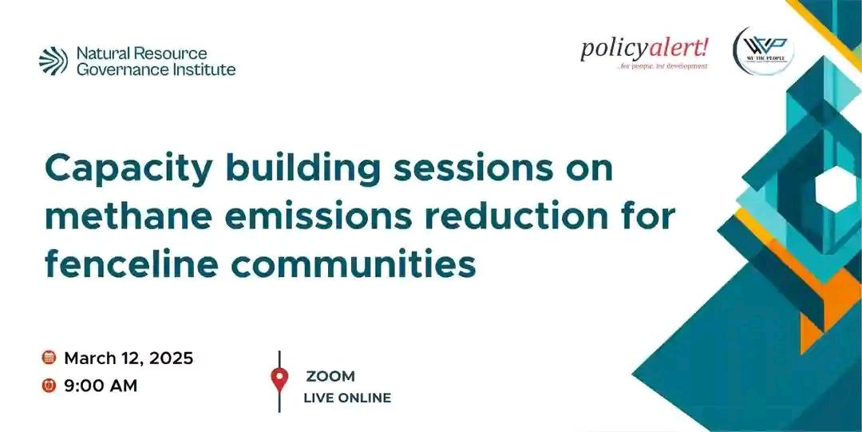
Figure 1: Wall Drape at the Capacity Building Workshop

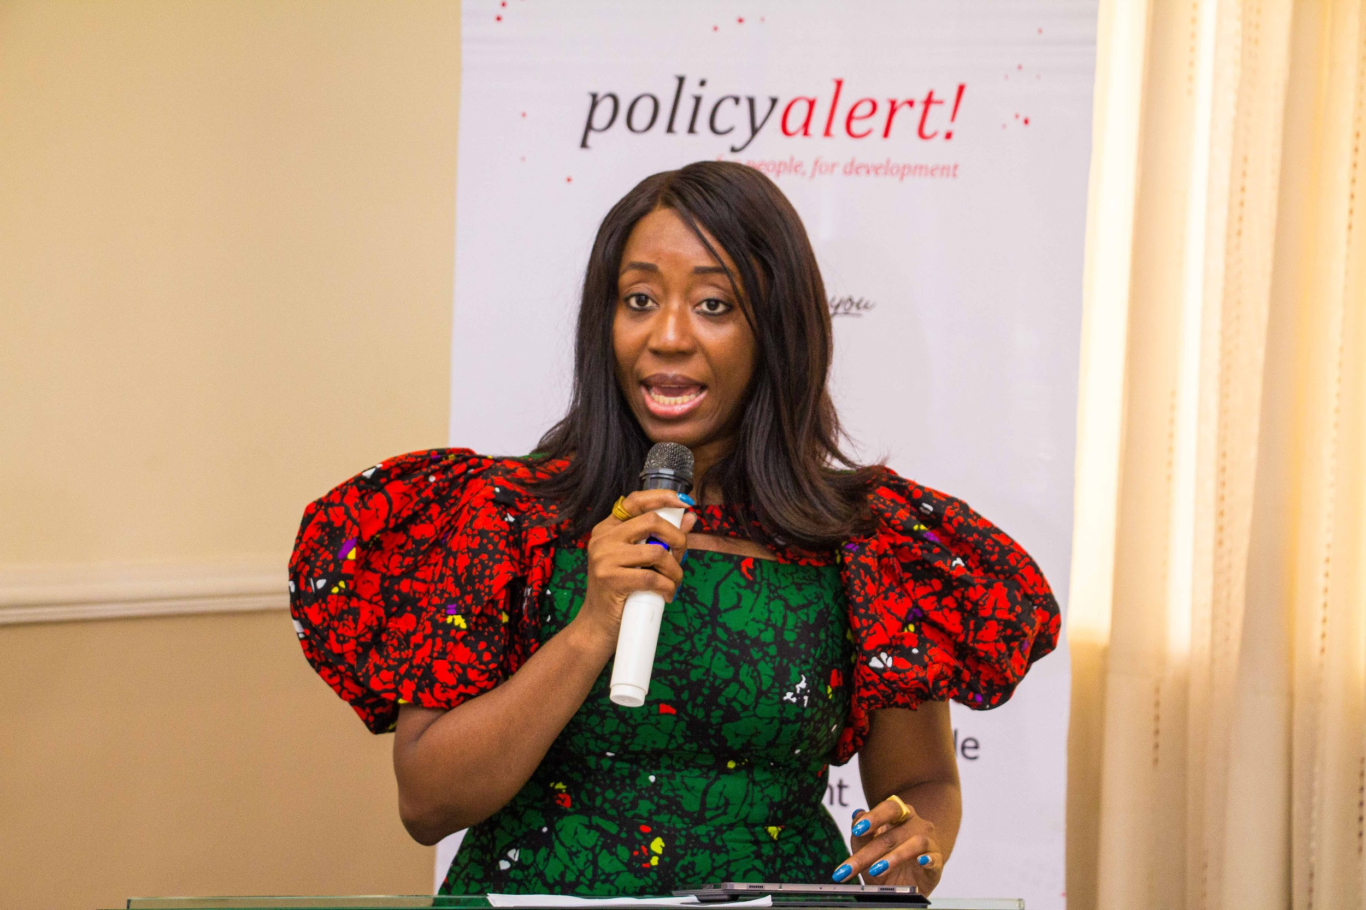
Figure 2: Tengi George-Ikoli Senior Officer NRGI

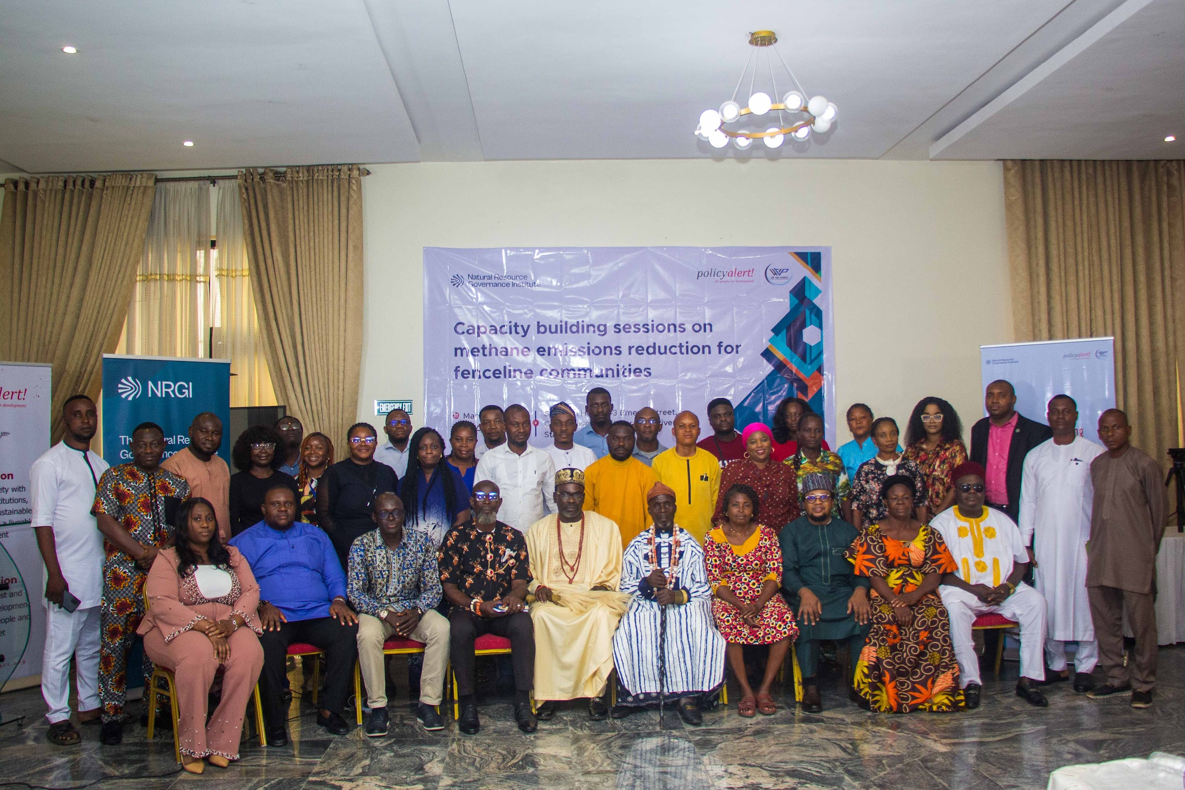
Figure 3: Participants at the one-day Capacity Building Session on Methane Emission Reduction for Extractive Communities

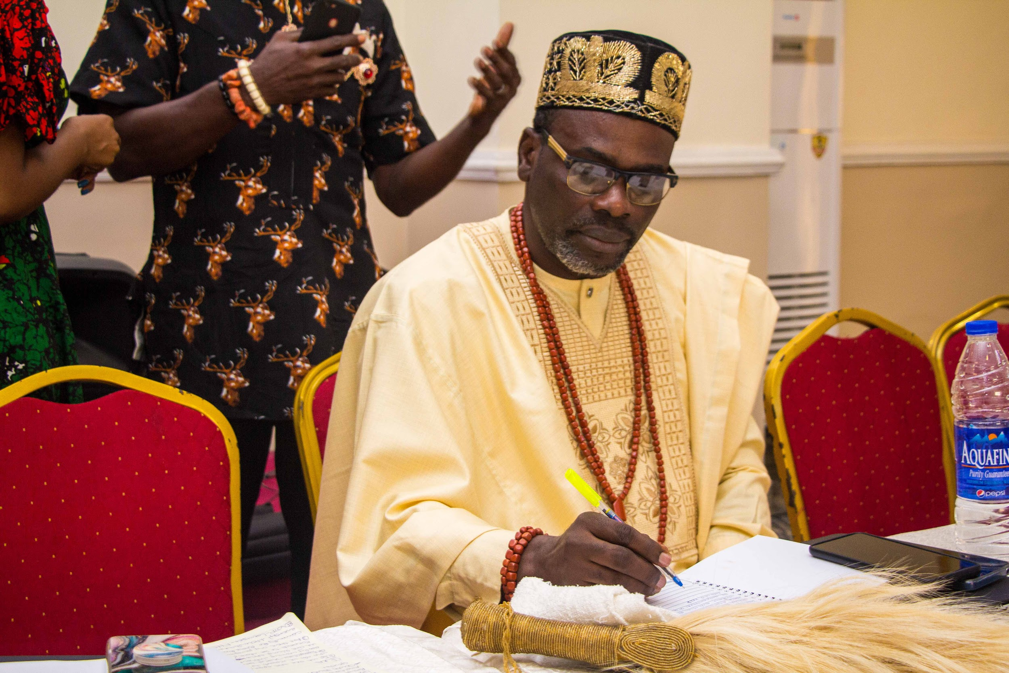
Figure 4: HRH Oba Oluwambe – From Ayetoro in Ondo State.

Resolution/commitments/recommendations
- Oil companies must be held accountable for the environmental damage they cause, and they should invest in remediation efforts and community development projects.

- As a matter of urgency, Civil society groups must set up initiatives to amplify voices of fence line communities. Forming a coalition that would help support coordinated advocacies where necessary

- The government should invest in Methane abatement and recovery technology across the oil and gas value chain, to reduce methane emissions, while also exploring ways to use this gas to the country’s economic advantage. For example, exporting the excess gas that is released to the air during venting and flaring or converting them to cooking gas.

- Increase community participation in environmental monitoring and decision-making processes, ensuring that local knowledge and concerns are integrated into policy development.

- The government should enforce stricter regulations on gas flaring and invest in alternative energy sources, such as solar, to reduce reliance on fossil fuels, making sure to involve community leaders in all meetings that discuss the energy transition, and methane mitigation.

- HRH Oba Oluwambe committed to regroup chiefs and do a step-down training from this event for other community chiefs for more enlightenment and awareness

- CSO’s will provide technical support for communities who need such support to improve the content of their advocacy and design programs to bridge knowledge gaps that exist in the Petroleum Industry Act (PIA).

- Policy Alert committed to developing and disseminating advocacy materials based on the localized case studies, including visual aids and simplified reports for community members.

- 11 participants agreed to conduct step down training in their communities on the impact of methane emission and how to engage the companies in their locality.

