REPORT ON NEITI OIL AND GAS 2022/2023 AUDIT REPORT
DATE: 26TH SEP, 2024
VENUE: FRASER SUITS, CBD, ABUJA
- INTRODUCTION.
- ACTIVITY DETAILS.
2.1. Introduction of guests.
2.2. Speech by the Executive Secretary.
2.3. Speech/Presentation by Adeshile Adedeji & Co
2.4. Speech by the SGF Senator George Akume
2.5. Speech by the EFCC chairman Mr Olanipekun Olukoyede
- CONCLUSION.

- INTRODUCTION
The Nigeria Extractive Industries Transparency Initiative (NEITI) launched the 2022 and 2023 oil and gas audit report on the 26th of September 2024. The report launch is part of NEITI’s yearly tradition where a comprehensive audit report is made available to the public, for dissection and for the general public to know what the companies, and the government got, and what was remitted back into the federation account.
The objective of the event was to promote NEITI’s work and the report as a whole.
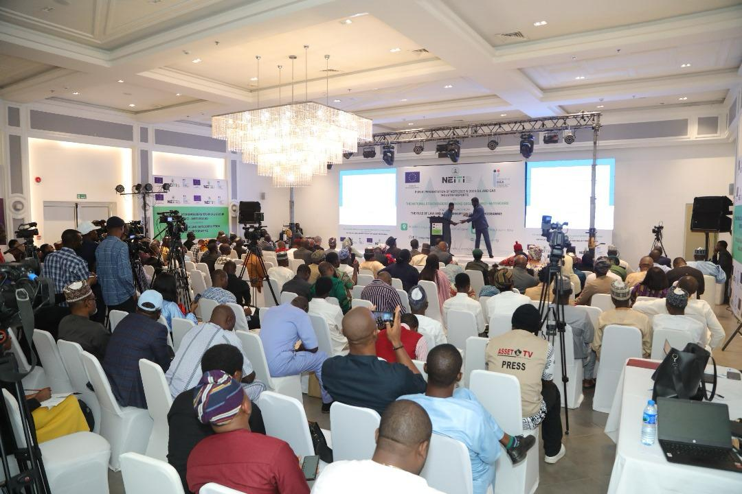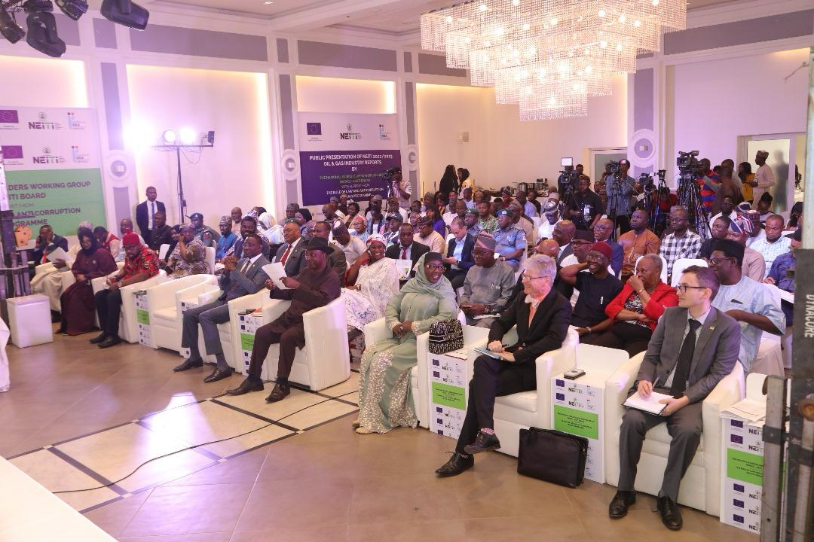

- Activity Details

  - Introduction of Guests
The event started 10am with the arrival of the Executive Secretary Dr Orji Ogbonnaya Orji and some very important guests from both the Government, the private sector and the Civil Society.
The facilitator, Mr. Kingsley Osadolor, introduced the guests present at the occasion. The guests include, the EFCC Chairman Mr. Ola Olukoyede, the Ambassador of Belgium Mr. Pieter Leenknegt, the Chairman Senate Petroleum Upstream Senator Eten Williams, Chairman House Committee on Petroleum Downstream Hon. Ugochinyere Imo, the NFIU chairman Haj. Hafast Bakare, the Chairman OPTS and a board member of the NSWG Mr. Gweke Ajaifia, Dr Erisa Danladi and Dr Emmanuel Uche the Project Manager of RoLAC among others. The media was strongly represented by over 20 media houses.
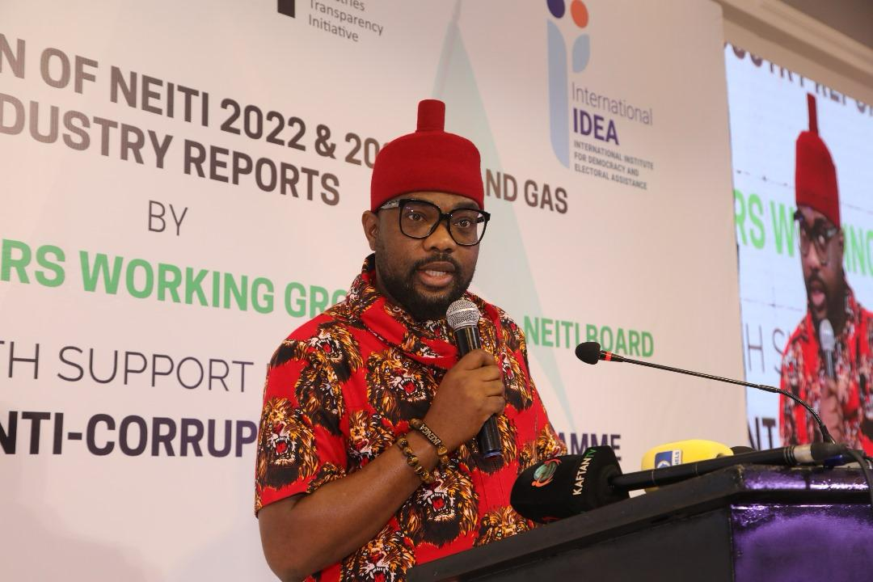
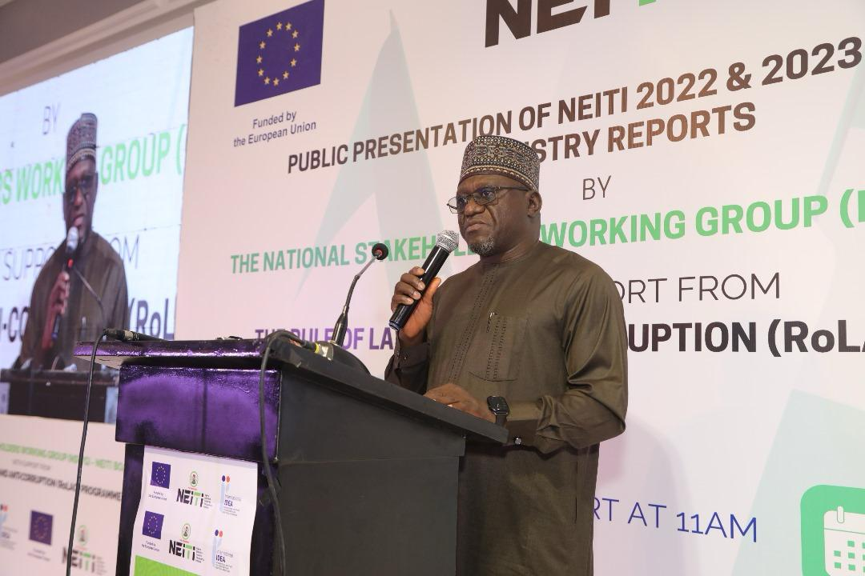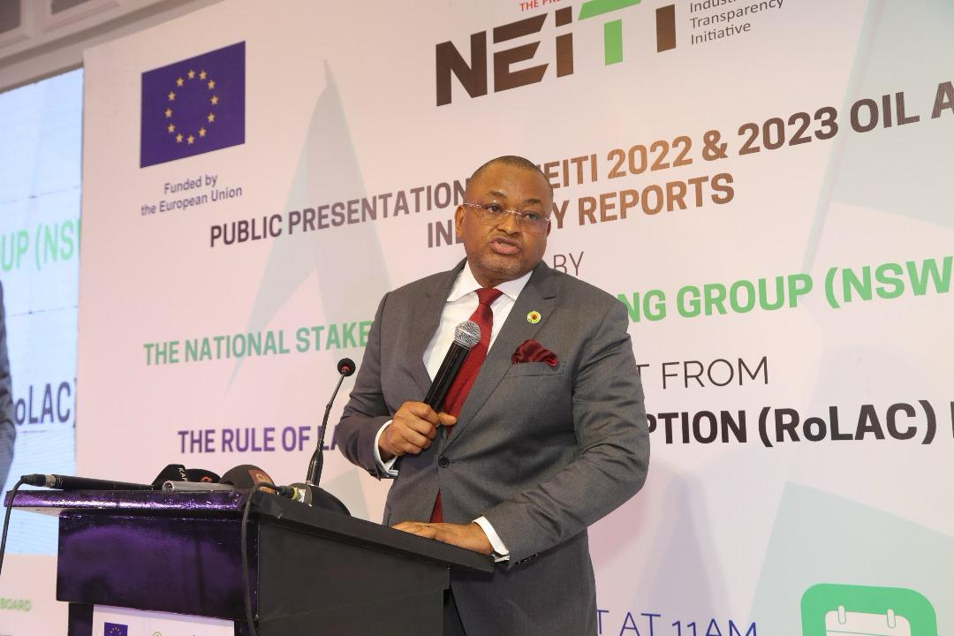
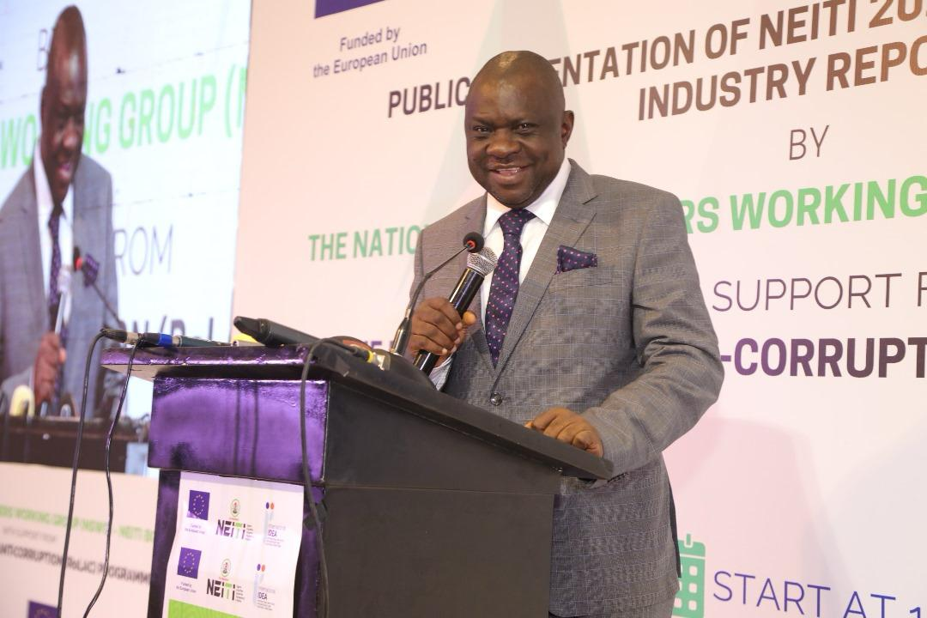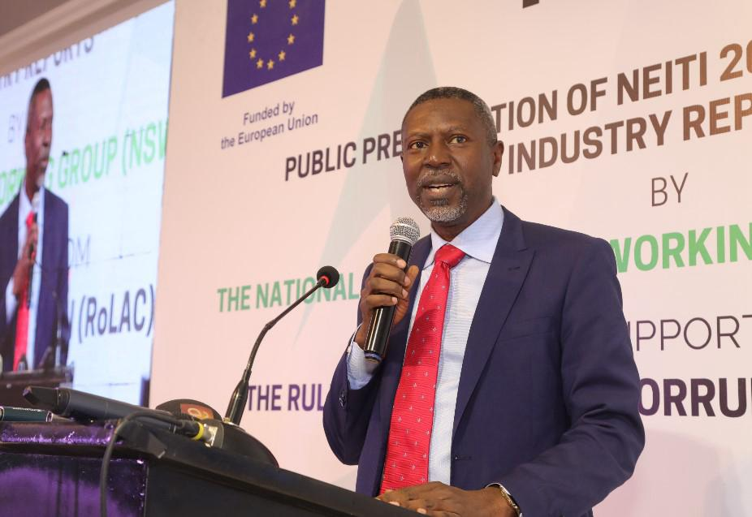
Mr. Osadalor described the report launch to be one of the milestones reached by NEITI with particular focus on the oil and gas industry. He also recognized and lauded the efforts of the Executive Secretary and the management of NEITI for a successful launch.
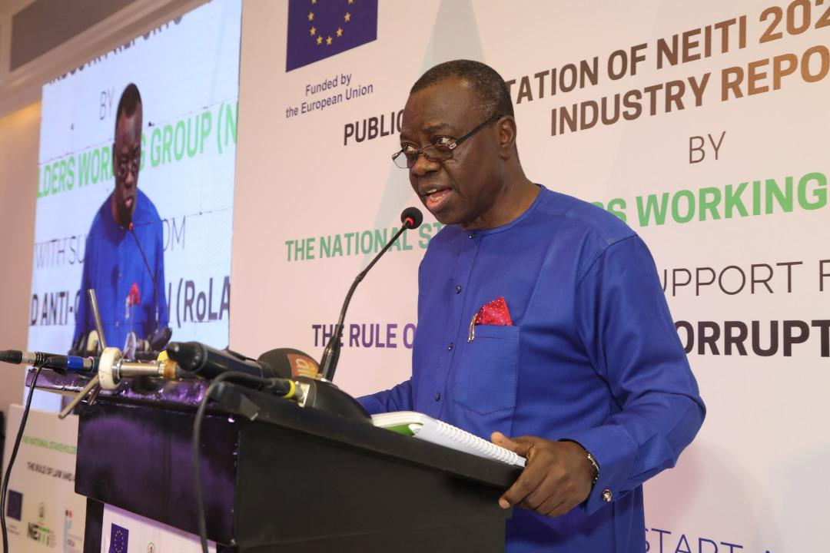

  - Welcome address by the Executive Secretary NEITI, Dr, Orji Ogbonnaya Orji.

Distinguished Ladies and Gentlemen,
Esteemed Stakeholders, Members of the Press, and All Our Guests,

It is my great pleasure to welcome you to this important event – the public presentation of the 2022/2023 Oil and Gas Industry Report. This is a significant milestone in our ongoing efforts to foster transparency, accountability, and good governance within Nigeria's extractive sector.

This report, produced by the Nigeria Extractive Industries Transparency Initiative (NEITI), comes at a critical time when the nation is intensifying its reforms in the oil and gas sector. The report provides valuable insights that will help guide policy, encourage robust public debate, and ultimately improve governance in the management of our natural resources.

The importance of this report cannot be overstated. It serves as an authoritative document that provides comprehensive data and information on revenues, governance structures, operations, and compliance within the oil and gas sector for the 2022/2023 period. The report, as always, remains a vital tool for identifying leakages, improving revenue collection, and promoting resource management reforms.

The Process Followed:

The preparation of this report followed a meticulous and transparent process, in line with the global Extractive Industries Transparency Initiative (EITI) standards. A rigorous, multi-stakeholder approach was adopted, involving extensive collaboration with government agencies, extractive companies, civil society, and indigenous consultants. We ensured that all data was collected, validated, and reconciled in an open and transparent manner.

Scope of Coverage:

The 2022/2023 report covers the entire oil and gas industry, including upstream, midstream, and downstream operations. It delves into critical areas such as revenues generated, taxes and royalties paid, production volumes, and overall industry performance. In addition, it explores issues around corporate social responsibility, environmental impact, and governance reforms. The goal is to provide stakeholders with a complete and accurate picture of the sector’s performance and the challenges it faces.

Challenges and Resilience:

The data collection process was not without its challenges. Our team of experts, alongside the indigenous consultants engaged for this project, encountered significant hazards in gathering accurate and comprehensive data. These included issues related to access to information, logistical difficulties, and security challenges in certain regions. However, NEITI’s resilience, along with the dedication of our partners, ensured that we overcame these obstacles. I commend the consultants for their professionalism and commitment in delivering a high-quality report, despite these adversities.

Key Contents of the Report:

This report contains several key findings and recommendations. These include the identification of revenue leakages, the need for improved compliance with regulatory frameworks, and suggestions for increasing transparency in oil and gas operations. The report also underscores the significance of improving governance structures in line with the Petroleum Industry Act (PIA) and highlights areas where reforms are urgently needed.

Role of Stakeholders:

As we present this report today, I urge all stakeholders—government agencies, civil society organizations, the private sector, the media, and the public—to use the information contained herein as a tool for civic engagement, constructive dialogue, and meaningful public debate. Your role in ensuring that the recommendations in this report are implemented is crucial to achieving the desired impact.

The report is not just a document; it is an invitation to action. We must collectively ensure that the findings and recommendations are translated into policies that will drive change in Nigeria's oil and gas sector, ensuring that the wealth derived from our natural resources benefits all Nigerians.

In conclusion, I wish to thank the Federal Government for funding this project and for its ongoing support of NEITI’s work. I also express my sincere gratitude to the NEITI Board, civil society, extractive companies, our development partners, and the entire NEITI Secretariat for their invaluable contributions to the success of this report.

Thank you all for your presence here today, and I look forward to fruitful discussions as we launch this important report.

Thank you.
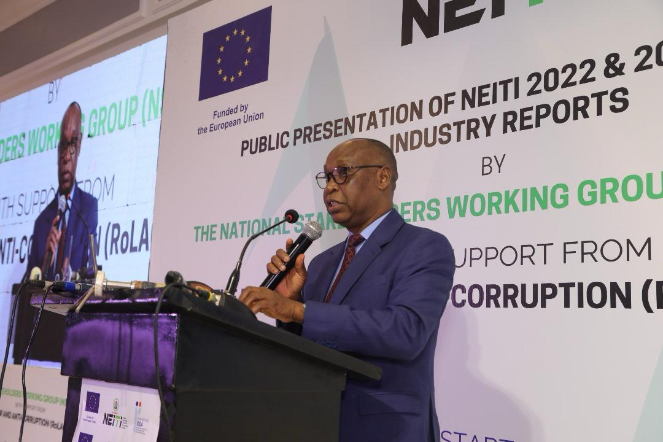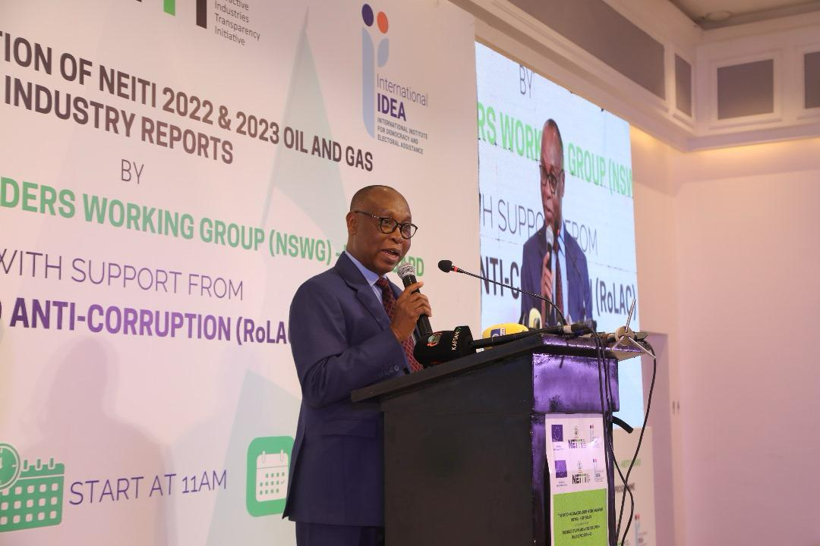

  - Presentation by the independent auditors Adeshile Adedeji & Co.
During the presentation made the representative of the independent auditors incharge of the NEITI 2022/2023 Oil and Gas audit report, the representative stated that the latest NEITI report reveals that outstanding collectible revenues owed to the Federal Government in the oil and gas industry, as of June 2024, have risen to over $6.071 billion and N66.4 billion. These include unpaid royalties and gas flare penalties owed to the Nigerian Upstream Petroleum Regulatory Commission, as well as petroleum profit taxes, company income taxes, withholding taxes, and VAT owed to the Federal Inland Revenue Service (FIRS), which amounted to $21.926 million and N492.8 million.
Fuel Importation: The report disclosed a significant decline in the importation of Premium Motor Spirit (PMS), with total imports dropping from 23.54 billion liters in 2022 to 20.28 billion liters in 2023, a 14% decrease following the removal of the fuel subsidy.
Crude Production: The report provided detailed data on crude oil production, showing an increase of 9.5% in 2023. Total fiscalized crude production rose to 537.571 million barrels in 2023, up from 490.945 million barrels in 2022, indicating a 46.626 million-barrel increase. Over a 10-year trend (2014–2023), the report revealed that the highest annual production volume of 798.542 million barrels was recorded in 2014, while the lowest, 490.945 million barrels, occurred in 2022.
Crude Lifting: Regarding crude lifting, total lifted crude stood at 534.159 million barrels in 2023, representing an 11% increase of 58.08 million barrels from the 482.074 million barrels lifted in 2022. This marked a significant recovery compared to the previous year's drop in lifting volumes.
Oil Theft and Crude Losses: NEITI reported a substantial reduction in oil theft and crude losses in 2023. A total of 7.68 million barrels of crude oil were either stolen or lost, marking a 79% decrease from the 36.69 million barrels lost or stolen in 2022.
Gas Production: Total gas production in 2022 was 2.521 trillion SCF, an 8% decline from the 2.744 trillion SCF produced in 2021. In 2023, gas production slightly decreased further to 2.491 trillion SCF, continuing the downward trend. The five-year trend (2018–2023) shows that the highest production volume of 3.048 trillion SCF was recorded in 2019, while the lowest, 2.491 trillion SCF, was in 2023.
Revenue Generation: On overall revenue generation in the oil and gas industry, material companies accounted for $15.549 billion in revenues in 2022, and $21.415 billion in 2023. The revenues were generated from taxes, oil and gas sales, NLNG dividends, royalty payments, and other streams.
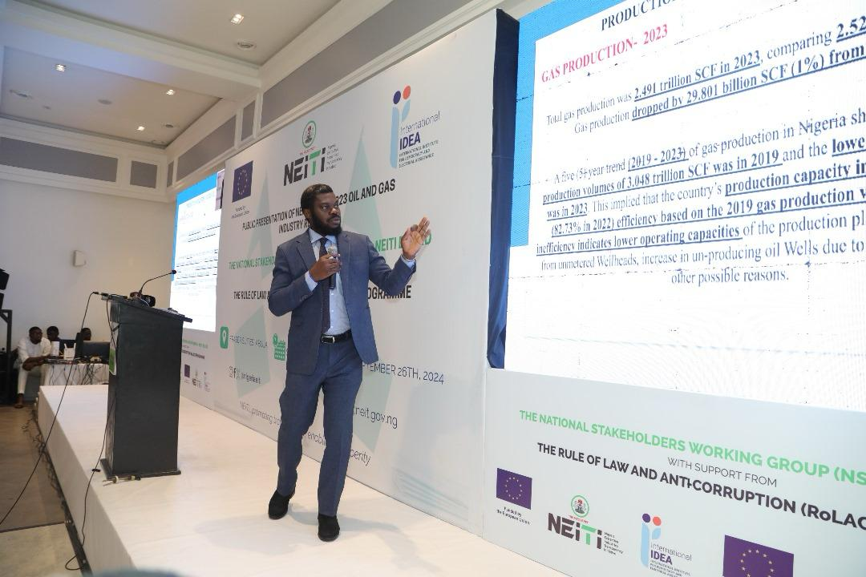 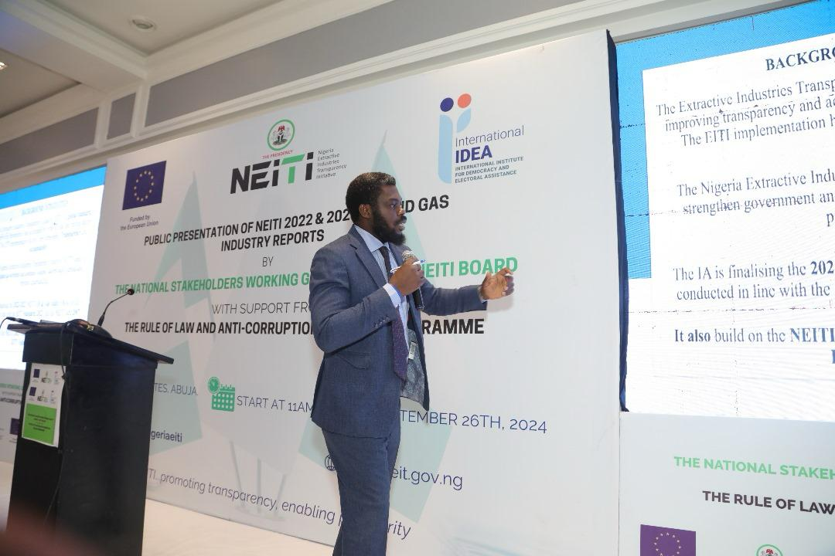
2.4 THE SECRETARY TO THE GOVERNEMT OF THE FEDERATION, SENATOR GEORGE AKUME HIGHLIGHT FROM HIS SPEECH.
At the public presentation of the report, as the Secretary to the Government of the Federation, Sen. George Akume, reaffirmed the Federal Government’s unwavering commitment to NEITI’s work. He emphasized that the data and information provided by NEITI have been instrumental in shaping government policies and decisions that foster accountability and revenue growth, particularly in the oil and gas sector. Sen. Akume also highlighted that NEITI’s independence remains sacrosanct, and its work will continue to guide the government's efforts in ensuring Nigeria's resources are managed for the benefit of its citizens.
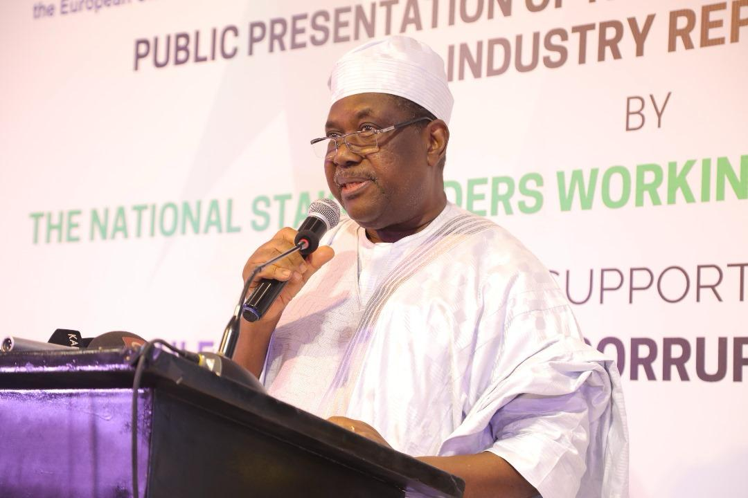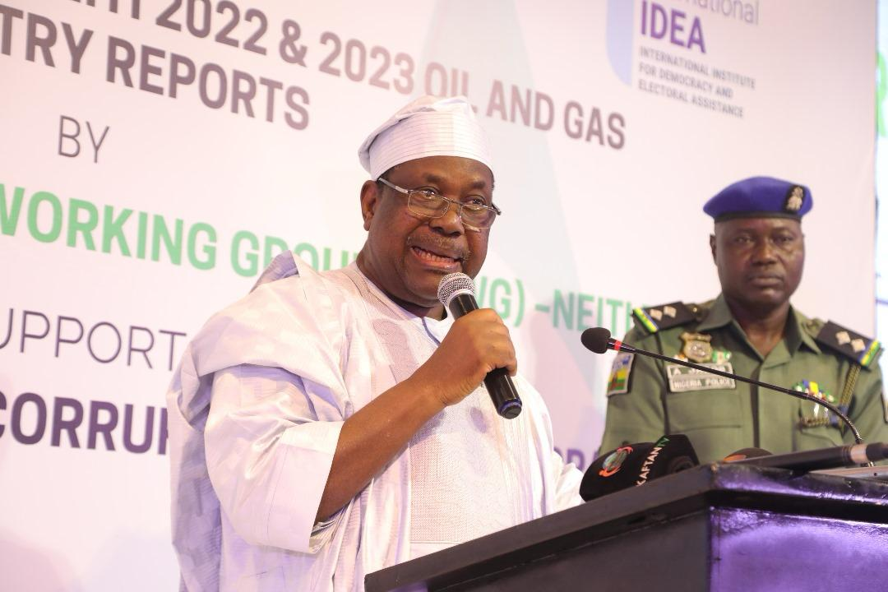

2.5 THE CHAIRMAN EFCC, Mr. OLANIPEKUN OLUKOYEDE HIGHLIGHT
Mr. Olanipekun Olukoyede, the Chairman of the Economic and Financial Crimes Commission (EFCC), noted that NEITI’s reports have been crucial to the agency’s anti-corruption efforts in the extractive sector. He acknowledged that the EFCC, in partnership with NEITI, had recently recovered over N1 billion based on NEITI’s past reports and assured that the current reports would undergo further investigations to recover additional revenues for the government.

- Conclusion
The public presentation concluded with the Unveilling of the report by the SGF, EFCC chairman and the Executive Secretary of NEITI after which the event was brought to a close. Following this, he joined the Executive Secretary of NEITI and other stakeholders for a group photograph and exchange of pleasantries, marking the end of the event.
