REPORT ON THE NEITI COMPANY’S FORUM
DATE: 10TH SEPTEMBER, 2025
VENUE: BLACK DIAMOND HOTEL, VICTORIA ISLAND, LAGOS.
- Introduction.
- Opening Ceremony.
2.1. Introduction of guests and Welcome Remarks
2.2. Opening Remarks by the Deputy Chair, NEITI-Companies Forum and President, Miners Association of Nigeria, and member of the NEITI Board, Mr. Dele Ayanleke
2.3. Remarks by the South West Representative on the NEITI NSWG
2.4. Speech by the Executive Secretary, NEITI, Dr Orji Ogbonnaya Orji
2.5. Presentation by the Commission Chief Executive of NUPRC, Engineer Gbenga Komolafe represented by the Director, Services and Administration, Mrs. Efemona Bassey.
2.6. Presentation by the Minster of Solid Minerals Development, Mr. Dele Alake represented by Dr, Mrs. Okono Vivian
3. Question and Answer Session
4. Conclusion.
5. Attendance at the event.

- Introduction
The NEITI-Companies Forum held on 10th September 2025 at the Black Diamond Hotel, Victoria Island, Lagos. The forum with the theme “Divestments, Liabilities and Impact of on-going reforms in the extractive sector” was organized by NEITI in collaboration with the Companies Forum. It was a platform for extractive industries companies to exchange information on how the on-going reforms in the extractive sector affect their operations. It is also a meeting of companies engaging in the extractive sector and covered by the implementation of the Extractive Industries Transparency Initiative, EITI.
The forum provided a structured platform for companies in Nigeria’s extractive industries to engage with NEITI, exchange perspectives on ongoing reforms, identify challenges affecting their operations, and explore collaborative solutions that promote transparency and accountability.
The meeting commenced at 10:00 AM with an introduction of all guests present at the forum.
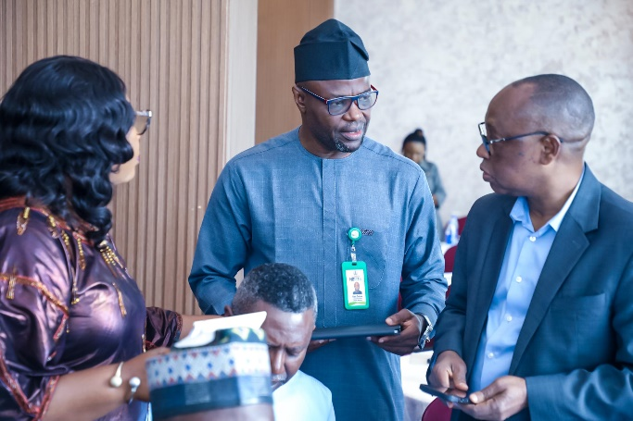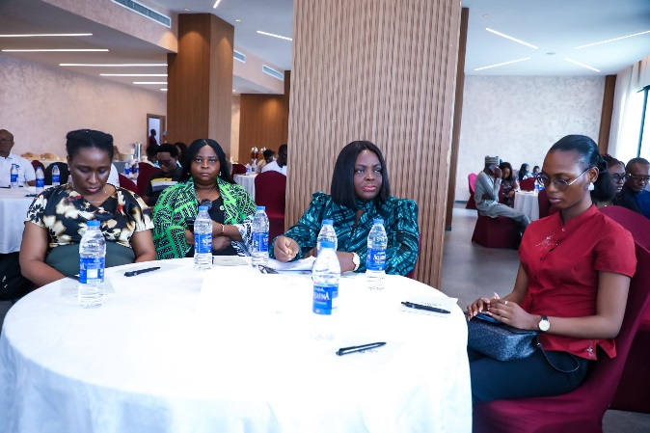
- Opening Ceremony
  - Introduction of Guests and Welcome Remarks
Following the introduction of guests, the Chairman NEITI Companies’ Forum and member of the NEITI Board Mr. Gwueke Ajaifia, gave his welcome remarks. The Chairman while welcoming members to the meeting explained that the forum of this nature helps companies to improve on their processes, also provide an opportunity to listen to ourselves, receive feedback and make progress. It is a matter of taking steps. I think NEITI is well positioned to guide this process.
He explained that proliferation of demands for data and payments from multiple government agencies are key factors frustrating business environment. The Chairman called on NEITI to escalate the matter to the federal government.
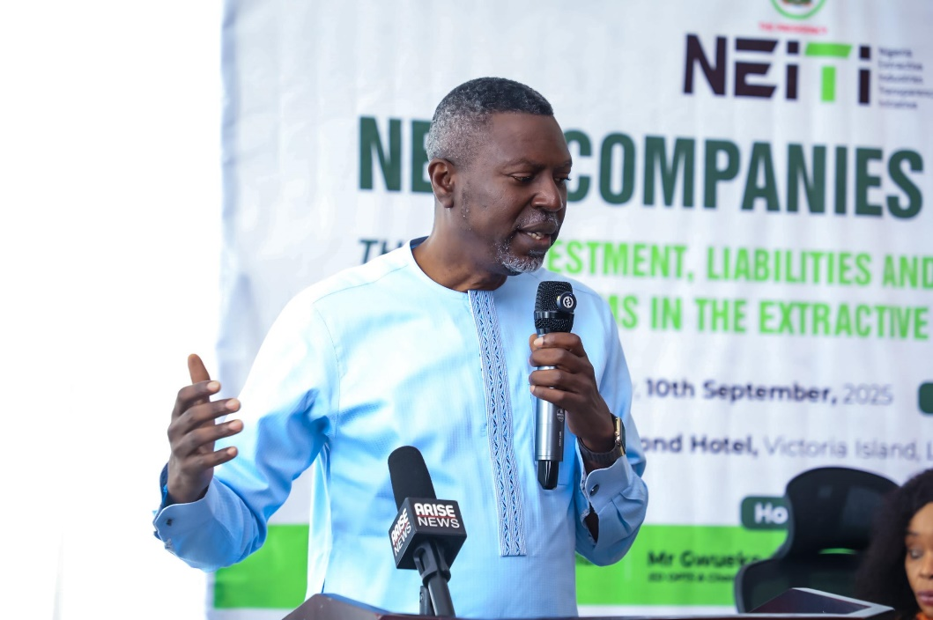

Mr. Gwueke Ajaifia, Chairman NEITI Companies’ Forum and member of the NEITI Board giving the Welcome Remarks at the NEITI Companies Forum.

  - Opening Remarks by the Deputy Chair, NEITI-Companies Forum and President, Miners Association of Nigeria, and also member of the NEITI Board, Mr. Dele Ayanleke
The President, Miners Association of Nigeria and a member of the NEITI Board, Mr. Dele Ayanleke made an opening remark at the NEITI-Companies Forum. In his remarks, he stated that one of the pillars of Extractive Industries Transparency Initiative (EITI) platform is the companies. He emphasized that The NEITI Companies Forum has crucial roles to play in promoting transparency and accountability in the extractive sector.
The Deputy Chair highlighted that companies can contribute to EITI's goals in several ways which includes: Disclosure, Reporting, Compliance, Stakeholder Engagement, Capacity Building. He expressed that by participating in EITI, companies can also help to improve governance, reduce corruption, increase trust and promote sustainable development.
“I want to recommend that we pass a resolution for each participating company to create a desk for NEITI Companies' Forum with a designated Senior Officer close to the decision-making organ of the company”. -Mr. Ayanleke said
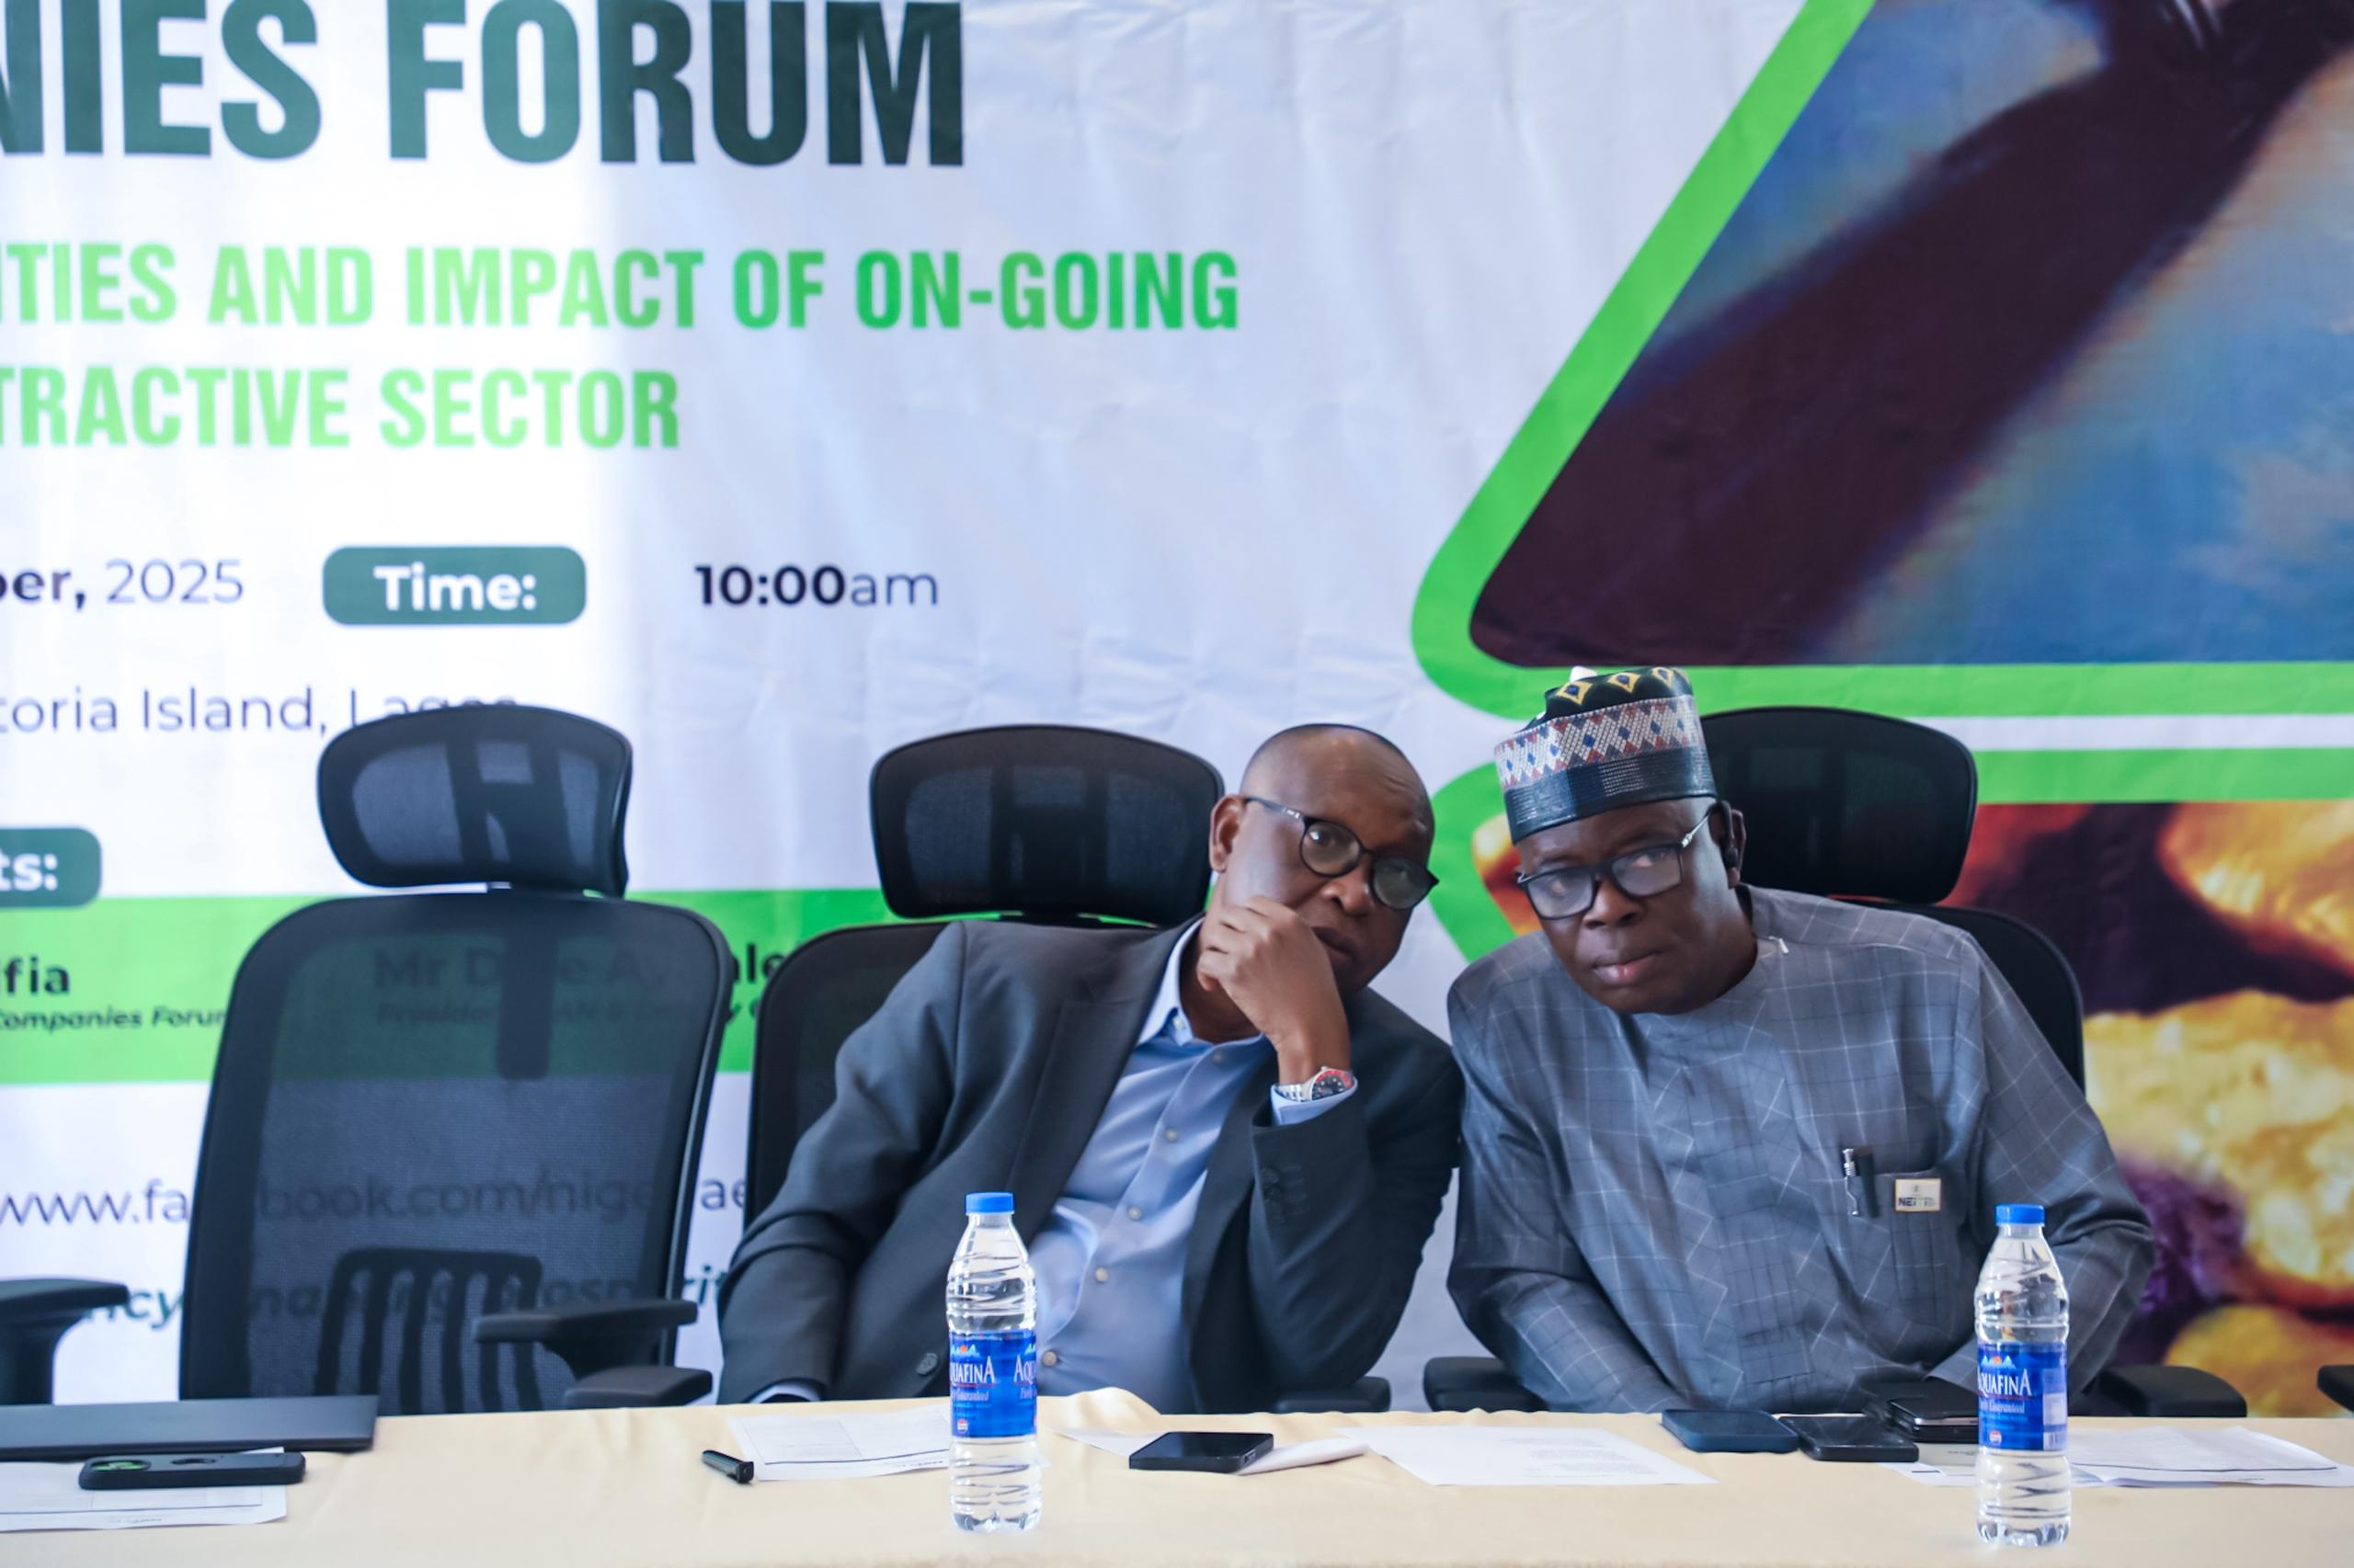
  - Remarks by the South West Representative on the NEITI NSWG Mr. Olasupo Abdel-Jeleel Taiwo
The South West representative on the NEITI Board, Mr. Olasupo Abdel-Jeleel Taiwo noted that the forum continues to provide a platform for open conversations, policy innovation, and a critical stakeholder in the governance of Nigeria's extractive sector.
Mr. Olasupo Abdel-Jeleel said that the theme of this year's Forum "Divestments, Liabilities and Impact of On-Going Reforms in the Extractive Sector” touches the core of our national priorities. “As we confront the realities of energy transition, climate change, and increasing international interest in Nigeria's critical mineral resources, we must also confront the governance gaps and community concerns that have shadowed our extractive history”.
“As a member of NEITI National Stakeholders Working Group and representative of the South-West region, I am deeply aware of the challenges facing our resource-rich states. For instance, in Ondo State, large deposits of bitumen hold immense potential, yet host communities continue to face environmental degradation and limited local benefits”. -Mr. Olasupo Abdel-Jeleel Taiwo stressed.
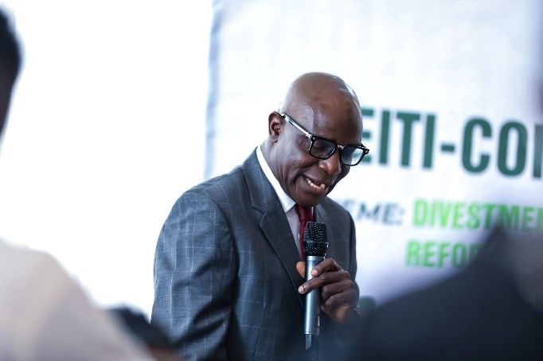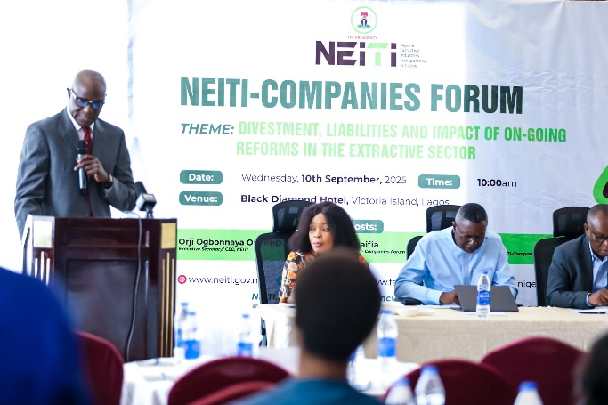
The South West representative on the NEITI Board, Mr. Olasupo Abdel-Jeleel Taiwo making his remarks at the NEITI Companies Forum in Lagos.
  - Speech by the Executive Secretary, NEITI, Dr Orji Ogbonnaya Orji
The Executive Secretary of NEITI, Dr Orji Ogbonnaya Orji while speaking at the opening session of the NEITI Companies Forum highlighted that transparency and accountability are not only national requirements but also critical pillars for building investor confidence, strengthening citizens’ trust, and aligning Nigeria’s extractive practices with global standards.
Dr. Orji explained that compliance with NEITI’s audit process underpins efforts to improve Nigeria’s business environment and attract sustainable international investments.
The Executive Secretary noted that the NEITI Companies Forum has become a strategic platform for forging closer partnerships with companies in the oil, gas, and mining sectors, focusing on: data disclosure on company payments; beneficial ownership transparency; contract transparency; sub-national fiscal sustainability; climate change, and multi-stakeholder collaboration.
Dr. Orji announced that NEITI has commenced the 2024 Industry Audit Reports and it will be concluded before the end of the year, urging companies to ensure full and timely compliance to meet reporting deadlines.
The Executive Secretary further made a presentation on Who We Are and how our work connects to what companies do explaining that the main objective of the EITI in Nigeria is to Improve Nigeria Macro economic environment, strengthen public expenditure management, improve our institutional and governance reforms and pursue structural reforms.
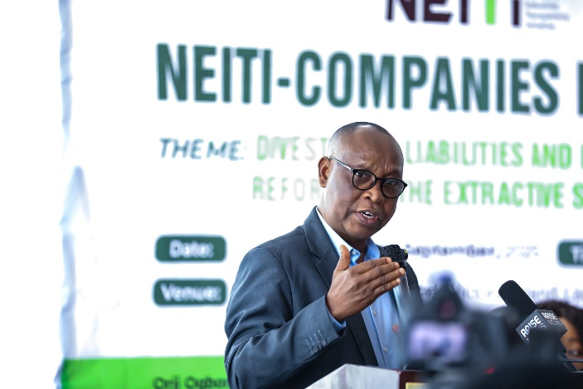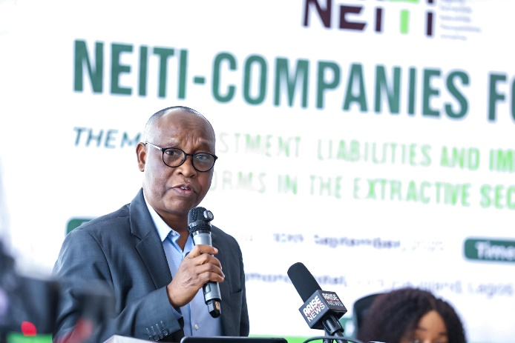
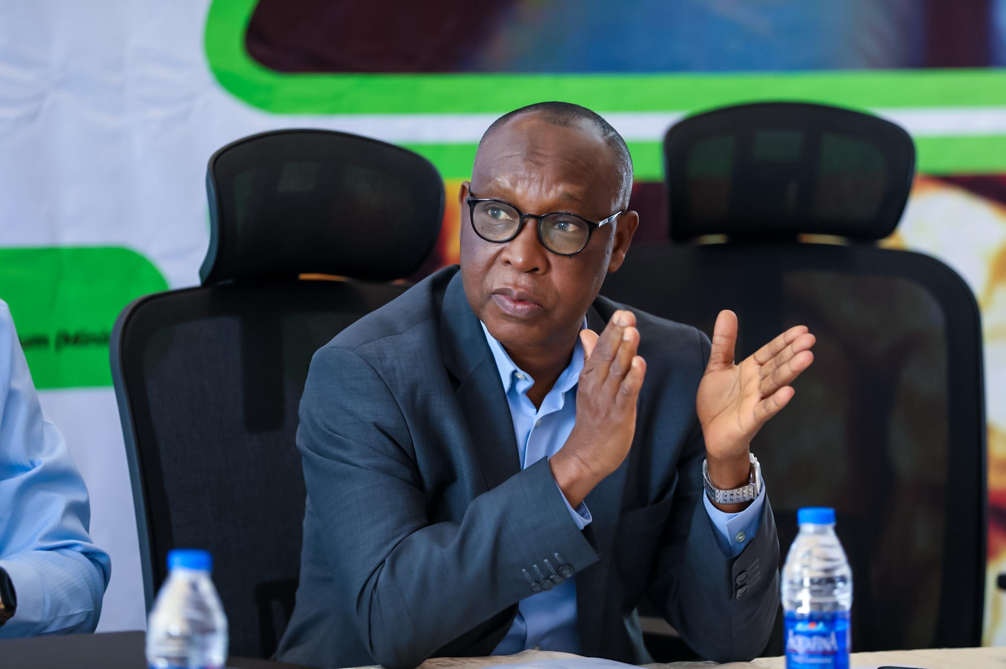
The Executive Secretary of NEITI, Dr Orji Ogbonnaya Orji giving his remarks at the NEITI Companies Forum.

  - Presentation by the Commission Chief Executive of NUPRC, Engineer Gbenga Komolafe represented by the Director, Services and Administration, Mrs. Efemona Bassey.
The Nigeria Upstream Petroleum Regulatory Commission (NUPRC) Commission Chief Executive, Engineer Gbenga Komolafe represented by the Director, Services and Administration, Mrs. Efemona Bassey delivered a comprehensive presentation on the “On-going divestments, liabilities and its implication to the growth of extractive industries- Upstream experience”.
The presentation examined the opportunities and risks posed by the ongoing wave of oil and gas divestments in Nigeria. She stressed that while divestment and reforms create economic opportunities, they also bring significant liabilities if poorly managed.
“Today, these twin forces which is divestment and reforms are creating tremendous opportunities for growth, jobs and resilience. However, if divestment is not properly managed and carefully stewarded, they can pose serious challenges including stranded liabilities, net environmental responsibilities and risk to the stability of Host Communities.” - The Commission Chief Executive stated.
The Commission Chief Executive identified the balancing act required in managing these transitions: “The central challenge before us is very clear, how do we balance the opportunities created by new entrance with the risk of inherited liabilities… how do we ensure that as IOCs exit, we do not wake up in 10–20 years from now weighed down by billions of dollars in abandoned infrastructure and devastated communities.” This concern underscores the need for a transparent and enforceable divestment framework to protect Nigeria’s national interest, communities, and environment.
The Commission Chief Executive stressed that Nigeria’s hydrocarbon basin is mature, with more than 7,000 of about 8,200 wells drilled before 2011. Many oil and gas facilities have exceeded two decades in service, raising urgent questions around decommissioning and abandonment.
As highlighted in the presentation: “The challenge of managing late life assets has become both urgent and unavoidable. Aging wells and infrastructure if not proactively managed present real risk of declining production, escalating maintenance cost, oil spills and environmental hazards.”
The presentation drew from global case studies to demonstrate the heavy costs of neglecting liabilities:
- United Kingdom – Decommissioning projected at £27 billion by 2032, with risks of escalation.
- United States – Over $9 billion in liabilities shifted to taxpayers in the Gulf of Mexico.
- California (U.S.) – Plugging all known wells could cost $1.8 billion.
- Australia – Bankruptcy of Northern Oil & Gas (2019) left AUD $200 million in liabilities.
- Canada (Alberta) – 97,000 inactive/abandoned wells, with liabilities of CAD $30–70 billion.
- Trinidad & Tobago – Collapse of a state-owned company left more than 2,000 wells requiring costly decommissioning.
Engr Komolafe warned: “The lessons from these global benchmarks are crystal clear, when divestments are not managed under a strict liability framework, the cost will not disappear. They return like a boomerang to government, regulators and ultimately, the communities themselves.”
Engr Komolafe pointed out that Nigeria has moved proactively to avoid these pitfalls. The Petroleum Industry Act (PIA) established clear responsibilities and safeguards:
- Sections 232–233: Responsibility for decommissioning and abandonment of wells, plants, and pipelines.
- Chapter 3: Host Community Development obligations.
- Section 101: Environmental remediation requirements.
The Commission Chief Executive emphasized: “For the first time the PIA set out clear rules for Host Community Development Funds, the Environmental Regulation Fund, and the decommissioning and abandonment obligations providing a clear legal foundation for accountability and transparency.”
  - Presentation by the Minister of Solid Minerals Development, Mr Dele Alake represented by Dr, Mrs. Vivian Okono
The Minster of Solid Minerals Development, Mr Dele Alake represented by Dr, Mrs. Vivian Okono made a presentation on the Impact of the renewed hope reform agenda on the solid minerals sector.
The Presentation reflected on how Nigeria is blessed abundantly especially on the quality and quantity of solid minerals available in the ground, which has been in existence since the early 20th century and its flourishing into the 60s and 70s until oil took over as the major source of revenue for Nigeria. Solid minerals have been abandoned for a long period of time until early 2000s when the government of Nigeria made decisions to prioritize solid mineral sector for economic diversification.
The Minister noted that the current administration views solid mineral sector as a key driver to the diversification of the economy. The Federal Government along with the solid mineral sector and the renewed hope agenda, the government aims at: Revenue generation; Job creation; Infrastructural development; Reduced dependance on oil and gas; Establishment of a Nigerian solid mineral companies limited that will be structured in a way the governing bodies will learn from the NNPC experience. The Company will be driven in a tripartite manner whereby private concerns own 50% and the government and citizens own 25% separately; Ensure joint ventures with mining and multinationals; Invest in big data gathering and storage on specific priority minerals and their depot; Integrate illegal miners to join artisanal cooperatives; Restructure and reinvigorate mines surveillance, task force and mine police; Comprehensive review of all mining licenses and creation of mineral processing centers to focus on value added products.
Engr Alake explained that the Ministry has adopted a non-coercive approach to encourage compliance among artisanal miners to form cooperatives and market access to pull ASM into the formal value chain and reduced smuggling. He maintained that “There are about 150 new minerals buying centers over 250 mining cooperatives enabling small scale miners to operate within the laws”. This formalization process enhanced transparency, proper monitoring and significantly boosting government revenue through increased royalty collections.
On international partnership, new technical and investment MOUs (France, Uk, Australia, Saudi Arabia and Nigeria-South African mining pact of April 17th 2025 on mapping, data sharing and skills development, capacity building of ministry and staff in Australia 2025.What these means in practice is; cleaner license book; fewer paper miners more credible projects.
Engr Dele Alake further emphasized that Nigeria solid mineral sector remains underdeveloped but highly strategic for economic development, current reforms under renewed hope agenda focus on effective governance and security. Value addition and partnership to unlock the sectors potential as a key driver for industrialization, job creation and profit to the economic from oil revenue.
- Question and Answer Session
During the question-and-answer session, various participants asked questions dwelling on;
- Security concerns; water ways for transportation, mine security
- The role of state government in the energy sector in easing the stress on the federal
- Multiple taxation and further understanding of payment of dues, taxes, levies and rents.
- Understanding the meaning of certificate of ownership and mining rights and how it plays in contract situations.
- A deeper understanding of contractual agreements with Government and obligations by mining companies
- Penalties and fines due to companies
The above questions were answered by the responsible agencies present and more insights were given by NEITI. At the end of the interactive session, the meeting resolved that we can use the Industries Audit platform to identify the issues so in the course of the on-going 2024 Audit process the companies can highlight the problems there are facing so that the independent auditors will flag them up in the report and also proffer solutions, by so doing the issues are properly documented in our reports which goes to the President and the National Assembly who have the capacity to address the issues.
NEITI also reinforced the additional benefits of the on-going innovation of the data centre project. “We also have the data centre which when completed will provide real time data and information to the public. Besides, we also have the IMTT where all government agencies are represented. The concerns raised can easily be cascaded to the President through these platforms.

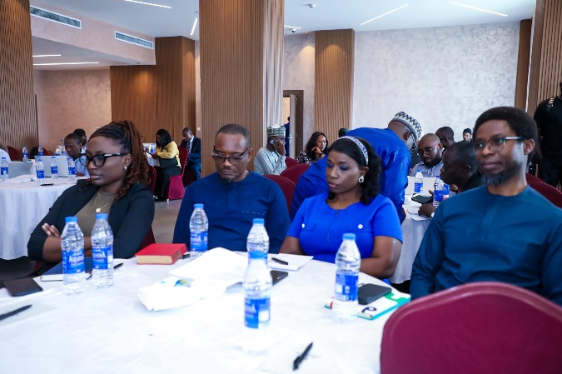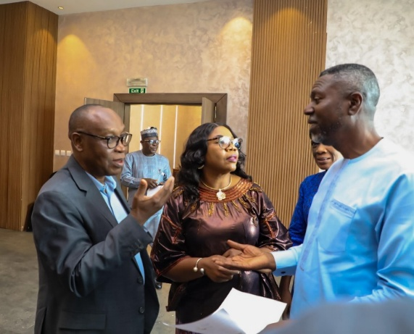
The latest NEITI policy brief on beyond Federal Allocations: The Cost of Borrowing and Debt Servicing at State Level in Nigeria was presented to the Forum.
- Conclusion.
The meeting concluded with a group photograph and exchange of pleasantries. Below are some of the captivating pictures from the event.
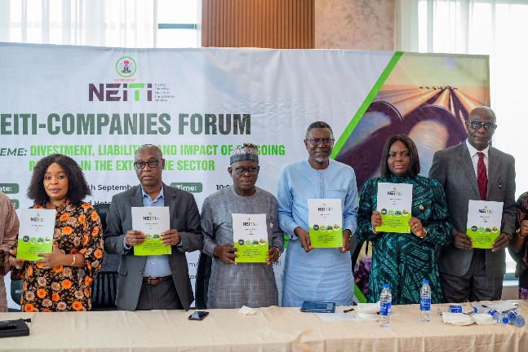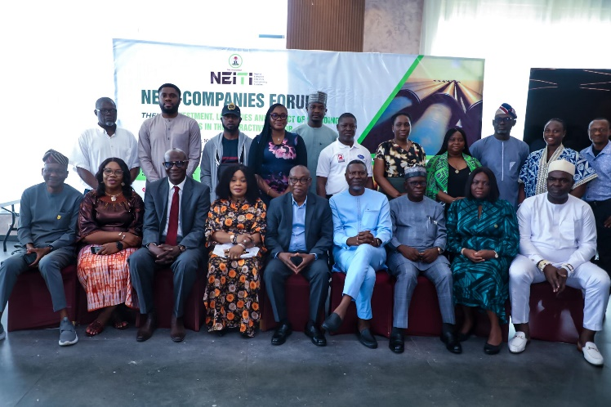
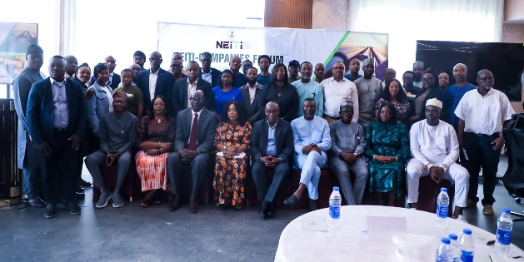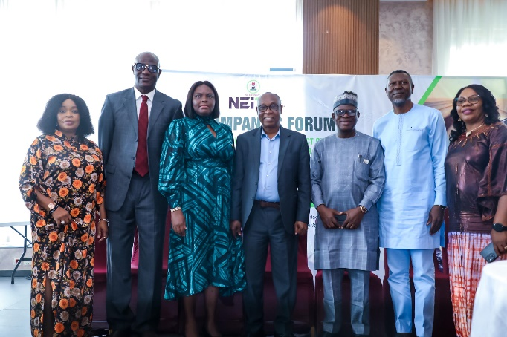

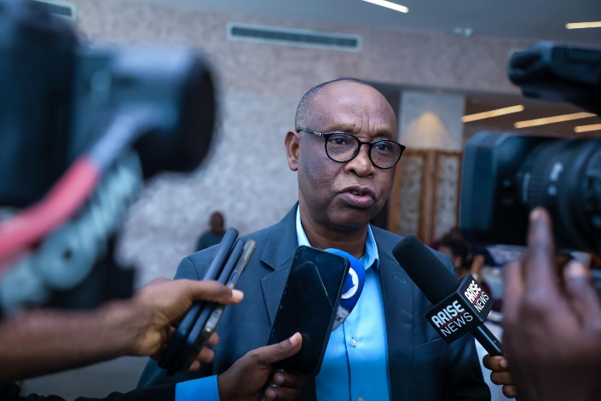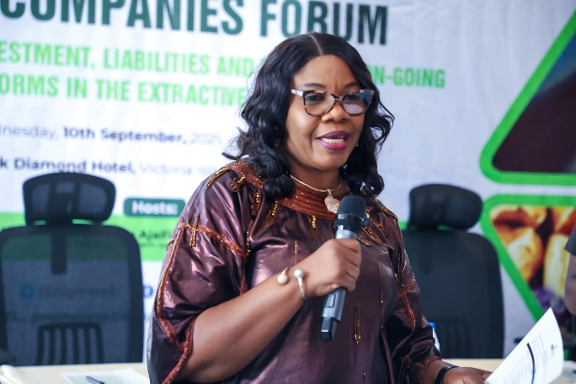
Please find below attendance at the event.

