Narrative Report for strengthening subnational fiscal resilience to minimize impact of the energy transition project
Submitted by Grassroots People Empowerment Foundation – Policy Alert
Submitted on 12/12/2024
Introduction
Project Overview
Fossil fuel-dependent economies risk revenue decline as fossil fuel production decreases and markets shrink globally in response to the climate change-inspired energy transition. Reduced revenues from fossil fuels translate to lower revenues for oil-producing countries like Nigeria. Failure to translate decades of fossil fuel wealth to sustainable growth continues to leave Nigeria dependent and increasingly threatened by the changing energy paradigm. Oil-producing states in Nigeria would suffer a similar fate as oil revenues account for between 50% to 80% of the revenues accruing to oil-producing states from the statutory entitlements including 13% derivation.

The fiscal sustainability of oil-producing states dependent on federal revenues to sustain them is threatened as revenue receipts from oil diminish. BudgIT’s State of States report revealed that Akwa Ibom, an oil-producing state relied on federal revenue allocations stems from oil to service 90.2% of its recurrent expenditure in 2022. Loss of federal revenues may translate to a loss of jobs for a huge sector of the population in Akwa Ibom state. Further proof is that internally generated revenue (IGR) only grew by 0.2% of that year. Despite huge potential from the non-oil sector; tourism the Akwa Ibom government has not successfully translated non-oil sector revenue into a diversified economy, independent of federal funds. Therefore, if the revenue from oil continually diminishes for Nigeria as projected, so will state allocations and their ability to fund their activities.

To build fiscal resilience, the Akwa Ibom state government must reduce its reliance on federal revenues and build resilience within the state. This will involve growing the state's IGR and diversifying its revenues, attracting investments, thus building fiscal resilience. It will also include incorporating energy transition financing into its medium term and long-term budgetary allocations at state level. The intended transition risks such as projected fossil fuel production and revenue decline can all be mitigated. Citizens including youth, media, women, and oil communities echo similar concerns about the lack of their states’ preparedness to mitigate energy transition-induced economic instability.

This intervention seeks to leverage the data, information, and lessons NRGI and partners have generated to support subnational governments in building fiscal resilience.

Rationale
This intervention builds on NRGI’s just energy transition work implemented in collaboration with BudgIT Foundation, Policy Alert, and other actors. It allows NRGI to integrate the concerns and perspectives expressed by stakeholders; oil communities, women, and youth groups from previous interventions into subnational government’s decision-making. It allows us to harness the local capacities built on energy transition and channel it towards influencing government action and response to the national energy transition. In addition, it tests the approaches and lessons shared in NRGI’s guidebook on energy transition and leverages partner expertise on economic diversification and revenue management relevant to this intervention.
Objectives
- To increase the capacity of subnational government to build fiscal resilience in response to the national energy transition
- To provide a guide for oil-producing states on how to build fiscal resilience in response to the national energy transition
- To develop a consensus on the appropriate approaches for Akwa Ibom state in response to the energy transition amongst state and non-state actors
Timeline
August 31st 2024 – November 30th 2024

Main Achievement
- Commitment by the Governor of Akwa Ibom State to move the state away from oil dependence. This commitment was made before the state’s house of assembly during the presentation of the 2025 budget estimates. This commitment is attributable to the strengthened capacity of critical government stakeholders on the imperatives of the energy transition through this project.
- Akwa Ibom State Internal Revenue Service (AKIRS) to digitise revenue collection from 2025 fiscal year. This is to improve efficiency in revenue collection and increase its internally generated revenue. Increased internally generated revenue is part of strategies to build fiscal resilience and reduce dependence on federally distributed oil revenues. This outcome has been a central message in both the capacity building and stakeholder engagement activities on the project.
- The creation of a savings account in the office of the state accountant general. This savings is designed as a counter balance for the fiscal risks that will accompany the energy transition. The state being a key recipient of oil revenues due to its large hydrocarbon reserves, is creating this savings account from the 2025 fiscal year as part of efforts to build the state’s fiscal resilience.
- During the presentation of the 2025 appropriation bill before the house of assembly, the governor was quoted as saying ‘to improve the effectiveness of our budget performance by ensuring fiscal discipline through implementing only programs that were captured in the Budget while ensuring value for money, greater transparency and accountability’. Fiscal discipline has been one of the messages out of this project.
- Production and dissemination of policy briefs containing strategies for building fiscal resilience for Akwa Ibom and other state actors from the region.

Purpose and scope of the report
The purpose of the report is to document all project activities, its outcomes and learnings. This provides a firm foundation to build succeeding interventions on, and to discern what strategies to maintain as those to be adjusted for efficacy. The scope of the report is for the entire project as implemented by Policy Alert. This covers the capacity building, stakeholders’ engagement and the research component of the project.
Activities
Capacity Building Workshop for Policy and Legislative Actors
State actors in Akwa Ibom State convened for a capacity-building workshop to address key issues on the global shifts towards renewable energy in response to the climate crisis leaving the future of oil-dependent states at a crossroads. The workshop aimed to expose policy and legislative actors with available data on financial receipts, the global energy trajectory and to advocate for an inclusive policy alternative to mitigate fiscal risk associated with the energy transition.
Tijah Bolton, the Executive Director of Policy Alert, opened the workshop with a call to action. Bolton underscored the profound impact that global industrial changes could have on local economies, emphasizing the need for proactive discussions and strategic planning. He articulated that while the energy transition presents significant opportunities, it also poses substantial risks. His goal was to bring together all stakeholders to address these challenges before it’s too late.
The Senior Officer Natural Resource Governance Institute (NRGI) Ms. Tengi George-Ikoli made the first presentation of the day titled: Navigating the Energy Transition: Challenges and Opportunities for Subnationals in the Niger Delta. She highlighted the importance of having adequate information and datasets to project the transition from an audit lens to develop an understanding of the energy ecosystem and its dependencies. Her presentation left no doubt on the global transition underway, emphasizing that there is no room for denying the reality of the transition. To avoid the doomsday, Akwa Ibom must plan to offset the associated risks of the transition.
Towards a Fiscal Reset for Akwa Ibom: Insights from the State of the State Report was the second presentation by Iniobong Usen, head of research and policy advisory at BudgIT Nigeria. The presentation drew from the flagship report of BudgIT – the State of States report. It showed the ranking of states gauging, from their fiscal health and economic prospects. Going by the 2022 States of States report, Akwa Ibom ranked 27 out of 36 states, with tax per capita at about 5000 naira, and per capita health spending at about 1500 naira. Therefore, the state must work to mobilize domestic resources beyond the 9.2 percent of total revenues.
The Subnational Audit Efficacy (SAE) Index was the fulcrum of a virtual presentation by the executive director, Paradigm Leadership Support Initiative (PLSI) – Mr. Olusegun Elemo. The presentation highlighted the role of audits in fiscal resilience; an effective audit process could block leakages and ensure value for money. Most importantly, entrenching an effective process would allow the state to align its priorities due to the realities accompanying the transition.
One of the key discussions during the event was led by Dr. Dieter Bassi from the Policy Planning and Strategy Department (PPS) of NEITI. Dr. Bassi addressed the concept of the "Resource Curse," which highlights the paradox of wealth derived from natural resources coexisting with poverty and underdevelopment. He pointed out that while natural resources like oil can be a blessing, poor management and governance often turn them into a curse. According to Bassi, the real issue lies not in the existence of resources but in their management and utilization.
He used trends in the NEITI Fiscal Allocation and Statutory Disbursement reports to demonstrate the declining fiscal space for states such as Akwa Ibom and emphasized the need for Akwa Ibom State to explore and exploit other mineral resources, such as clay and lead/zinc, to boost its Internally Generated Revenue (IGR) and reduce dependence on oil allocations. This diversification is crucial for the state’s economic resilience and long-term prosperity.
The last presentation by Edidiong Dickson was on addressing the social and ecological costs of the energy transition. It detailed what dependence on fossil linked jobs have caused the country in terms of employment structure. It outlined the ecological impacts that fossil extraction has had on communities, which could be compounded by stranded assets dotting otherwise productive land in the transition scenario. While these are challenges, astute planning and fiscal discipline can free up resources to address these challenges and turn them to opportunities for fence line communities. The solutions presented included more investment in agriculture and upskilling young people with jobs that are future relevant.
Highlights
The Director, Policy Planning and Strategy Department, (PPS) NEITI, Dr. Bassi stressed the need for Akwa Ibom State to explore and tap from other solid minerals such as clay, and Lead/Zinc as the state is blessed with enormous resources to boast its Internally Generated Revenue (IGR) aside dependence on crude allocation.
The Senior Officer Natural Resource Governance Institute (NRGI) Ms. Tengi Okoli highlighted the importance of having adequate information and datasets to project the transition from an audit lens to develop an understanding of the energy ecosystem and its dependencies.
Based on the revenue sharing formula, Akwa Ibom State receives 13% of its revenue from the federation account. Of the revenue generated from mineral resources, 45.83% is allocated to the federal government, 23.25% to the state government, and 17.92% to local governments (NBS).

Despite receiving allocations from the federation account, Akwa Ibom State faces an increasing debt burden. The state's investment in human capital development has been a significant issue within its budget. Ranking 27th in overall fiscal performance among states, Akwa Ibom needs to implement a robust regulatory framework to address high interest rates. The challenge now is how to raise the state's Internally Generated Revenue (IGR) from the current 8% to 23%, while managing a substantial domestic debt of 219.3 billion Naira.
To move forward effectively, Akwa Ibom State should focus on key sectors and empower its ministries to work efficiently. One significant opportunity lies in the Aluminium Smelter Company of Nigeria (ALSCON) power plant in Ikot Abasi. Additionally, the state’s 129-kilometer coastline along the Atlantic Ocean provides a prime location for generating solar and wind power, which could help reduce reliance on generators that many local industries currently use.
Furthermore, major state projects such as the 21-story Dakkada Towers, the International Worship Centre, and the Akpabio International Stadium offer substantial revenue potential. To maximize these opportunities, the state must make the assets ‘sweat’ offering the state commensurate returns on investment.
Implementing a Treasury Single Account (TSA) will be crucial. This system will streamline and digitize revenue collection and expenditure, ensuring better oversight and efficiency in handling state funds. By focusing on these steps, Akwa Ibom can enhance its revenue generation and financial management, supporting sustainable development and economic growth.

Akwa Ibom State needs to focus on making the most of foreign loans by investing in key areas that can boost its income. Hotels and businesses in the state should be held accountable for their performance, with underperformers being replaced.
Links to photos on google drive:
https://drive.google.com/drive/folders/1ceJg-V5JRFVc63W1INp61bVqfWYE3ngF

Link to Facebook post:
https://web.facebook.com/share/p/iC1rjAzSDuJjMBRs/

Links to posts on X:
https://x.com/PolicyAlert/status/1831924339782119670?t=U7aqgLF40PGL41iKGmIu7w&s=19
https://x.com/PolicyAlert/status/1831924409906688118?t=U3nK2DXfKN_i07mH6nbngg&s=19
https://x.com/PolicyAlert/status/1831924450251698606?t=nX2gKMh4oDUfF4nxubEFHA&s=19
TVC Report:
https://youtu.be/172KCsmtmaY?si=aZVSyXRhCLdKrBrz

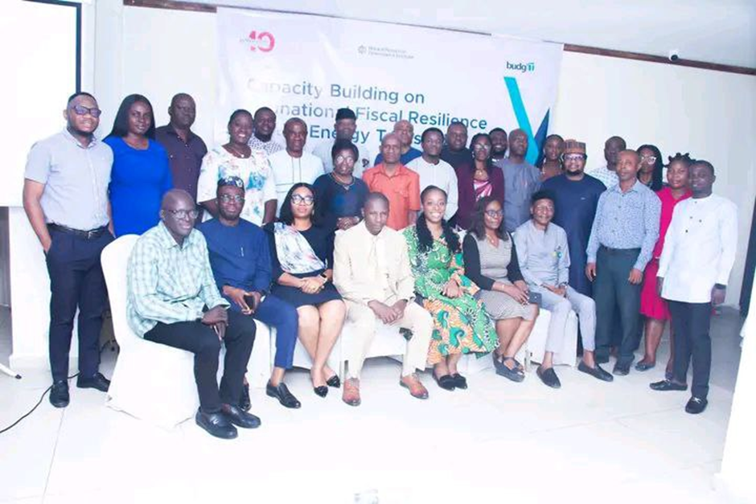
Figure 1 Participants at the one-day capacity building workshop for policy and legislative actors in Uyo, Akwa Ibom

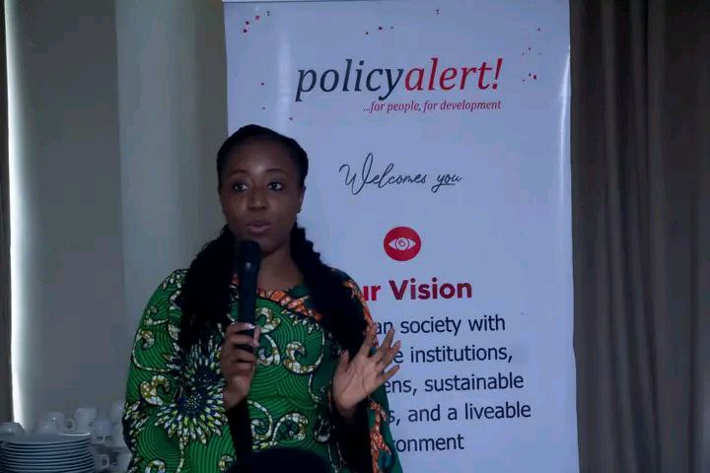
Figure 2 Tengi George-Ikoli Senior Officer NRGI


Figure 3 Ekemini Effiong - Deputy Director Budget Office

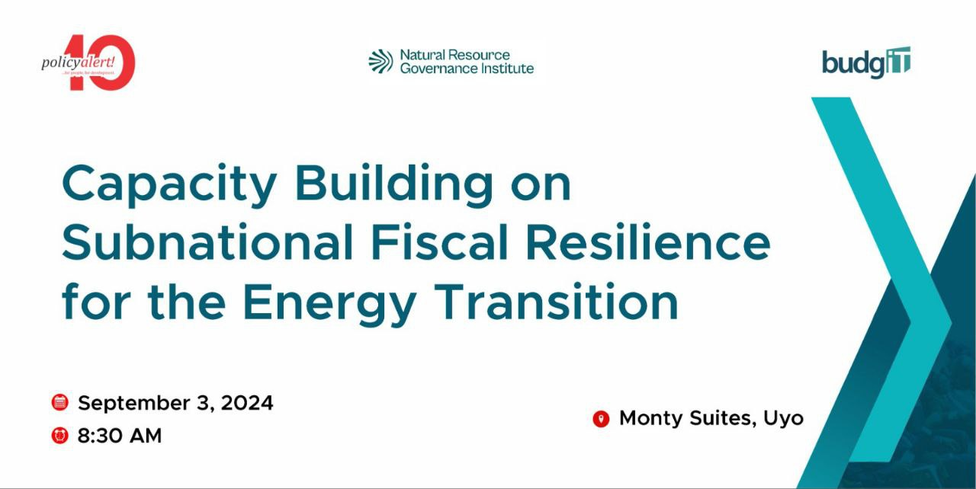
Figure 4 Wall Drape at the Capacity Building Workshop
Resolution/commitments/recommendations by state actors
- Establish an Energy Transition Research Centre: Although challenging, setting up such a centre of excellence could provide valuable insights and support for managing the transition.
- Address Social Problems: Tackling fundamental social issues such as poverty and education is essential for gaining public acceptance of the energy transition. Fossil extraction has disrupted and displaced whole communities. Communities have had to pay a huge social cost for oil and gas activities in their vicinity. State governments must play a role in ensuring that the transition happens in a way that addresses these challenges rather than exacerbates them.
- Skills Reorientation: The energy transition would cause structural changes in the state’s job market. Participants observed that the state government must be deliberate in re-skilling young people for the jobs of the future and should place less emphasis on jobs tied to the fossil ecosystem. With the world going green in energy solutions, state government investments in skills acquisition, livelihoods, and job programmes must begin to reflect this change sooner or risk doing that later at a much higher cost to the budget.
- Policy Alignment: The states fiscal responsibility law makes provision for a contingency fund. The major motivation for the creation of the fund was to help the state navigate emergencies. Going by the BudgIT 2022 state of states report only 9 percent of revenues were mobilized domestically. If there are shortfalls in oil-derived revenues flows from the centre, the state will grapple with a fiscal emergency like no other. Fittingly, the Director General of the Fiscal responsibility board has committed to facilitating deductions to the contingency fund from the 2025 budget.
Although the state has a revenue mobilization strategy, it is not yet ambitious enough to replace federal transfers. It was noted that the state’s Revenue Mobilization Strategy requires further review to make it more transition responsive. Meanwhile, the Deputy Director at the State Budget Office pledged to the advance an increased IGR outlay for the 2025 budget during bilateral engagements with other MDAs.
Seeing that the budget is the primary policy document for any fiscal year, officials from the Ministry of Finance committed to insert language recognizing the fiscal implications of the energy transition in the 2025 budget speech of the governor. Such a speech would become an entry point for targeted advocacy on the subject.
- Mining sector development: Participants harped on the potential of the state’s mining sector as a means of diversifying revenue sources. Effectively taxing mining activities can help the states mobilize more resources domestically. Recent reforms in the sector which now allows state governments to participate directly in mining business despite constitutional hurdles was identified as an opportunity for the state. Direct participation can also help the state to manage the ecological footprint of such activities which could add to the ecological restoration bills of the state, thereby creating future fiscal burdens as oil revenues decline. The state government was also encouraged to strengthen the Mineral Resources and Environmental Committee (MIREMCO) in the state to strengthen the state’s cooperation with the Federal Government on mining sector development.

- Linking host community provisions in the PIA 2021 to the Energy Transition Plan: It has been noted that the PIA 2021 does not contain explicit provisions to support the energy transition, including at the community level. Granted, the PIA provides for three percent mandatory contributions of operating expenses by oil companies to the Host Community Development Trust Fund (HCDTF) with a huge potential to buffer sub-national fiscal shocks at community level. However, there are no safeguards to ensure that Community Development Plans (CDPs) to be implemented with the HCDTF prepare communities to deal with fallouts of the energy transition. While participants noted the need to review the PIA to address its energy transition blind spot, they also urged that CDPs should prioritize climate resilient infrastructure, and provision of relevant renewable energy skills to ensure that communities are better equipped to adapt to the transition.
- The Chair of the House of Assembly Committee on Appropriation and Finance noted that stronger legislative oversight was key to ensuring fiscal resilience for the state in the face of the energy transition. She committed that her committee would ensure more prudent and aggressive measures in the areas of revenue mobilization, reduction of debt stock, and budgeting for economic diversification, especially in agriculture.

Two Day Regional Stakeholders Dialogue on Building Subnational fiscal resilience
Stakeholders from across the Niger Delta converge in Uyo, Akwa Ibom State, for a regional stakeholders’ dialogue on strengthening subnational fiscal for the energy transition. The dialogue was opened by Koko Udo who gave welcome remarks on behalf of the Executive Director Policy Alert, Tijah Bolton. According to him, the looming global energy transition presents a significant challenge for oil-dependent regions including Akwa Ibom to ensure the state's long-term fiscal health, we must proactively explore and unlock alternative revenue sources and that is why this partnership between Policy Alert, NRGI, and BudgIT is committed to driving this essential conversation.
The dialogue opened with the first presentation by Tengi George-Ikoli, senior officer NRGI. Her presentation titled: Securing an economic future for the Niger Delta amidst the energy transition. She laid out the fiscal risks that the global energy transition would trigger. She admonished that countries of the world have repositioned their economies for the fallout of the energy transition. The Niger Delta stats must therefore wean itself off oil dependence, and chart a new course to secure their economic future. This critical as the market for fossils, the mainstay of their economies will continue to shrink going into a clean energy future.

Figure 5 Tengi George-Ikoli Senior Officer NRGI
The first panel discussion focused on improving government responses to the global energy shift. The discussants highlighted that states in the Niger Delta region must boost non-oil revenue through a combination of diversification of their economies and sound public financial management. The panel featured experts such as Dr. Gills Harry (Deputy Director, Office of the Auditor General, Rivers State), Mr. Emeka Okonkwo (Deputy Director of Budget, Delta State), Mr. Razaq Fatai (Chief Data Officer, Nigeria Governors Forum, Abuja), and Mrs. Ekemini Effiong (Deputy Director, State Budget Office, Akwa Ibom State). The panel ended with a pledge from the discussants to adopt the suggestions that came out of the panel.
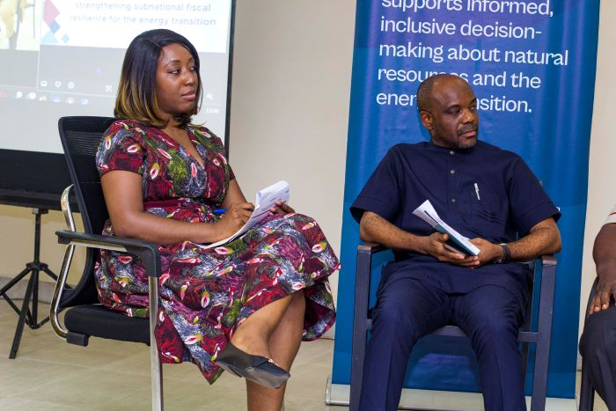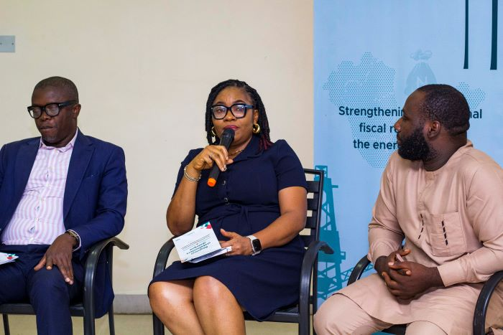

Figure 6 First Panel Discussion
The last presentation of the first day of the dialogue was on debt management. In building fiscal resilience, a deliberate focus must be on debt management. Edidiong Dickson, programme officer Policy Alert, highlighted that debt management is one leg of tripod in building fiscal resilience, the other two being revenue generation and expenditure management. He concluded by emphasising the transition would shrink the fiscal space for oil dependent states; hence these states must be weary of piling on more debt.

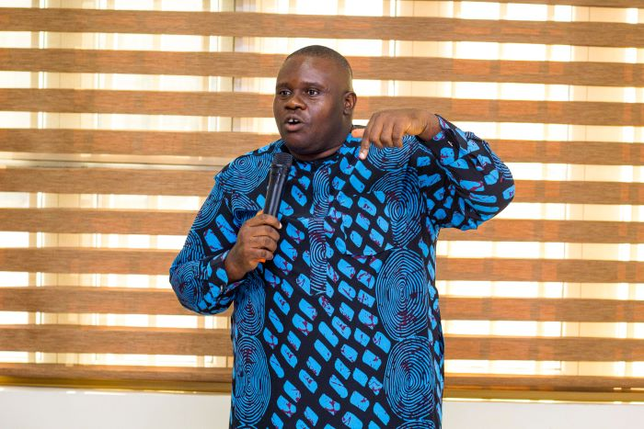
Figure 7 Edidiong Dickson - Policy Alert

Day 2
Felicia Dairo of the Centre for Journalism, Innovation and Development (CJID). Kicked off the second day of this regional stakeholders’ dialogue. Her presentation titled From Boom to Bust: Social imperatives of fiscal resilience for oil producing states. She analysed that in real terms the states of the region are earning less from oil than they were earning a decade ago. Considering that these states are have built their economies around fossil revenues, these opens them up to a number of social challenges. This she noted is another incentive for these states to build resilience and diversify their revenue bases to continue to provide basic social services to their people, when oil earnings dry up.
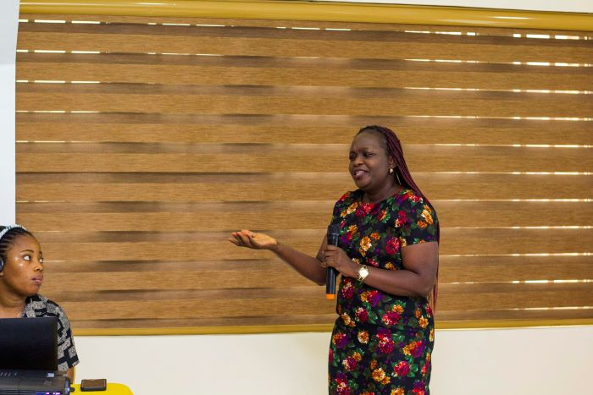
Figure 8 Felicia Dairo – CJID
Tengi George-Ikoli, senior officer NRGI highlighted the need for people centered transition in her second presentation of the dialogue. She posited that citizens welfare, especially those at the fence line of extraction must be prioritized. She shared, insights from NRGI’s work in other region of the world at the center of the transition conversation. She advised that in building resilience the perspectives, aspirations and yearnings of the people have must be incorporated into strategies that the government would be adopting to counter the fiscal risks of the transition.

The highlight of the second day was the presentation by Iniobong Usen, Head Research and Policy Advisory at BudgIT Foundation. He presented the insights from the research work spearheaded by BudgIT on the project with regards to the pilot state – Akwa Ibom. He relied also on BudgIT flag ship out the ‘State of States’ report highlight the fiscal challenges of states of the region and why the need for strengthening fiscal resilience cannot be over-emphasized. He presentation saw the launch of the report – ‘Strengthening subnational fiscal resilience to minimize the impacts of the energy transition: The Akwa Ibom Case Study.

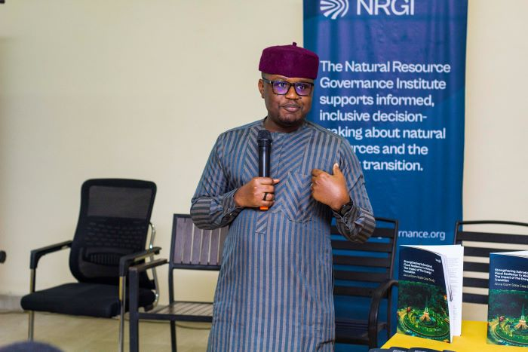
Figure 9 Iniobong Usen - BudgIT Foundation

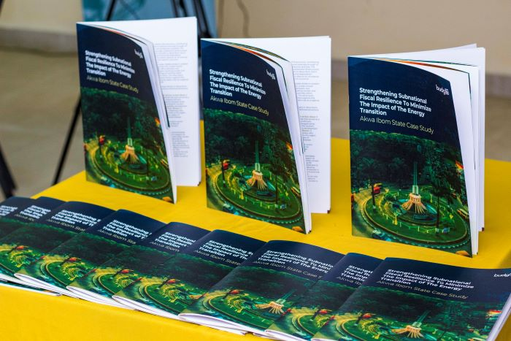
Figure 10 Copies of the report
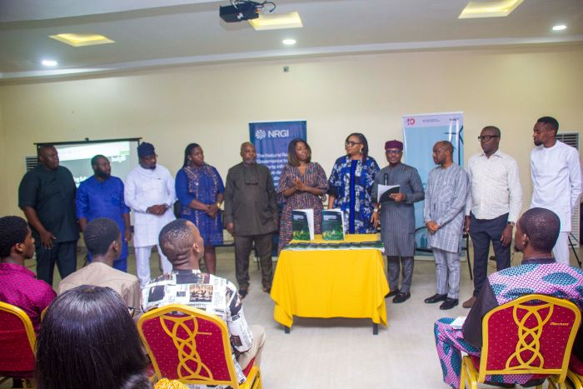
Figure 11 Report Launch with Regional Stakeholders
The second panel discussion of the dialogue focused on how citizens are demanding for their governments to respond to the energy transition. It included speakers like Mr. Bassey Willie (Daily Trust), Mr. Emeka Okonkwo (Deputy Director of Budget, Delta State), Mrs. Linda (Kebetcache Women Resource Centre), Mr. Emem Edoho (ED, NAPDRR), and Mfon Gabriel (ED, Citizens Advocacy Centre). They shared insights on the situation in fence-line communities, highlighting the struggles of marginalized groups who lack access to basic services. The plight of these communities have been exacerbated by the lack of fiscal resilience. The panel called on the government to increase investment in the social sector. This would be part of efforts in building fiscal resilience.

The launch was followed by a plenary discussion on the issues affecting young people. The plenary teased out problems affecting youths in the Niger Delta region the challenges identified included youth unemployment, illiteracy, poverty, poor health care, youth exclusion in decision making. These issues are magnified because the region has a less fiscal resilience structure and building resilience would help address these challenges.
The dialogue concluded with remarks from Tengi George Ikoli of NRGI. She thanked all participants at the dialogue for their perspectives, which contributed to enlivening and enriching the event. She urged the government stakeholders at the event to adopt the ideas shared towards building a resilient Niger Delta region.
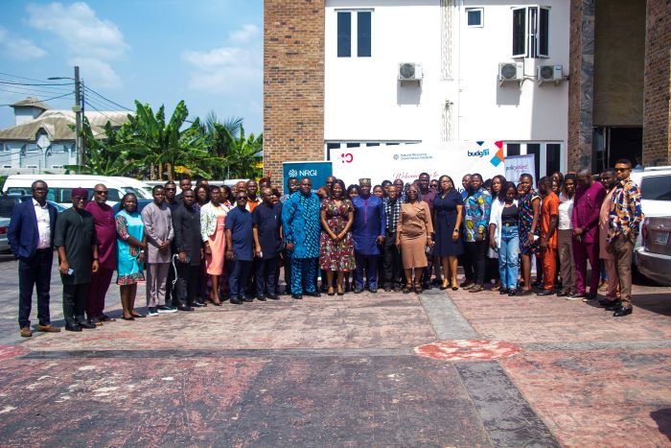
Figure 12 Group Photo of Participants at the Regional Stakeholders Dialogue

Links
Link to photos at the event: https://drive.google.com/drive/folders/1zFZ6dIDTdfY8bKfOZb5iCJsJsobok4cP
Facebook Post on the event:
https://www.facebook.com/share/1GyzEK8WSt/
Report of the dialogue by daybreak.ng:
https://daybreak.ng/energy-transition-oil-producing-states-urged-to-reduce-debt-diversify-for-fiscal-resilience/
Report by the Independent Newspaper:
https://independent.ng/what-happens-when-the-oil-stops-flowing-csos-sound-alarm-for-niger-deltas-future/
Report by the guardpost:
https://guardpost.ng/energy-transition-oil-producing-states-urged-to-cut-debt-diversify-for-fiscal-resilience/
Report by the Mail Newspaper:
https://themail.com.ng/energy-transition-stakeholders-call-for-policy-reforms-to-strengthen-niger-deltas-fiscal-resilience/
Report by Premium Times:
https://www.premiumtimesng.com/regional/south-south-regional/757270-policymakers-advocate-regional-collaboration-for-energy-transition.html
Report by Daily Post:
https://dailypost.ng/2024/11/25/csos-urge-niger-delta-states-to-collaborate-in-energy-transition-process/
Post Event Press Release:
https://policyalert.org/press-release-energy-transition-oil-producing-states-urged-to-act-on-debt-reduction-diversification-for-fiscal-resilience/
Flyer
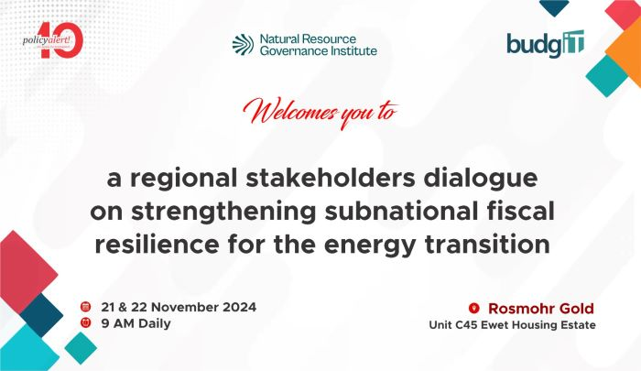
Figure 13 Banner for the dialogue

Research
The project had a research component that informed the production of two policy briefs for advocacy engagements and to drive knowledge on the energy transition as well as the associated fiscal risks. Most importantly, the policy briefs outline recommendation for state actors in Akwa Ibom State and other oil producing states in the region.
Links to the policy briefs
https://policyalert.org/download/future-proofing-akwa-ibom-building-a-resilient-economy-away-from-oil/
https://policyalert.org/download/before-the-cookie-crumbles-the-energy-transition-and-fiscal-risks-in-nigerias-oil-producing-states/

Outcomes
Evaluation
The following are the achievements of the projects:
- Commitment by the Governor of Akwa Ibom State to move the state away from oil dependence. This commitment was made before the state’s house of assembly during the presentation of the 2025 budget estimates. This commitment is attributable to the strengthened capacity of critical government stakeholders on the imperatives of the energy transition through this project.
- Akwa Ibom State Internal Revenue Service (AKIRS) to digitise revenue collection from 2025 fiscal year. This is to improve efficiency in revenue collection and increase its internally generated revenue. Increased internally generated revenue is part of strategies to build fiscal resilience and reduce dependence on federally distributed oil revenues. This outcome has been a central message in both the capacity building and stakeholder engagement activities on the project.
- The creation of a savings account in the office of the state accountant general. This savings is designed as a counter balance for the fiscal risks that will accompany the energy transition. The state being a key recipient of oil revenues due to its large hydrocarbon reserves, is creating this savings account from the 2025 fiscal year as part of efforts to build the state’s fiscal resilience.
- During the presentation of the 2025 appropriation bill before the house of assembly, the governor was quoted as saying ‘to improve the effectiveness of our budget performance by ensuring fiscal discipline through implementing only programs that were captured in the Budget while ensuring value for money, greater transparency and accountability’. Fiscal discipline has been one of the messages out of this project.
- Production and dissemination of policy briefs containing strategies for building fiscal resilience for Akwa Ibom and other state actors from the region.
The project set out to strengthen subnational fiscal resilience for the energy transition. Akwa Ibom was chosen as the pilot state for this intervention. By building the capacity of state actors on the subject, advocacy engagement and through the stakeholders’ engagement, the intervention proved persuasive enough for state officials to make critical commitment and follow through on fulfilling those commitments. On comparing these outcomes with the objectives defined prior to implementation, the intervention has been impactful. It has provided a firm foundation to build on to ensure other states in the region equally strengthen their fiscal processes and frameworks with a view to achieving resilience.

Successes
- Strengthened capacity for critical states actors in Akwa Ibom and in the region on the subject of the energy transition and its fiscal risks.
- Achieving policy influence in key areas like revenue collection management, diversifying the economy and a commitment to fiscal discipline and increased transparency and accountability in managing public funds. All of these are vital if Akwa Ibom must build resilience.
- Making inroads to other states of the region for policy influence through the stakeholders’ dialogue.
- Empowering communities especially young people with the knowledge to engage their leaders and representatives for required action on the subject.
Challenges
- Limited timeframe for the project has limited the scope of engagement with stakeholders.
- Resources to have incorporated more stakeholders in the region on this pilot stage was lacking.
- Inability of invited guests to be punctual interfered with the schedule.
Attendance sheet
Link to attendance for capacity building for policy and legislative actors:
https://docs.google.com/document/d/1BxgnIiKVag9er2K17FfqnWxvqH_M49yi/edit?usp=sharing&ouid=115004213295391560316&rtpof=true&sd=true

Link to attendance sheet for regional stakeholders’ dialogue:
https://drive.google.com/file/d/1I8Aj5CMLkRgVjGLiuv0Ok-T9YQhcKGyH/view?usp=sharing
Demographic Analysis
Total Number of participants for both activities on the project: 115
Number of male participants for both activities on the project: 75
Number of female participants for both activities on the project: 40
Percentage of male participants for both activities on the project: 65.22%
Percentage of female participants for both activities on the project: 34.78%
Number of participants above for both activities on the project 35: 75
Number of participants below 35 for both activities on the project: 40
Percentage of participants above 35 for both activities on the project: 65.22%
Percentage of participants below 35 for both activities on the project: 34.78%

Government Involvement
The project had policy and legislative actors in Akwa Ibom State as the primary target. Therefore, representation was sought and obtained from responsible ministries, department and agencies (MDAs) relevant to the project objectives. These MDAs included; ministry of finance, ministry of economic development, accountant general office, budget office etc. The point of strengthening fiscal resilience for subnational was emphasized to these actors, and they committed to adopting the strategies discussed on the project in the operations of their MDAs. The project also incorporated the perspective of national institutions with extractive and fiscal purviews such as the Nigeria Extractives Industries Transparency Initiative (NEITI). The executive secretary of NEITI was represented at the event by the south-south zonal representative on NEITI board. The National Council on Climate Change (NCCC) also participated in one activity on the project. The regional stakeholders dialogue had a political appointee, a permanent secretary, directors and other representatives of relevant MDAs from eight other states namely; Abia, Bayelsa, Cross River, Delta, Edo, Imo, Ondo and Rivers. This regional representation has allowed the key messages of the project to be extended beyond the pilot state – Akwa Ibom.
Lessons Learned and Recommendations
The project has shown that with the right approach, it is possible to achieve policy influence on critical areas. The incorporation of second and third bureaucrats allowed these actors to take ownership of the project. Some of the outcome is attributed to this. Therefore, while we hope to always have key decision makers as our target, it is also proper to acknowledge and leverage the key role of second and third bureaucrats as influencers.
Recommendations
Seeing the centrality of fiscal resilience to the economy of the region, it is important to expand the scope of the project beyond Akwa Ibom. Therefore, it is recommended that other states in the region have their capacity built and specific recommendations which will be unearthed through research presented to them. This will afford other oil producing subnationals the opportunity to re-engineer their operations with a view to attaining fiscal resilience. To this end it is advised that the project be scaled across the region.
Sustainability and next steps
The project has hit the mark on key areas, that momentum must be maintained. Policy Alert is the secretariat for the Niger Delta Open Government Observatory (NOGO). Through NOGO and its outputs such as the open budget snapshot series, a healthy focus and pressure on the key commitments would be maintained. Direct advocacy visits to policy and legislative would be another avenue for continuous engagement with stakeholders. The annual open budget forum organized by Policy Alert will be another way to continue to review the resilient level of states of the region and offer recommendations.
From quarter 1 2025, we will begin to engage stakeholders on the commitment made in Akwa Ibom, ranging from revenue collection and management automation, investment in key areas such agriculture and tourism demonstrated by improved budgetary releases to these sectors and reflecting the imperatives of the transition in government operations.
Appendix
