

NEITI Civil Society Roundtable on the EITI
Framework Report

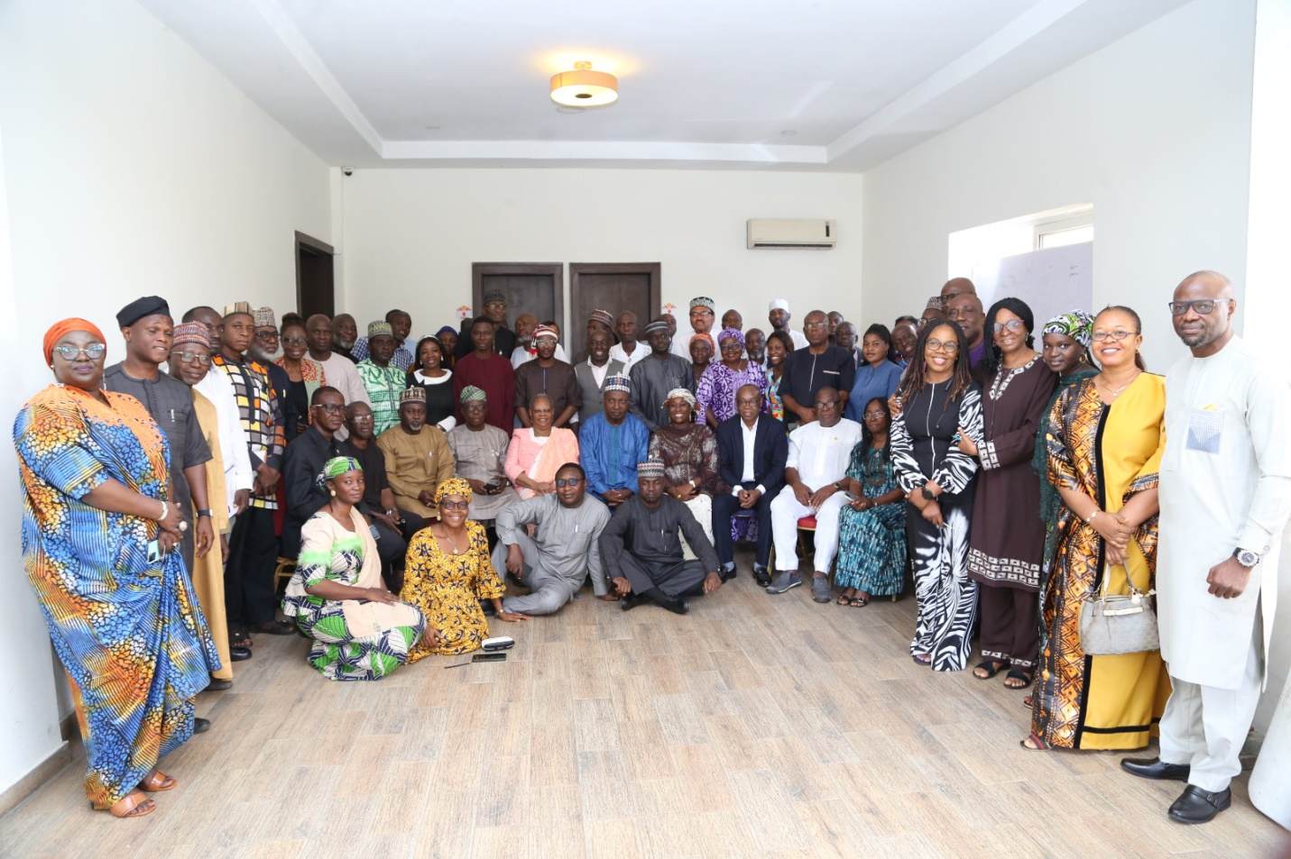
Participants at NEITI Civil Society Roundtable on the EITI Framework

Date of Event : October 31 - November 2, 2024
Location: Hawthorn Suites, Garki, Abuja
Prepared by: Augusta Akparanta-Emenogu

TABLE OF CONTENTS
TABLE OF CONTENTS 2
SECTION I. INTRODUCTION AND BACKGROUND 3
1.1. BACKGROUND 3
1.2. BACKGROUND ON NEITI 4
SECTION II. PRESENTATIONS AND EVENT PROCEEDINGS 5
2.1. OVERVIEW OF PRESENTATIONS 5
2.2. DRAFTING IMPACTFUL ADVOCACY BREIFS FOR POLICY CHANGE 11
SECTION III. TRAINING AGENDA, TOPICS, AND INSIGHTS 12
3.1. KEY TRAINING TOPICS AND INSIGHTS 12
3.2. OUTCOMES AND ACHIEVEMENTS 12
3.3. KNOWLEDGE AND SKILLS GAINED 13
SECTION IV. ACTIONS PLANS AND COMMITMENTS 13
4.1. DEVELOPMENT OF NETWORKS AMONG CSOs, GOVERNMENT REPRESENTATIVES, AND IDNUSTRY STAKEHOLDERS TO SUPPORT ONGOING TRNASPRENCY EFFORTS. 13
4.2. FEEDBACK FROM PARTICIPANTS 14
4.3. OPPORTUNITIES FOR FURTHER CAPACITY BUILDING 14
SECTION V. CONCLUSIONS AND NEXT STEPS 14
5.1. CONCLUSION 14
5.2. RECOMMENDATIONS 14
ANNEXES 15
ANNEX I. TRAINING AGENDA AND STRUCTURE 15

SECTION I. INTRODUCTION AND BACKGROUND

BACKGROUND
On 23rd to 27th January 2024, a high-level Mission from the Global Extractive Industries Transparency Initiative (EITI) Secretariat, led by the Deputy Executive Director, Bady Balde visited Abuja to assess Nigeria’s progress in implementing the EITI. The mission engaged with government, industry players, civil society, media, and citizens to communicate the outcomes of Nigeria’s 2023 Validation Exercise, aimed at enhancing transparency and accountability in the extractive sector.

During their visit, the EITI officials observed some gaps and made recommendations on how best to fill them. One of the Corrective Actions taken by NEITI was to organize a three-day training course for Civil Society Organisations (CSO), media and other stakeholders on the EITI Framework.

High Level Executive Summary
The training was held at Hawthorn Suites, Garki, Abuja. It brought together past and current members of the NEITI board, the (National Stakeholders Working Group (NSWG), media personnel and government officials. There were goodwill messages from sponsors of the event, European Union/ Rule of Law (RoLAC) program as well as their partners, the Institute for International Democracy and Assistance IIDEA. During the first two days, the workshop facilitators took turns to take participants through the EITI Process and Standards; Nigeria’s 2023 Validation Exercise from the CSO angle; EITI Corrective Actions and the Role of CSO as well as some of the Highlights of the NEITI 2022 and 2023 Solid Minerals Industry Reports.

The presentations also focused on signing the Freedom of Information Act to Demand for Accountability; Negotiation as an Effective Advocacy Tool; Extractive Industries Result Management and Oversight by CSOs; Drafting impactful Advocacy briefs as well as group work on target topics. There were also questions and answer sessions to clarify grey areas. Some of the participants were distributed into various committees which were inaugurated on the last day. The Executive Secretary of NEITI, Dr Orji Ogbonnaya Orji and the CSO representative on the NEITI board, Dr Erisa Danladi Sarki, anchored the session on rebuilding trust between the CSOs and the NEITI team.

Brief Overview of the Training Purpose, Target Audience, and Key Outcomes
The purpose of the training was to enlighten key participants on the Extractive Industries Transparency Initiative (EITI)’s framework as well as Nigeria’s last validation process. It was also to update participants about the EITI mandate, its operations and the importance of its activities to those countries who have signed on to their protocols. Participants ranged from the current and former NEITI board members representatives of civil society working in the extractive sector the media, government officials as well as private companies operating in the extractive sector or those utilizing funding and resources.
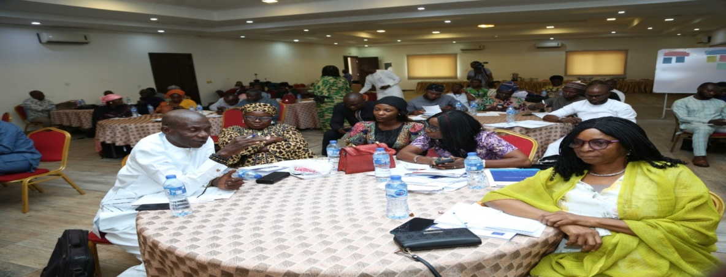
Participants at the NEITI/CSO RoundTable on the EITI Framework

The event increased participants’ knowledge on key selected topics . There were also practical classes to provide hands-on learning as well as interactive sessions to clarify grey areas. At the end of the training, participants agreed that they understood better the workings of the EITI, NEITI’s mandate as well as what each key player was expected to contribute to NEITI’s transparency and accountability work in the extractive sector.

Summary of major topics covered, activities conducted, and overall participant feedback
The focus of the training included ` Understanding the EITI process and the 2023 EITI Standards. This topic x-rayed basis tenets and principles of the EITI as well as the latest modus operandi. The NEITI team shared proceeding for Nigeria’s EITI Validation Exercise from the Civil Society angle. Other topics included the EITI Validation and Corrective Actions: Role of Civil society; Highlights of the NEITI 2022 and 2023 Oil and Gas and the Evolving Remedial Issues; Highlights of the NEITI 2020 and 2023 Solid Minerals Reports; Demanding Accountability through the Freedom of Information Act; Negotiation as an effective Advocacy Tool; Extractive Industries Results Management and Oversight by Civil Society; Drafting Impactful Advocacy Briefs for Policy Change and Reforms.

Key takeaways and any anticipated follow-up actions
The training provided the opportunity for new members of the NEITI board, civil society, media as well as other stakeholders to gain an insight into and understand basic guidelines of the EITI, its validation process as well as the status of such validations for Nigeria. It also provided the opportunity to follow Corrective Actions and remedial steps being taken by NEITI following EITI official visits and Nigeria’s validation process. Participants learnt the various roles expected for each key player to complement NEITI’s efforts to entrench and sustain transparency and accountability in Nigeria’s extractive sector.

BACKGROUND ON NEITI
The Nigeria Extractive Industries Transparency Initiative (NEITI) is the national chapter of the Global Extractive Industries Transparency Initiative (EITI) mandated by law (The NEITI Act 2007) to promote transparency and accountability in the management of Nigeria’s oil, gas and mining revenues. The organization’s mission is to institutionalize accountability mechanisms and processes to instill a culture of transparency in Nigeria’s extractive sector for the benefit of all. Its vision is to achieve a Nigeria whose extractive industry is transparent, accountable, and beneficial to all Nigerians. In this regard, NEITI has engaged stakeholders in the solid minerals and the oil and gas sectors to execute this mandate.

The organization focuses on four main areas: improving Nigeria’s macroeconomic environment, pursuing structural reforms, strengthening public expenditure management, and implementing institutional and governance reforms. In pursuance of these objectives, NEITI has continued to produce and publicly prepared three reports: One on the Mining sector, another on the Oil and Gas, and a third one on Nigeria’s Fiscal Allocation and Statutory Disbursement at the Federal level.

Objectives of the Training: Outline the Specific Goals of the Training
The overall goal was to enhance understanding of transparency initiatives while promoting accountability by key players in the Extractives. The objectives include Building capacity for civil society engagement, Sharing Effective Negotiation Skills for an all-round win-win situations, Ensuring increased knowledge and skills in drafting and successfully implementing effective advocacy briefs, as well as promoting accountability in the extractive sector.

Participants: Overview of the Participant Profile, including Civil Society Organizations (CSOs), Industry Stakeholders, Policymakers, and Community Representatives
The training attracted several stakeholders and partners working in the extractive sector such as the Alternate Chair, NEITI National Stakeholders Working Group and Representative of the North Central Zone, Ambassador Matthew Sunday Adoli, CSO Representative, Dr Erisa Danladi Sarki, European Union (EU) Rule of Law/Institute for International Democracy Assistance (IDEA), Dr. Emmanuel Uche, Faith Nwadishi, Former NEITI Board Member and Executive Director of Centre for Transparency and Advocacy (CTA), representatives of the private sector, Civil Society Organisations working in the extractives sector and the media.

SECTION II. PRESENTATIONS AND EVENT PROCEEDINGS

2.1. OVERVIEW OF PRESENTATIONS
The participants listened to various presentations over the first two days. There were interactive sessions as well as group work. On the Third day, two bodies were inaugurated. They were the Think- Thank Group and a Communications and Civil Society Steering Committee. There was also a session on ` CSOs and NEITI Secretariat- Rebuilding Trust, Strengthening Partnership and Collaboration. Participants received copies of various documents to help build their capacity for the various roles they were expected to play.

2.1.1. Presentation of NEITI/EITI 2022-2023 Status Report
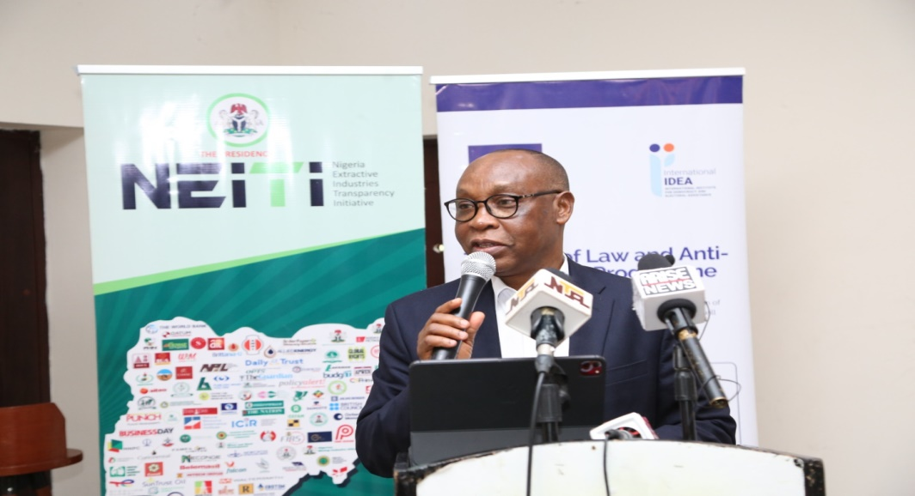
Dr. Orji Ogbonnaya Orji, Executive Secretary/CEO of NEITI
The Executive Secretary of NEITI, Dr Orji Ogbonnaya Orji provided a comprehensive overview of Nigeria's progress in implementing the Extractive Industries Transparency Initiative (EITI) and highlighted key findings from the NEITI 2022/2023 Solid Minerals Industry Report. According to him, Nigeria scored 72/100 in the 2023 EITI Validation, reflecting strengths in: Stakeholder engagement, Transparent reporting and Adherence to EITI standards.
Areas for Improvement include:
- Board Reconstitution: The National Stakeholders Working Group (NSWG) was dissolved and later reconstituted on 22nd April, 2024.
- Civil Society Participation: Needs strengthening through more transparent and quality representation.
- Engagement with Extractive Companies: Requires deeper collaboration to improve data credibility and compliance with EITI standards. The NEITI Executive Secretary also provided highlights for the Solid Mineral sector for 2022 and 2023.

Solid Minerals Sector (2022 Highlights)
- Total revenue generated: ₦345.41 billion (final reconciled revenue: ₦329.92 billion).
- Largest revenue stream: Value Added Tax (VAT) contributed ₦128.32 billion (38.9% of total).
- Contribution to GDP: ₦1.66 trillion, representing only 0.83% of Nigeria’s total GDP.
- Top mineral-producing states: Ogun, Kogi, and Rivers.
- Export performance: 4.31 million metric tons of minerals valued at ₦117.29 billion.
Solid Minerals Sector (2023 Highlights)
- Total government revenue (reconciled): ₦382.51 billion.
- VAT remained the largest revenue source, contributing ₦118.47 billion.
- Production reached 95 million tonnes, with royalties paid at ₦9.01 billion.
- Contribution to GDP: ₦1.76 trillion (0.75% of total GDP).

Dr. Orji’s paper concluded that NEITI had made significant progress in improving transparency within Nigeria’s extractive industries through regular audits and reconciliations. On the resultant economic impact, he asserted that despite the growth in revenues, the Solid Minerals sector remains underutilized, contributing less than 1% to Nigeria’s GDP. He called for greater stakeholder engagement and collaboration among government bodies, civil society organizations, and private companies to ensure full compliance with EITI standards, stressing that the reconstitution of the NSWG in 2024 marked a critical step toward improving governance within the sector.
The Executive Secretery further spoke of NEITI’s plans to strengthen its internal processes, assist other stakeholders to expand oversight, enhance stakeholder participation, elicit and improve legislative support as well as its data management initiatives. He concluded that “NEITI remains committed to shaping a transparent and accountable extractive industry that benefits both present and future generations of Nigerians. Through continued collaboration with stakeholders and adherence to global EITI standards, NEITI aims to further improve governance in Nigeria's extractive sector while driving economic growth through enhanced sector contributions.’’

2.1.2. Presentation of Goodwill Messages
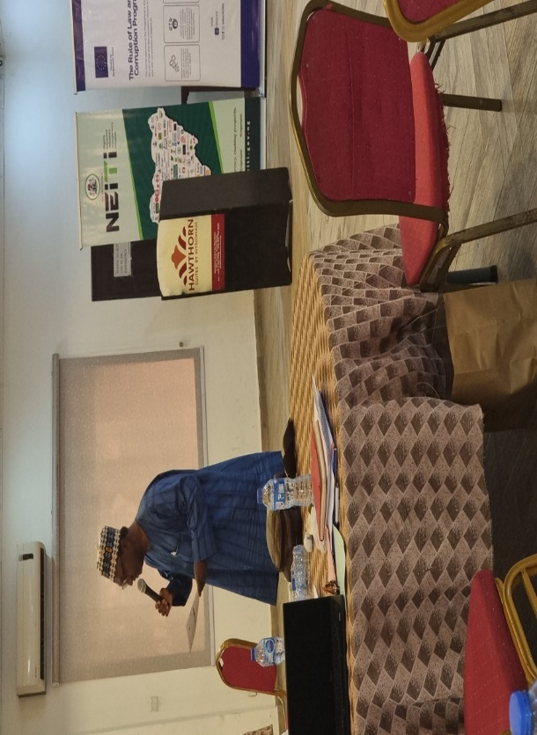
Ambassador Mathew Sunday Adoli (Alternative Chair – NEITI National Working Group)

The Alternate Chair, NEITI National Working Group and Representative of the North Central Zone, Ambassador Mathew Sunday Adoli
Ambassador Mathew Adoli appreciated NEITI ES Dr. Orji and his team for their doggedness in continuously producing and publishing the annual reports in the extractives. He said the reports would aid the government in its policy influencing work.

European Union (EU) Rule of Law/Institute for International Democracy Assistance (IDEA), Dr. Emmanuel Uche’s paper was on Oversights of the Extractives by CSOs
Representative of the European Union (EU) Rule of Law/Institute for International Democracy Assistance (IIDEA), sponsors of the event, Dr. Emmanuel Uche, spoke on ` Extractive Industries Results Management and Oversight by CSOs’. Dr Uche noted that the extractive industry, encompassing both renewable and non-renewable resources, is a cornerstone of the global economy. He explained that in Nigeria, this sector is critical, accounting for 90% of export earnings and 80% of government revenue. However, the industry is plagued by challenges such as corruption, mismanagement, and environmental degradation. Therefore Civil Society Organizations (CSOs) play a pivotal role in ensuring transparency, accountability, and good governance in the management of extractive resources. He listed how CSOs can provide oversight for the sector:
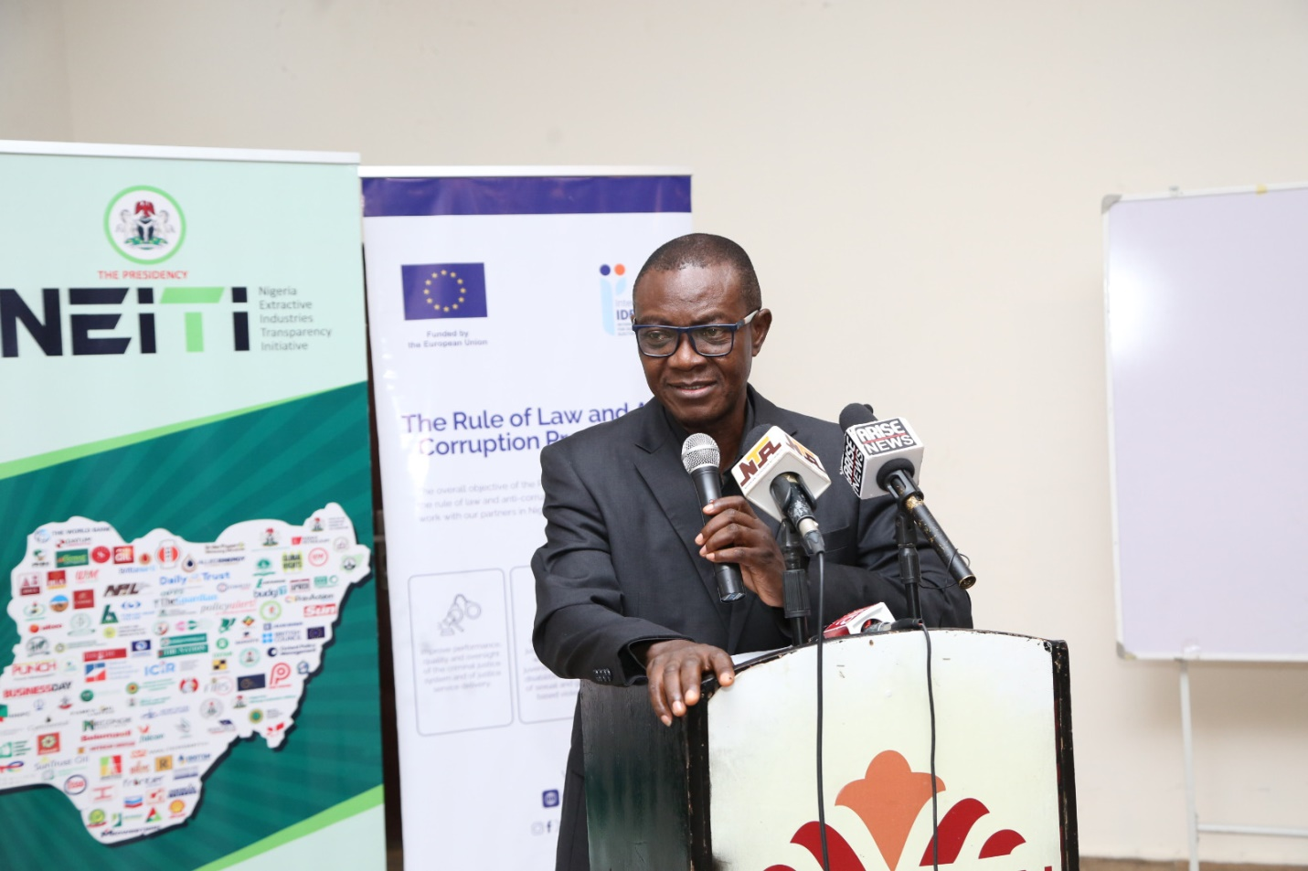
Dr. Emmanuel Uche (EU IIDEA &RoLAC)

- Monitoring Government Policies and Actions: CSOs should track the implementation of policies related to extractive industries to ensure they align with national interests and public welfare
- Advocating for Transparency and Accountability: They should push for transparent practices in revenue collection, contract management, and resource allocation
- Engaging Communities and Stakeholders: CSOs act as intermediaries between communities affected by extractive activities and the government or corporations involved
- Conducting Research and Analysis: They provide data-driven insights into the industry's operations, highlighting areas for improvement.

Dr. Uche also listed existing challenges that must be overcome for there to be effective oversight by CSOs.
- Lack of Access to Information: Many CSOs struggle to obtain essential data about contracts, revenues, and policies
- Limited Capacity and Resources: Financial constraints limit their ability to carry out comprehensive oversight
- Corruption and Intimidation: CSO members often face threats or are hampered by corrupt practices within the industry
- Inadequate Legislation: Weak laws or poorly enforced regulations hinder effective oversight
- Conflict and Security Issues: The extractive industry often operates in areas prone to conflict, making oversight dangerous

According to him, although CSOs had recorded several successes in exposing corrupt practices, contributed to the passage of the Petroleum Industry Bill (PIB), aided direct community monitoring of extractive operations, there is still the need to sustain such efforts while capitalizing on emerging opportunities. He called for the strengthening of regulatory bodies such as NEITI; increased access to information; increased capacity building for key players and stakeholders as well as Promoting international cooperation to share best practices and resources.

In conclusion, Dr Uche stated that Civil Society Organizations remain indispensable in promoting transparency, accountability, and good governance within Nigeria’s extractive industry. He also admitted that they face numerous challenges—ranging from lack of information access to security threats—CSOs have made significant strides in improving the sector’s governance through advocacy, research, and community engagement. Additionally, continued collaboration with government agencies, international partners, and local communities will be key to sustaining these efforts. Dr. Uche stressed that it was important to employ such key performance indicators as:

- Revenue Transparency: Percentage of revenues disclosed and verified publicly
- Budget Allocation: Percentage of revenues allocated toward social-economic development projects
- Revenue Collection Efficiency: Ratio of actual revenue collected compared to projections
- Contract Transparency: Number of contracts made publicly available for scrutiny

The Director, Communications & Stakeholder Management, Mrs Obiageli Onuorah: Nigeria EITI Validation Corrective Actions and Civil Society Engagement
Mrs Obiageli Onuorah, NEITI’s Director of Communication and Stakeholders Management, gave a presentation on: "EITI Nigeria‘s Validation Corrective Actions”. The presentation focused on Nigeria's progress in implementing Corrective Actions following its 3rd validation under the Extractive Industries Transparency Initiative (EITI) Standard. She highlighted the role of CSOs in ensuring transparency and accountability in the extractive sector.

Spon Civil Society Engagement, she emphasized that civil society engagement was crucial to ensur eaking ing transparency and accountability in the extractive sector. According to her, although the Federal Government had reconstituted the National Stakeholders Working Group (NSWG), through a self-nomination process, to ensure civil society representation, there is still a need for regular sensitization programs to educate civil society on EITI standards and requirements.
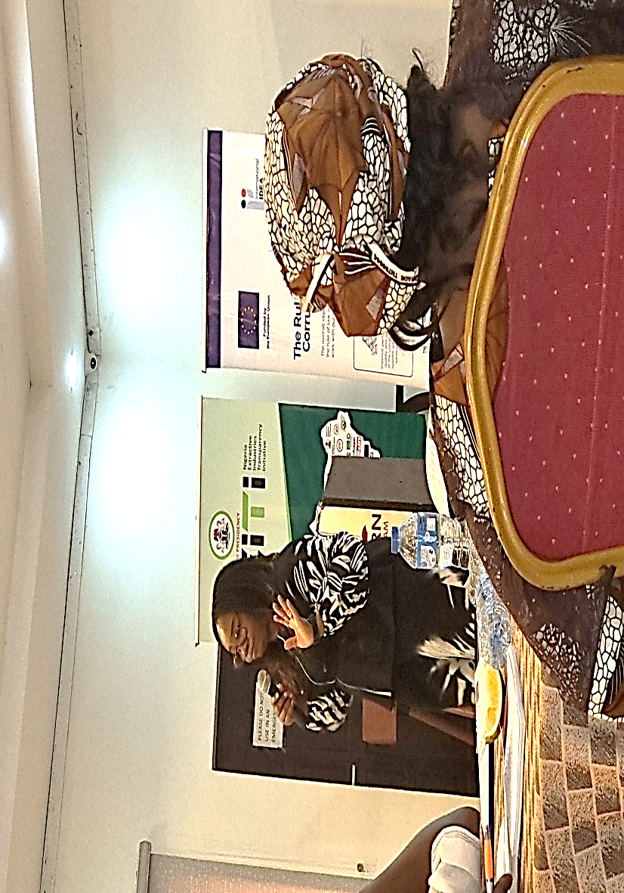
Obiageli Onuorah, NEITI’s Director of Communication and Stakeholders’ Management

Mrs Onuorah noted Nigeria’s 3rd validation resulted in an overall score of 72/100, categorized as "moderate" performance. For Requirement 1.3 (Civil Society Engagement), Nigeria scored 60/100, indicating that this requirement was "mostly met." The validation assesses stakeholder engagement, transparency, and outcomes/impact based on prior performance and corrective actions required by the EITI Board.

The Validation team concluded that:
- Moderate Progress: While Nigeria has made moderate progress in its EITI implementation, there are still significant areas for improvement, particularly in civil society engagement and overcoming legal barriers to transparency.
- Civil Society’s Role: Civil society plays a critical role in advocating transparency and accountability; however, their participation needs to be more structured, independent, and supported by a robust framework that ensures their protection from harassment or intimidation.
- Gender Equity: There is a growing recognition of the need for gender equity within the extractive sector's governance structures. Both government agencies and companies are encouraged to adopt gender-sensitive policies.

To implement Corrective Actions on gaps identified, she emphasized the need for gender balance in stakeholder representation, stressing that there should be advocacy to companies to develop gender policies that promote equity. NEITI is also working on developing its own gender policy to ensure equitable participation in governance processes. NEITI Director of Communication revealed that legal barriers to disclosures and weakened coordination among CSOs were identified as bottlenecks during the validation exercise. `` Broader civil society coordination has been weakened, reducing engagement with the NSWG and NEITI's outreach efforts,’’ she further added.

The proposed recommendations include:
- Improving Legal Frameworks for Transparency.
- Enhancing Gender Representation.
- Increased Security for Civil Society Actors.
- Increased capacity Building for Civil Society, media and other stakeholders.
- Sub-National Outreach Expansion.

Faith Nwadishi, Former NEITI Board Member and Executive Director, Centre for Transparency and Advocacy (CTA) Presented the Paper on Negotiations as an Effective Advocacy Tool.
The interactive session led participants through best practices in negotiation. It highlighted why and how negotiation remains a critical tool for Civil Society Organizations to use to influence policy, promote transparency, and advocate for community interests within the Extractive Industries Transparency Initiative (EITI) framework. Nwadishi demonstrated how CSOs can balance diverse stakeholder interests and build long-term partnerships.
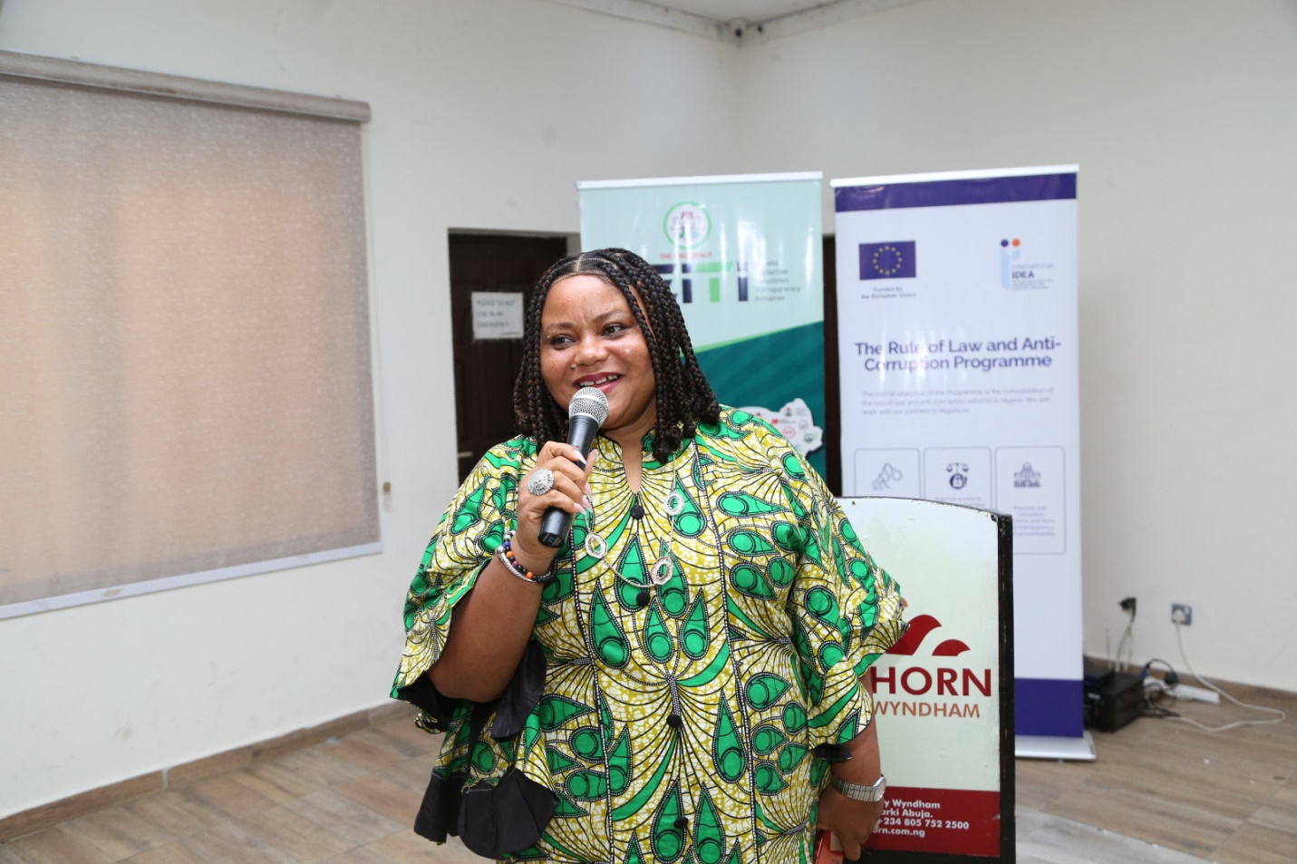
Faith Nwadishi, Former NEITI Board Member and Executive Director, Centre for Transparency and Advocacy

The presentation focused on Multi-Stakeholder Collaboration; Challenges in Negotiation, Power Imbalances, Aligning the objectives of CSOs, government, and industry, Maintaining Independence, as well as Principles of Effective Negotiation. She said that for negotiation to be successful, partners must have a win-win mindset. She asked CSOs working in the extractive sector to polish their negotiation skills to help get more women in decision making positions in the sector as well as guide host communities in their negotiations with companies operating in their program locations, stressing that such actions would greatly benefit host communities and the country in general.

Mr. Godwin Garuba, Freedom of Information (FOI) Department, Federal Ministry of Information spoke on the FOI Act
He took participants through the provisions of the Freedom of Information Act, the purpose and spirit of the law, processes and procedures, challenges and value to transparency and accountability especially with regards to the extractives, Nigeria’s main sources of revenue. He said it was important to understand the basic tenets of the law, its various provisions to apply it to transparency and accountability work. Mr. Garuba provided guidance on how to successfully use the FOI to request information about public expenditure and resources. Mr Godwin listed the various steps involved, the conditions for granting and refusing such requests. He encouraged various stakeholders to employ the tool to contribute to making Nigeria’s governance process more transparent.

NEITI Energy and Mines Director, Mr. Balarabe Saad, Presented the highlights of the NEITI’s Solid Minerals Reports for 2022 and 2023.
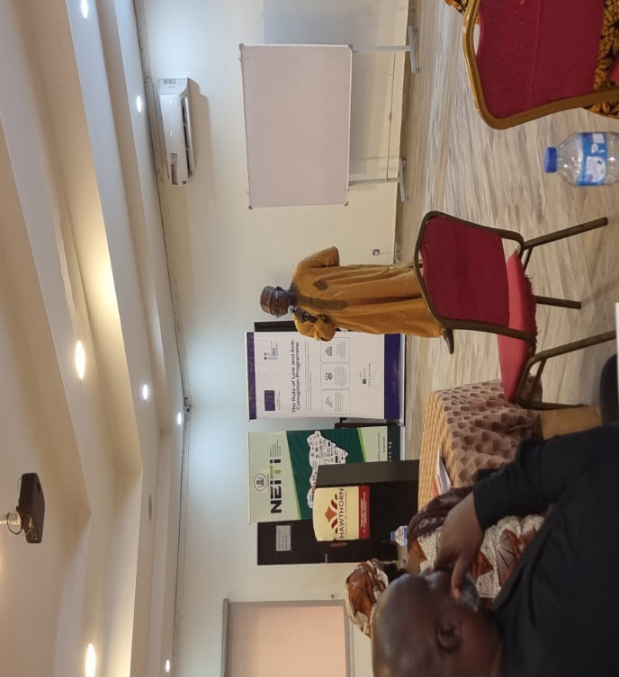
NEITI Energy and Mines Director, Mr. Balarabe Saad.

Mr. Saad informed that a total of One Thousand Six Hundred and Thirty-One (1,631) companies paid both Royalty and Annual Service Fees in 2022, explaining that the Solid Minerlas Reports covered entities comprising 85 extractive industries and 9 Government entities. In 2023, One Thousand, five hundred and thirty-seven (1,537 companies paid royalties and annual service fees. A total of 110 extractive companies and nine government entities were covered. According to him, there was an improvement in the discrepancies recorded after reconciliation of the figures from 2022 to 2023.

In 2022, there were 1631 ( 100%) companies at the beginning of the audit but only 85(52.11%) are reconciled ones at the end. For the 2023 Materiality Outcomes, 1,537 (100%) companies started at the beginning of the audit, while 110 reconciled companies were recorded at the end of the audit. (75.56%). The total mineral production was 70,727,531 Tonnes which represent a decrease of 5,549,656 Tonnes when compared to the 2021 production of 76,277,187, this indicates a 7.2% decrease from 2021. Accordingly, the total royalty payment was ₦6,272,880,565. As regards State production, Edo recorded the highest production in the years under review, with a total of 19.4 million Tonnes, followed by Ogun with 15.3 million Tonnes, and Kogi with 10.9 million Tonnes.

The least production volume was recorded in Borno State with 9,352 Tonnes. On exports, he said in both years under review (2022 and 2023), Nigeria is endowed with vast deposits of mineral resources spread across its thirty-six states and the Federal Capital Territory. The solid minerals sector contributes 0.53% to the country’s Gross Domestic Product (GDP).

On Key findings, he explained that there was presence of many non-active operators in the sector suggesting that some license holders remained mere speculators. Mr Saad said this situation discouraged genuine investors and reducds potential revenue for the country. `` There is multiple taxation. Some operators with licenses are inoperative. Many entities owe Annual Service Charges to government.’’
The Ministry of Mining Development and Mining Cadastre Office (MCO) should create a system of monitoring and tracking the operators that are active and non-active within the sector. Also, MCO should enforce the penalty of non-usage of licenses as stipulated in the Minerals and Mining Regulations 2011 in Part II, Section 93.

The Government should increase funding and introduce appropriate technology to support accounting, monitoring and enforcement activities. The Federal Government should encourage whistle blowing on illegal mining and environmental violations by putting in place compatible policies.
For example, this may include:
- Regular Audits: Conduct regular audits to ensure compliance and identify non-payment issues early.
- Enhanced Penalties: Implement stricter penalties for non-compliance to deter companies from defaulting on their liabilities, and simplify and harmonize taxes among the various levels of government.

2.2. DRAFTING IMPACTFUL ADVOCACY BREIFS FOR POLICY CHANGE
The presentation on ` Drafting Impactful Advocacy Briefs for Policy Change and Reforms’ by Tessy Effa the Country Representative, RiseUP Together outlined the process of creating effective advocacy briefs aimed at influencing policy changes and reforms. The presentation emphasized the importance of strategic messaging, evidence-based recommendations, and the need for continuous evaluation of advocacy efforts. The main conclusion is that advocacy briefs are most successful when they are tailored to specific policymakers and supported by a broader communication strategy.
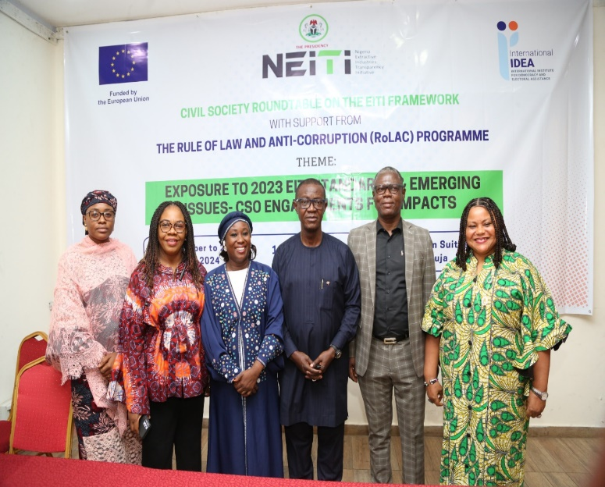
Cross-Section of Facilitators

Such briefs must also provide actionable recommendations to enhance their effectiveness. Tessy Effa is the Country Representative, RiseUP Togather. Her paper was presented by Faith Nwadishi.

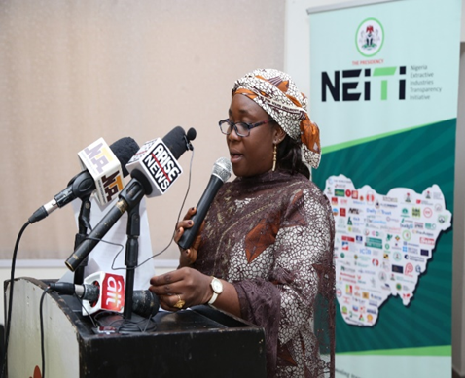
Dr. Erisa Sariki Danladi, CSO Representative on NEITI Board

Dr Erisa Sariki Danladi, CSO representative on the NEITI Board
Dr Erisa Sariki Danladi, gave a welcome remarks and thanked the EU and the IDEA for sponsoring the program. appreciated Dr. Orji and team for their relentless efforts in building the capacity of CSOs and continually supporting then in their transparency and accountability work.

SECTION III. TRAINING AGENDA, TOPICS, AND INSIGHTS
One of the prominent features and recurring themes at the training was the need to engender the extractive industries by increasing the female workforce in the formal sector, especially in decision making positions. This is expected to result in increased economic growth for women and by extension for their families and the society at large. Other areas of concern were improving Contract Transparency, Ensuring Beneficial Ownership, working through Energy transition in a way that would benefit all and grow the economy. It is also important to work with communities to eliminate both oil theft and illegal mining of solid minerals.
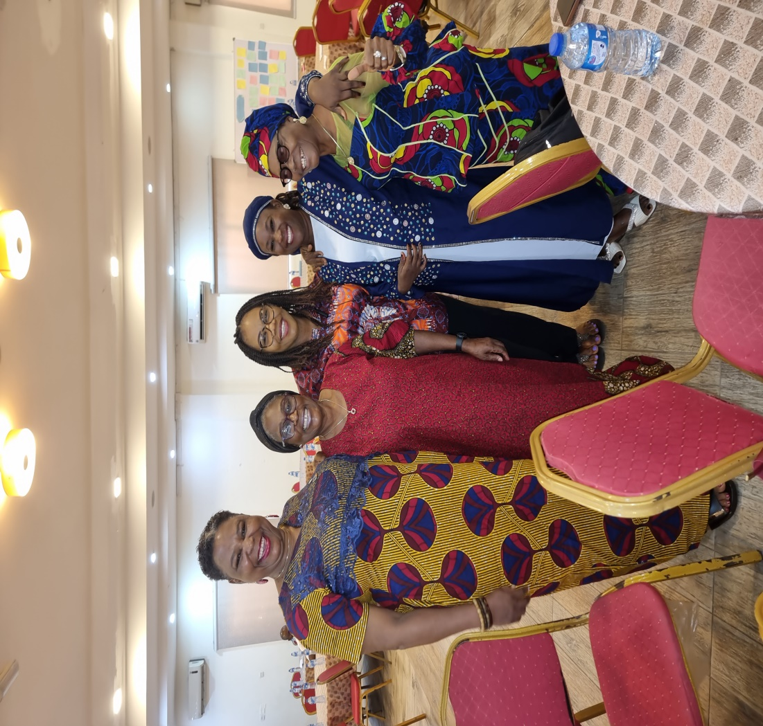
Cross-Section of Participants

Overall, the various topics were complimentary in increasing participants’ knowledge. The interactive and practical sessions provided a hands-on activities for internalizing the different sessions. Participants were encouraged to investigate, interrogate issues, identify problem areas, learn and share knowledge about target issues; identify policy makers and those with the authority to make the desired changes. They were also told to partner and collaborate with significant others to increase mileage, engage in continuous and targeted advocacy to make the extractive sector transparent and accountable. This should contribute to increased GDP as well as judicious use of the nation’s resources for its citizens.

3.1. KEY TRAINING TOPICS AND INSIGHTS
The following key training topics and insights were highlighted during the different training sessions i.e.
- Transparency and Accountability: Importance of transparency in resource management and NEITI’s role in fostering accountability.
- Monitoring and Reporting: Techniques for monitoring compliance, data reporting standards, and interpreting audit reports.
- Stakeholder Engagement: Approaches to strengthening civil society’s role and building partnerships with government and industry players.
- Advocacy and Policy Influence: Strategies for effective advocacy to influence policy, ensure environmental sustainability, and safeguard community interests.

3.2. OUTCOMES AND ACHIEVEMENTS
The workshop highlighted both achievements and areas requiring further attention as Nigeria continues its EITI implementation journey. These include strengthening civil society participation, addressing legal barriers to transparency, promoting gender equity, and enhancing security measures for civic actors are critical steps towards improving governance in Nigeria's extractive sector. These recommendations aim to guide future actions as Nigeria prepares for its next validation under the updated EITI Standard starting January 2026.
Participants also agreed on the need to strengthen Civil Society Engagement by developing a comprehensive framework or guideline to guarantee the independence of civil society actors participating in EITI processes. They will regularly liaise with broader civil society constituencies to ensure their input is reflected in national work plans. Also, partner with host communities to reflect their needs in all engagements and work towards engendering the sector and instituting beneficial ownership in the Solid Minerals sector as has been done with Oil and Gas.

3.3. KNOWLEDGE AND SKILLS GAINED

3.3..1. Summary of Skills and Knowledge Participants Acquired, Particularly in Monitoring, Reporting, and Policy Advocacy.
The presentations increased participants’ knowledge on the EITI process, including the validation process, Prescribed Corrective Actions, Indices for measuring progress, negotiation and advocacy skills.

SECTION IV. ACTIONS PLANS AND COMMITMENTS
Overview of individual or organizational commitments made by participants to promote NEITI principles in their work Networking and Collaboration:

4.1. DEVELOPMENT OF NETWORKS AMONG CSOs, GOVERNMENT REPRESENTATIVES, AND INDUSTRY STAKEHOLDERS TO SUPPORT ONGOING TRNASPRENCY EFFORTS.
The event provided the opportunity for interaction among all stakeholders. It also showcased the diversity of transparency and accountability work being done as well as available expertise and connections that can be leveraged for future partnership and engagement. The engagement presented an opportunity for CSO and media to receive assurances of collaboration and partnership support from NEITI, EU/RoLAC and IIDEA to continue to fund and support transparency and accountability work in the sector.

The following proposed recommendations were highlighted by participants i.e.
- Strengthen Civil Society Engagement: Develop a comprehensive framework or guideline to guarantee the independence of civil society actors participating in EITI processes. Regularly liaise with broader civil society constituencies to ensure their input is reflected in national work plans
- Improve Legal Frameworks for Transparency: Address legal barriers that hinder data disclosures and public access to information. Promote systematic data disclosures through routine government and corporate reporting mechanisms
- Enhance Gender Representation: Implement NEITI’s gender policy to promote equitable representation within governance structures. Encourage companies in the extractive sector to develop and publish gender policies that promote equity
- Security for Civil Society Actors: Engage with law enforcement agencies to secure their commitment toward protecting civil society actors involved in natural resource governance
- Finalize a Memorandum of Understanding (MoU) between NEITI and the National Human Rights Commission to safeguard civic space.
- Capacity Building for Civil Society: Conduct regular capacity-building workshops for civil society organizations on EITI standards, requirements, and advocacy strategies. Establish mechanisms for documenting civil society engagements in the extractive sector, with regular reporting to NEITI
- Sub-National Outreach Expansion: Ramp up outreach efforts at sub-national levels to ensure broader stakeholder engagement across different regions of Nigeria.

4.2. FEEDBACK FROM PARTICIPANTS
Key areas participants felt they needed more attention, as well as suggestions for improving future training sessions. This was because the country has witnessed worsening insecurity and threats from multiple armed groups, especially in the Northern part of the country, where large deposits of gold which happens to be one of the seven strategic minerals in Nigeria is found. The worsened insecurity in the country has hindered mining activities and operations in some mining sites of the country which has resulted in lower activities and production, reducing potential revenue to be generated by the industry

4.3. OPPORTUNITIES FOR FURTHER CAPACITY BUILDING
In terms of proposed recommendations for future training or additional resources to reinforce learning; both the NEITI management and program funders, EU RoLAC/IDEA pledged to continue to support capacity building for all key players to ensure that they upgrade knowledge, improve skills to support NEITI to sustain its engagement to make the extractive industry transparent and increase its value to Nigerians.

SECTION V. CONCLUSIONS AND NEXT STEPS

5.1. CONCLUSION
In terms of charting a credible pathway forward, participants commended the inauguration of the THINK-Thank Group as well as the Communications and Civil Society Steering Committee stated that the inauguration of these two committees has set the stage for focused and strategic engagement. The interactive session on “Rebuilding trust, Strengthening Partnership\Collaboration between NEITI and CSO’’ also charted the path for fences to be mended for productive, fruitful and closer collaboration going forward. The CSOs formally moved and seconded a motion to adopt study and adopt some working documents to guide future transparency and accountability work in the sector.

The documents are:
- How to voice your concern.
- Constituency Guidelines for Civil Society.
- Policy Guidelines on Appointment/Nomination of Civil Society Representative.
- Terms of Reference: Communications/ Civil Society Committee (Sub Committee on Remidiation, Monitoring and Evaluation, Dissemination)
- NEITI Memorandum of Understanding with Civil Society.

5.2. RECOMMENDATIONS
CSO groups have achieved some level of success in ensuring transparency and accountability in the extractives. For ease of engagement, they should use the FOI law to remove the bottlenecks of absence of information in the sector. Members should partner and collaborate with each other to make the desired difference. Each stakeholder should identify areas of specialty and focus for impact. There is also the need for continuous capacity building to ensure that CSOs can meaningfully engage in the process. The value of a knowledgeable and empowered civil society and stakeholder engagement constitute is the gateway for a more transparent and responsible extractive industry.

ANNEXES

ANNEX I. TRAINING AGENDA AND STRUCTURE

Day 1: Topics Covered:
- Understanding the EITI Process and the EITI Standard
- Nigeria 2025 EITI Validation exercise from the Civil Society angle
- EITI revalidation Corrective Actions, Role of CSOs
- Highlights of the NEITI 2022 and 2023 oil and gas reports and the evolving remedial issues
- Highlights of the NEITI 2022 and 2023 Solid Minerals reports
- Key activities: (e.g., presentations, group discussions, Q&A sessions)

Day 2: Topics Covered:
- Demanding Accountability through provisions of the FOI Act
- Negotiation as an effective advocacy tool
- Extractive Industry Result Management and oversight by civil society
- Drafting impactful advocacy briefs
- Group work on Contract Transparency; Beneficial ownership, Energy Transition
- Oil theft
- Key activities: (workshops, case studies, hands-on exercises).

Day 3: Topics Covered.
- The third day was devoted to Open House discussions on various topics.
- Dr. Erisa took participants through their group presentations and reported back to plenaries on the main topics: Gender and the Environment; Contract Transparency; Beneficial Ownership, Energy Transition as well as oil theft.
- CSO representatives who programmed these target areas led the discussions on the challenges, gaps and the way forward. Publish What You Pay Chair, Dr. Mustapha Mohammed, inaugurated the two committees, the Think -Thank and one on Communications and Civil Society. Membership was drawn from all the zones.

