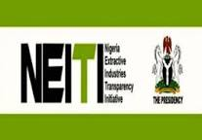
CSO/Media Roundtable for Building a Framework for Engaging on Energy Transition Costs and Impacts for Nonstate Actors

16th September, 2025.

Held at Yellow Trumpet Hotel, No 16, Lingu Crescent, off Aminu Kano way, Wuse II, Abuja

Rapporteur:
Affiku Luka
affikuluka@gmail.com
08069621537

Table of Contents
EXECUTIVE SUMMARY 2
Abbreviations 4
1.1 Background 5
1.2 Objectives of the Roundtable 6
2.0 Workshop Method 7
3.0 Report 8
3.1 Recognition of Guests 8
3.2 Welcome Address 9
3.3 Goodwill Messages 12
3.4 An overview of the Project 14
3.5 The Draft Report by the Consultant, Dr. Friday K. Ohuche 18
3.6 Questions, Answers and Contributions 21
3.7 Response by the Consultant 27
3.8 Centring Community Justice: Reflection from some communities in the Niger
Delta. By Tiga Bolton 28
3.9 What Next? 36
3.10 Vote of thanks 36

Annex: Photo Gallery 38
49

EXECUTIVE SUMMARY
Nigeria Extractive Industries Transparency Initiative (NEITI) is the Nigerian chapter of the global Extractive Industries Transparency Initiative (EITI), mandated by the NEITI Act (2017) to promote transparency and accountability in the processes of mineral and natural resource administration, especially in the management of revenues from oil, gas and solid minerals sectors in Nigeria.
NEITI’s intervention over the years has dealt deeply in areas of improving Nigeria’s macroeconomic environment; pursuing structural reforms; strengthening public expenditure management; and implementing institutional support stemming from its transparency and accountability drive in the mineral sector with multiplier effects on the whole economy. Nigeria joined the EITI fundamentally to promote transparent processes and prudent management of revenues from its abundant natural resources to reduce poverty, enhance inclusivity and ensure sustainable development.
To achieve its goals, three policy instruments have been introduced between 2016 and 2019 which NEITI still maintains till date. These are the NEITI Occasional Paper Series, The NEITI Quarterly Review, and the NEITI Policy Brief. This roundtable for Civil Society Organizations and the Media on Building a Framework for Engagements on Energy Transition Costs and Impacts for Nonstate Actors is a logical extension of the policy-shaping ambition of NEITI. This rountable was conceived as a platform to bring together the expertise and deep experiential knowledge of the Civil Society Organizations (CSOs) and Media on the subject matter, to critically interrogate all the aspects of the study done so far by the consultant and the preliminary findings, make informed contributions and suggestions for a more robust engagement, and thereafter, continue the enlightened engagement till this study is concluded. By which time, it is expected that an unassailable study would have been delivered, from where policy recommendations would be made to the government for seamless energy transition.
This roundtable is aimed at intelligent interaction about the study, especially the interim report that was presented today, that is properly tailored towards answering all the pertinent questions that arise from Nigeria’s transition from fossil fuel to cleaner energy. Of utmost importance is the question around dynamics of costs and impacts for nonstate actors in our effort towards transition to renewable energy, as well as the economic and social implications of such transition given our peculiarity. The roundtable is also meant to, after getting harmonized thoughts of the CSOs and media, communicate same to the consultant for possible integration of those experiential comments and recommendations that would be made today, get the buy-in and ownership of the study by all stakeholders including the CSOs and the media.
The Civil Society Organizations and the media had a robust retreat, listened to the presentation of the interim report by the consultant, broke into two sessions – oil and gas, and mining, where they deliberated on most important issues of energy transition costs and impacts as they affect them and the society in general. They had this discussion under five different subheadings:
- Impact description (list impact types)
- What are the impact indicators?
- Who would we or should we engage with? (stakeholders’ map)
- What engagement tools and strategies do we use?
- What are the expected outcomes? (In shaping energy transition policy and implementation)
After deliberation, they made their inputs based on the questions above.

Abbreviations
COO Chief Operations Officer
CSO Civil Society Organizations
EITI Extractive Industries Transparency Initiative (International)
EU European Union
FRC Fiscal Responsibility Commission
GMD Group Managing Director
NDDC Niger Delta Development Commission
NEC National Executive Council
NEITI Nigeria Extractive Industries Transparency Initiative.
NIA National Intelligence Agency
NNPC Nigeria National Petroleum Corporation
NSWG National Stakeholders’ Working Group
NUPRC Nigerian Upstream Petroleum Regulatory Commission
PIA Petroleum Industry Bill
PIGB Petroleum Industry Governance Bill
UN United Nations

Background
In November 2021, at the United Nations Climate Change Conference COP26, held in Glasgow, Scotland, Nigeria committed to achieving net-zero carbon emissions by 2060. This was straight up ten years beyond the 2050 timeline set out in the Paris Agreement on climate change. Notably, the 2015 Paris Agreement had clearly set emission reduction targets and demanded pledges by all countries to commit to Nationally Determined Contributions (NDC) to decarbonise with the goal of preventing the global average temperature from rising to 2 oC (3.6 F) above preindustrial levels on a sustainable basis. The main purpose was for countries to sincerely, willingly and strategically pursue efforts to keep global temperature below or at 1.5 oC (2.7F), a statistic theorized and projected to limit the harmful impact of carbon emissions on economies and livelihoods on a sustainable basis.
Consequently, on August 24, 2022, Nigeria launched the Nigeria’s Energy Transition Plan (ETP) which clearly set out Nigeria’s Country Strategy to achieving the objective of reaching net-zero carbon emissions energy systems by 2060.
The global transition from fossil fuels to renewable energy sources poses significant risks to countries that depend on hydrocarbon-based natural resources for revenues. As one of the countries with the highest dependence on oil and gas for revenues and for energy, the prospect of phasing out fossil fuel has potential significant risks to Nigeria’s economy. Oil and gas sector accounts for more than 65 percent of budgetary revenues and over 90 percent of foreign exchange earnings through fossil fuel exports. Therefore, whether eliminating fossil fuel in order to achieve energy transition objectives in 2060 will threaten Nigeria’s fiscal sustainability and consequently impact negatively on Nigeria’s economy remains an empirical question.
While the transition from carbon-based fuel will have significant long-term impact on Nigeria’s revenue and exports, the transition would also have other impacts on the economy. A direct consequence of the transition would be the loss of fossil fuel as a source of energy. In 2021, crude oil and gas accounted for 46% of energy use and 78% of electricity generation in Nigeria. The transition would therefore require prohibitive financial investment for the country to generate renewable energy to replace energy previously generated from carbon fuels. This financing (and technological) burden is in addition to the equally significant amount of money that is required to close Nigeria’s current energy supply gap.

In August 2022, the Nigerian government launched the country’s plan to transit from fossil fuel to renewable energy. The plan proposes a transition to net-zero carbon emission by 2060, ten years later than the global target for energy transition. The main thrust of the plan is to cut carbon emissions and to provide the infrastructure for renewable energy. While the plan also addresses key economic objectives like economic energy access, economic expansion, and job creation, there is little detail on how the country plans to cover the gap that would be created from loss of government revenue and foreign exchange earnings arising from loss in crude oil production and export.

The Nigeria Energy Transition Plan (NETP) estimates that $1.9 trillion is required to address the country’s energy needs. This translates to an annual spending of $10 billion in addition to a “business as usual” investment requirement of nearly $40 billion annually to achieve the country’s transition targets by 2060. The plan relies on private capital, mostly from foreign sources, to finance this significant transition outlay.

Having stated the practical and significant challenge of achieving this funding target, and coupled with the potential loss of revenue from crude oil production and export, Nigeria faces additional challenge in implementing its transition plan and hence a real prospect of not meeting its transition targets.

Given the choices that Nigeria faces on energy transition, it is necessary to establish the direct and opportunity costs of the country’s transition decisions and actions. And given the difficulty of the choices imposed by practical economic circumstances, it is necessary to evaluate the possible trade-offs that are attainable and options for Nigeria to prevent a transition impasse. This objective necessitates the conduct of an in-depth study and economic analysis on the impact of the transition to Nigeria’s economy. NEITI therefore seeks a detailed study that will:
- Review current (global) trends in energy transition and assess the cost of the transition to Nigeria.
- Review Nigeria’s energy transition plan and implementation.
- Consider options for a more attainable energy transition part for Nigeria
- Assess Nigeria’s transition opportunities in the critical minerals required for the production and supply of renewable energy.
- Facilitate engagement with key stakeholders to support the study and communicate its findings and recommendations

Given the plethora of issues raised from the foregoing, NEITI deems it necessary that a comprehensive, detailed and well-researched study be carried out to establish long term economic impacts of transitioning from fossil fuel to cleaner energy not just in terms of monetary costs, employment related challenges, inclusivity issues and environmental concerns, but also in terms of institutional, process and procedural systems that would ensure that we are not just moving from one opaque institutional framework to the other. The aim is to have a robust study that lays bare our costs and benefits in all ramifications, as well as requisite institutional, legal and systemic frameworks necessary for success in the “new era.”.

Objective of the Roundtable.
This roundtable was organized for the nonstate actors, particularly the Civil Society Organizations and the media to among other things consider the following:
- Assess the progress of NEITI’s ongoing project on energy transition, particularly the status of the study on the impact of energy transition on Nigeria’s economy.
- Understand the interim report that will be presented today, constructively critique it; drawing from scholarly, critical and experiential knowledge gotten from the field, identify gaps in the report
- Based on thorough understanding of the interim report and in-depth discussion on it, recommend what should be included or removed, emphasized or deemphasized with a view to helping in achieving the best report possible that reflects reality of our people at the end of the study

2.0 Workshop Method
The roundtable made use of:
- PowerPoint presentation
- Zoom presentation and
- Breakout session for two groups – Mining and Oil/Gas
- An interactive session for contributions, questions and answers.

The Report

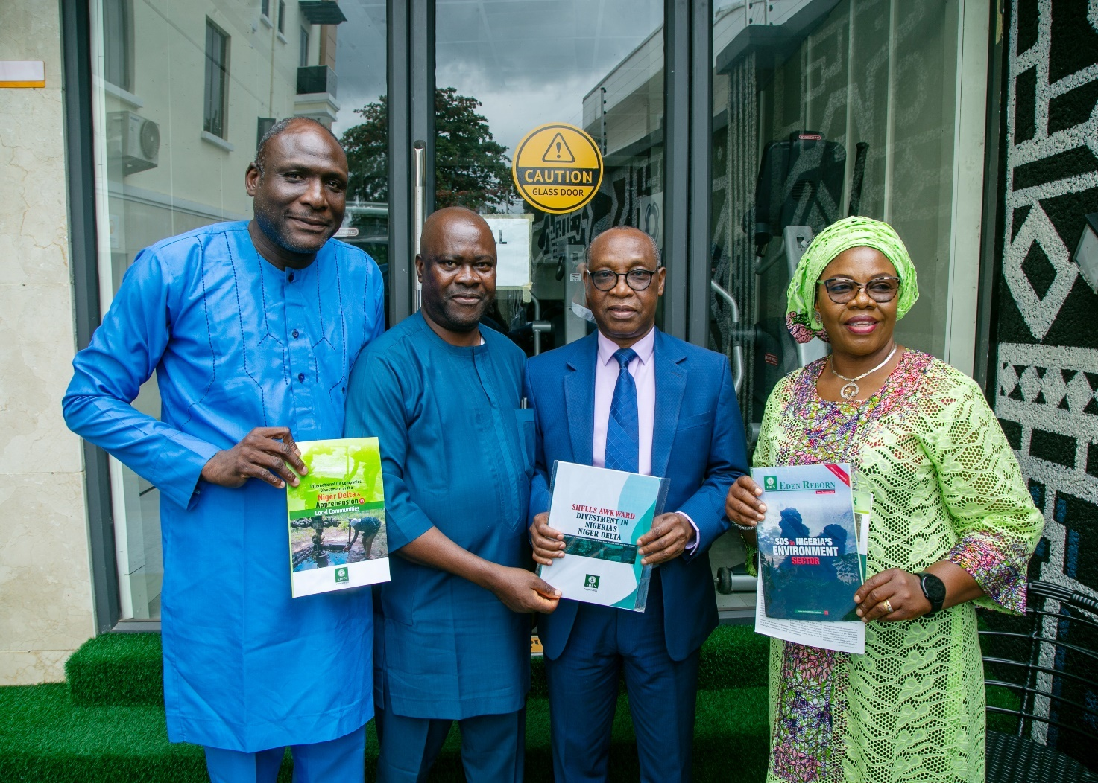

Recognition of Guests.
The anchor, Mr. Kingsley Osadolor welcomed all participants to the event. He specifically recognized certain dignitaries and key stakeholders. He thanked management of NEITI for coming up with such an initiative. He especially thanked Ford Foundation for not just funding the study but being an integral partner in the entire project lifespan.
He solicited the full participation of all participants especially the Civil Society Organizations and the Media, enjoining them to bring in practical experiences they have had from the field and the true state of the people and the community as well as their level of preparedness (community) for the big task of energy transition. He equally explained to CSOs and media practitioners present that this event was specifically organized for them to understand the study so far, listen to presentation of the interim report, make significant inputs and finally make recommendations that would further enrich the final report. It is important that you understand and own this study, therefore brace yourselves up for a robust session that would culminate on the way forward for this all-important study, he remarked.

Welcome Address/Status Report on EITI Standards by Executive Secretary, NEITI.
The welcome address was delivered by Dr. Orji Ogbonnaya Orji, the Executive Secretary of NEITI. He started by appreciating the Board of NEITI for their unfailing support. He thanked the Alternate Chair of the Board of NEITI present at the event, Ambassador Mathew Adole. He thanked the management of NEITI, the Technical Team handling the project, members of the Civil Society Organizations, members of the press and all participants for availing themselves for this all-important event.
The world is transiting from fossil fuel to renewable energy. This transition presents both complex challenges and a lot of risks. Some of the challenges are in the area of revenue, fiscal planning frameworks, job creation, employment in extractive industry, the viability of energy infrastructure and development. It also provides positive opportunities for innovation, diversification and economic repositioning.
Transitioning from fossil fuel will affect jobs, infrastructure in host communities, deepen energy poverty if we don’t manage it well.
“At NEITI, we approach this study not as a formality, but as an urgent national necessity. We must confront the transition with evidence, foresight, and strategy. That is why, under the leadership of the National Stakeholders Working Group (NSWG) and with support from the Ford Foundation, we commissioned this research”. He remarked.
He stated further that this study is not sitting on its own but is an integral part of NEITI’s Policy on Climate Change, Energy Transition and Environmental Accountability, which we developed together with our civil society partners.
That policy commits us to:
- Integrate climate and energy transition disclosures into our EITI reporting.
- Track emissions, stranded assets, and energy access gaps.
- Hold government and companies accountable for environmental justice and just transition commitments.
He stated emphatically that for this study to make the desired impact, each stakeholder must play their part effectively.
- The Media – Investigators and Amplifiers
- Simplify and disseminate findings to the public.
- Investigate and expose gaps between research recommendations and actual policy implementation.
- Hold all actors accountable to their transition promises.
- Amplify community voices, ensuring no group is ignored.
- For the Civil Society Advocates and Guardians of Justice
- Mobilise citizens to demand transparency in transition planning.
- Identify and spotlight gaps between study outcomes and government action.
- Advocate for the protection of vulnerable groups women, youth, and host communities.
- Push for climate and environmental justice, ensuring Nigeria does not carry an unfair burden in the global transition.
- On our part as members of the NSWG, the Policy Anchors
- Ensure that NEITI’s climate and transition agenda remains integrated with EITI reporting.
- Guide the institutional response to the study’s findings.
- Champion Nigeria’s voice in both national and global transition debates.
- I must sincerely acknowledge the NSWG for its consistent leadership and guidance throughout this process.
- For Non-State Actors; Innovators and Bridge Builders
- Academia should enrich the study with fresh data and analysis.
- Industry players should innovate in balancing profitability with sustainability.
- Development partners should align financing and technical support towards a just and inclusive transition.

Nigeria, being in the fold of many other resource-dependent countries, is both vulnerable and disadvantaged in the transition regime. We must join voices with others in this bracket to demand:
- Equal access to global climate finance to fund transition investments.
- Technology transfer and capacity support to enable renewable adoption.
- Climate and environmental justice, recognizing that Africa, which contributed the least to emissions, should not bear the heaviest costs.
This study provides us with the data and evidence to strengthen Nigeria’s voice in those debates.

The Executive Secretary heartily recognized the following:
The National Stakeholders Working Group (NSWG) for its steadfast guidance; The Global EITI Secretariat for constantly reviewing and strengthening our work; The Ford Foundation for generously funding this project; Our consultants, for rising to the occasion with professionalism and rigour. Your collective support has brought us thus far
The Data has been gathered; Preliminary findings are on the table. The task now is to sharpen, validate, and most importantly act. This study when completed will not sit on shelves. It must guide policies, influence reforms, and empower citizens.

Distinguished colleagues, the energy transition is upon us. Whether it is just, fair, and beneficial to Nigerians depends on the choices we make today and this study is a compass to navigate this journey.

As Executive Secretary of NEITI, I reaffirm our unwavering commitment to transparency, accountability, and environmental responsibility in this journey. With your partnership, I am confident that we will secure Nigeria’s future and position our nation. He concluded.
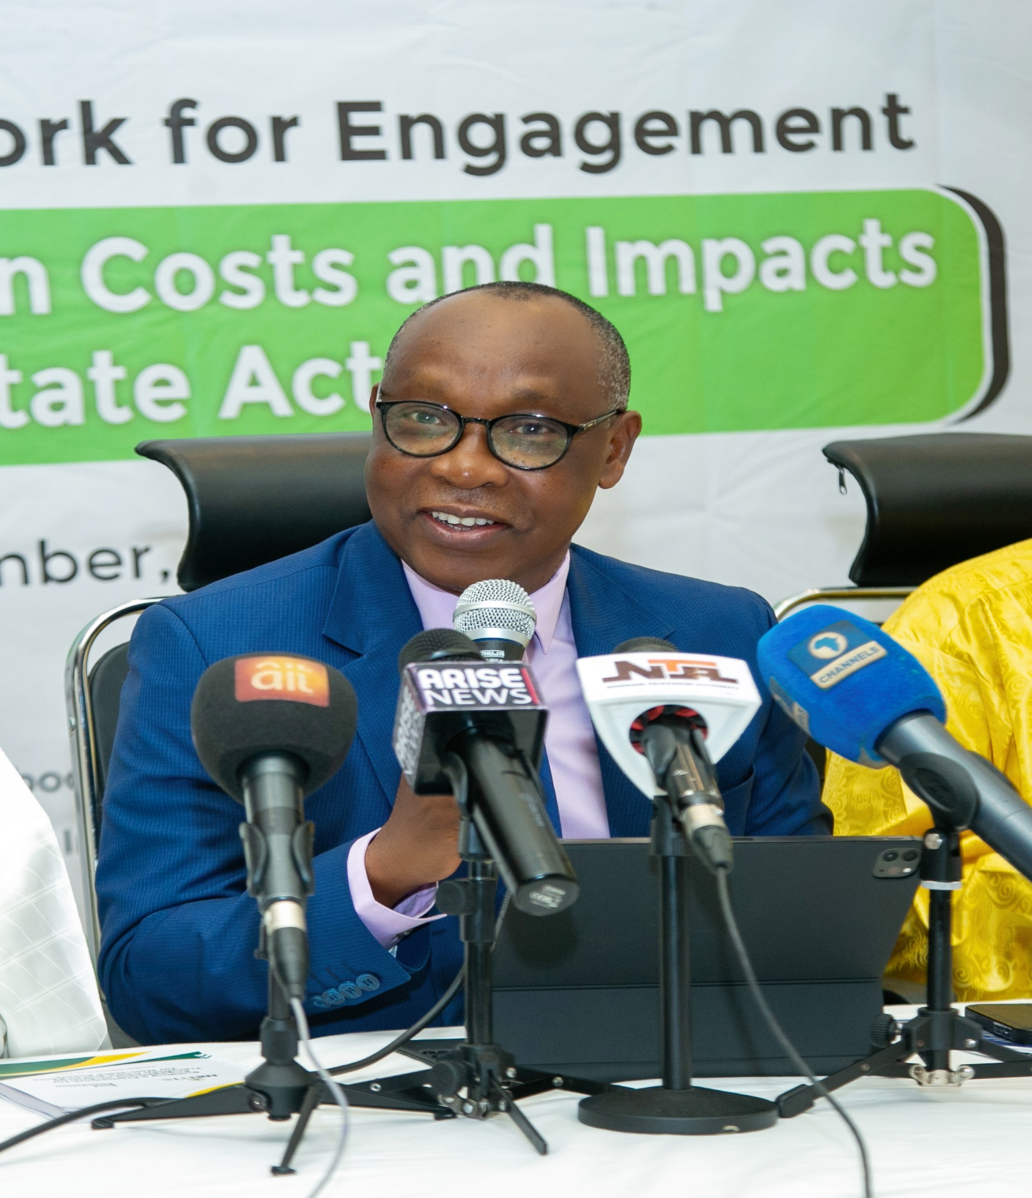

Goodwill Messages

By Ambassador Mathew Adole, Alternate Chair, NEITI National Stakeholders’ Working Group.
He extended the appreciation of the NEITI National Stakeholders’ Working Group to Civil Society Organizations and the media for the huge contributions they are making in ensuring that NEITI implements the global standards for extractive industry transparency in Nigeria. This commitment is seen in the work you are doing in your advocacy in energy transition at the local, subnational, national and even global levels.
He said as soon as they came on board, barring the fact that energy transition is recommended by global EITI, they saw it as a necessary issue to delve into because it is critical to the survival of our country.
The planned transition from fossil fuel – particularly oil, gas, and coal – to renewable energy poses significant risks to the economies of oil and gas-dependent economies like Nigeria. Nigeria depends largely on oil and gas not only for export and revenue but for its energy consumption.

Recognising the need to deepen our knowledge about the transition, the NSWG wasted no time in approving the study, which we are convinced would facilitate engagement on the country’s transition policy and implementation.

Even while the study was in progress, the NSWG proceeded to approve a framework for energy transition and climate accountability, which enabled us to commence implementation of disclosure practices in our annual industry audit.

The engagement with civil society seeks to deepen knowledge about the scope and magnitude of energy transition impacts to enable actors to engage more effectively with the energy transition policy design and implementation.

We beseech you therefore, to provide quality input to ensure that this work reflects the experience, insights, and perspectives of all stakeholders who are involved in this programme. 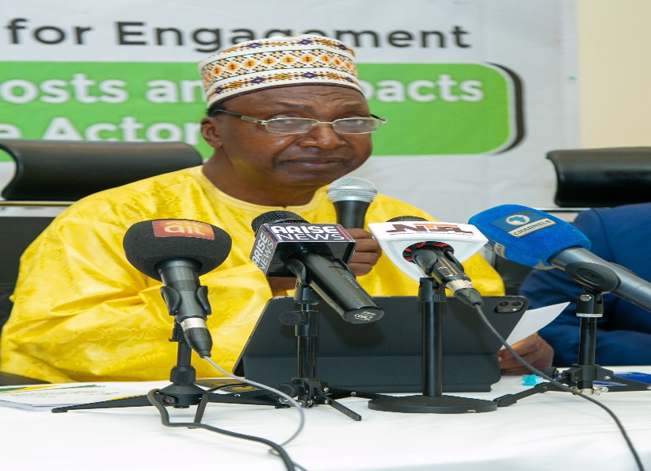

This study will undoubtedly serve as indispensable resource for engagement and advocacy on energy transition when concluded.

From Board Chairman, Resource Justice Network, (Formally, Publish What You Pay) Dr. Yahaya Mohammed Mustapha
Resource Justice Network fully supports this study and aligns itself with all the work NEITI is doing. NEITI has over the years established itself as a reliable and dependable institution in key areas of accountability, transparency and achieving results. So, we are delighted to be associated with her in this very important study. 
He enjoined all participants to give support to the study as well as the drive towards renewable energy through advocacy. For this study, especially the interim report that will be delivered shortly, the Board Chairman earnestly requested that participants should brace up for thorough job. He particularly called on them to identify gaps in the report and proffer insightful recommendations.
He also charged the Executive Secretary of NEITI to keep to his words which he declared earlier that the final report will not be left on the shelf.

By Country Manager, Natural Resource Governance Institute,

Tedy George
She was so delighted to be part of this conversation as she recalled that when she was in the Global Council of EITI, she pushed vehemently for what NEITI is doing today. She also commended NEITI for being in the frontline of this discussion spotlighting key issues in energy transition.
She reiterated that any conversation on energy transition that is worth its name must take into cognizance costs to the host communities such as environmental, health, social and economic. Others to be considered are potential revenue losses, abuse of women and children and leaving environment degraded after divestment.
We resolved in our organization that we have to go all out to support communities that provide Nigeria’s mainstay that they may not be left desolate.
“In our economy, our country, we must prioritize human lives, and this is achieved through a just, inclusive energy transition”. She remarked.
She concluded by assuring NEITI of her organization’s support at all times.
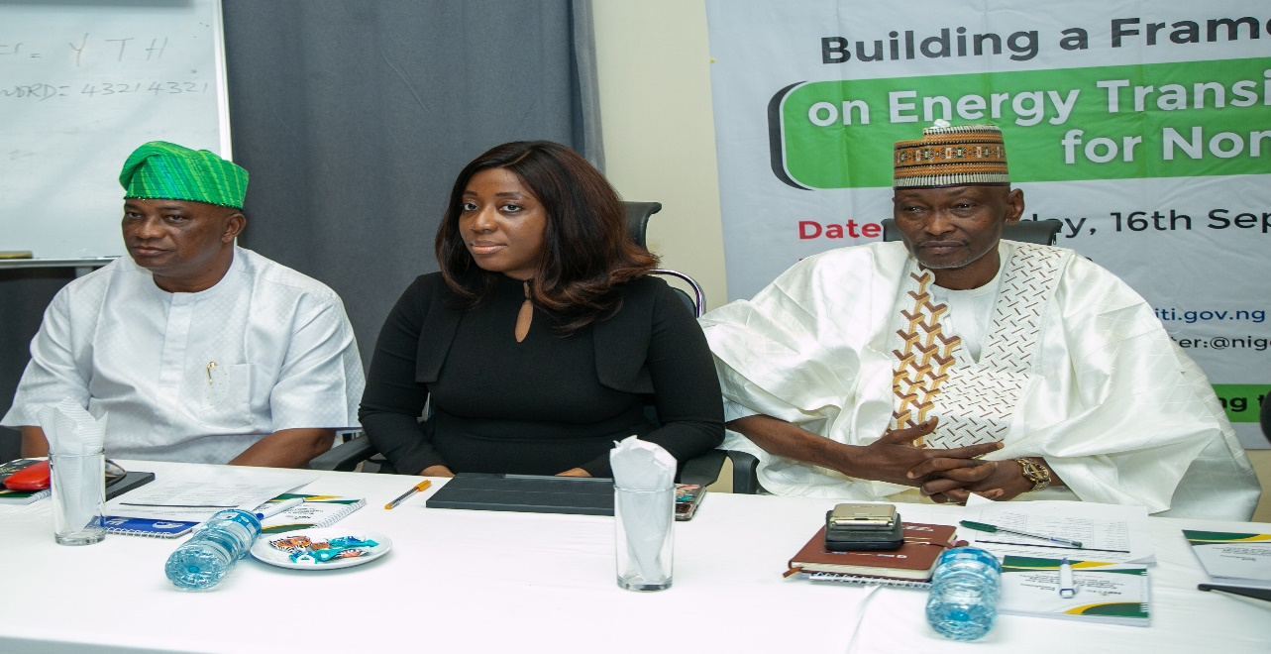

By Chairman, Media Initiative for Extractive Industry, Mr. Bassey Udoh
The Executive Secretary, during his remark, couldn’t help but keep mentioning the media. It is due to the immense importance of media in the era of this transition, Mr. Udoh stated. He went further to say that if anyone has a beautiful message but is not able to disseminate it to his intended audience in such a manner that they understand, he has failed in his duty. He said this apparently buttresses the indispensability of the role of the media in this conversation.
He said his organization has been working together with NEITI for a long time, and that they have been best of partners in most of the projects they have done together. This project, he said, will have even better attention from them.
We, media operators in the energy sector will project all activities being carried out by NEITI in energy transition as best as we can, and when the report is finally out, we will do even more. We are ready to partner with NEITI at any point in time.

3.6 An Overview of the Project, delivered by Mr. Godwin Okpene, NEITI Project Lead
This was delivered by Mr. Godwin Okpene, Deputy Director, Policy, Planning and Strategy at NEITI. NEITI, in collaboration with Ford Foundation, is conducting this roundtable “CSO/Media Roundtable on Building a Framework for Engagements on Energy Costs and Impacts for Nonstate Actors”. In this session, interim report of our study “Long term Impact of Energy Transition on Nigeria’s Economy” will be delivered. Participants are expected to thoroughly engage with the report, critique it, especially with real on-the-field experiences and knowledge and recommend what to be done to make the report a robust one.

Project Background
The project is supported under the Natural Resource and Climate Justice Programme. This is an initiative that Ford Foundation supports NEITI and other organizations to create systems that focus on ensuring equitable and sustainable management of natural resources. These programmes aim to promote transparency, promote and protect community rights, and address environmental and social injustices associated with resource extraction and use.
These discussions become necessary because some countries that contribute little to the conditions that lead to climate change and global warming are being asked to contribute maximally towards its neutralization thereby exposing them to extremely difficult situation for the fact that they do not have financial resources to drive their energy transition processes. Therefore, countries in global south are most hit and bear direr consequences in energy transition. Abandoning their natural resource for cleaner energy is also another conundrum for them to solve.
This study by NEITI is therefore intended to measure the exact quantity of resources needed by Nigeria to be able to successfully transit to cleaner energy. Furthermore, to establish empirically the size of losses accruable to Nigeria as a result of our gradual transition to net zero emission by 2060. The study is also to tell us in clear terms what opportunities are out there for us, and how to strategically optimize such opportunities. This roundtable is necessary because, interim report is going to be presented for critical deliberation. The interim report is to be exhaustively discussed to produce recommendations that will, at the end of the day, serve as guide or response to/for policy advocacy, a tool for a call for national policy reform, and an unimpeachable instrument to clamour for reform in international energy transition framework.
Project Objective
The objective of this study is to strengthen engagements of resource dependent countries through generation of evidence of energy transition risks to them (resource dependent countries). The focus is to generate data that can help our country to respond to global discussion on energy transition from informed position. It will also help other resource dependent countries to understand the precarious situation in which they all stand in this matter. This data will be used to canvass for better conditions for resource dependent countries in the journey to renewable energy destination.
Project Design
The study is to measure the impact of energy transition to non-renewable energy resource dependent economy like Nigeria.
Stakeholder Engagements: (government, civil society and industry operators) to enhance understanding and promote multistakeholder participation in advancing the debate and policy intervention on energy transition impacts.
Develop tools and mechanisms to deploy in the EITI process in promoting engagements and policy response to energy transition impacts
The study is to develop tools and mechanisms to deploy to EITI process in promoting engagement and policy response to energy transition impact.
In the EITI framework there are three major stakeholders’ constituencies who are distinct in their own respect but coordinate to each other - the government, Civil Society Organizations and the companies.
Project Task
The project tasks include among others the following:
- Review global trends in oil and gas demand and investments and implications for Nigeria’s economy
- Assess energy transition plan and related policies
- Assess opportunities in the transition for Nigeria
- Engage with relevant government institutions, civil society organizations and oil and gas companies

Project Implementation Status
- Methodology workshop – completed
- Study to assess energy transition impact – ongoing; draft report submission = May 2025
- NSWG retreat to provide update and background of the study and project objective to the National Stakeholders Working Group completed
- Stakeholders’ engagements ongoing.

Roundtable Objectives
- Presentation of interim report of the study on “Long term Impact of Energy Transition on Nigeria’s Economy”.
- In-depth engagement with the study by Civil Society Organizations and the media based on their respective fields
- Critique the interim report and proffer quality recommendations for necessary improvement. This will be sent to the consultant for necessary consideration and subsequent action
- Get the perspectives of nonstate actors on this important conversation
- Get the buy-in of CSOs/media and nonstate actors in the campaign for energy transition.
- Have the perspective of all critical stakeholders in the energy transition scheme forwarded to the consultant for consideration and possible update of the report.

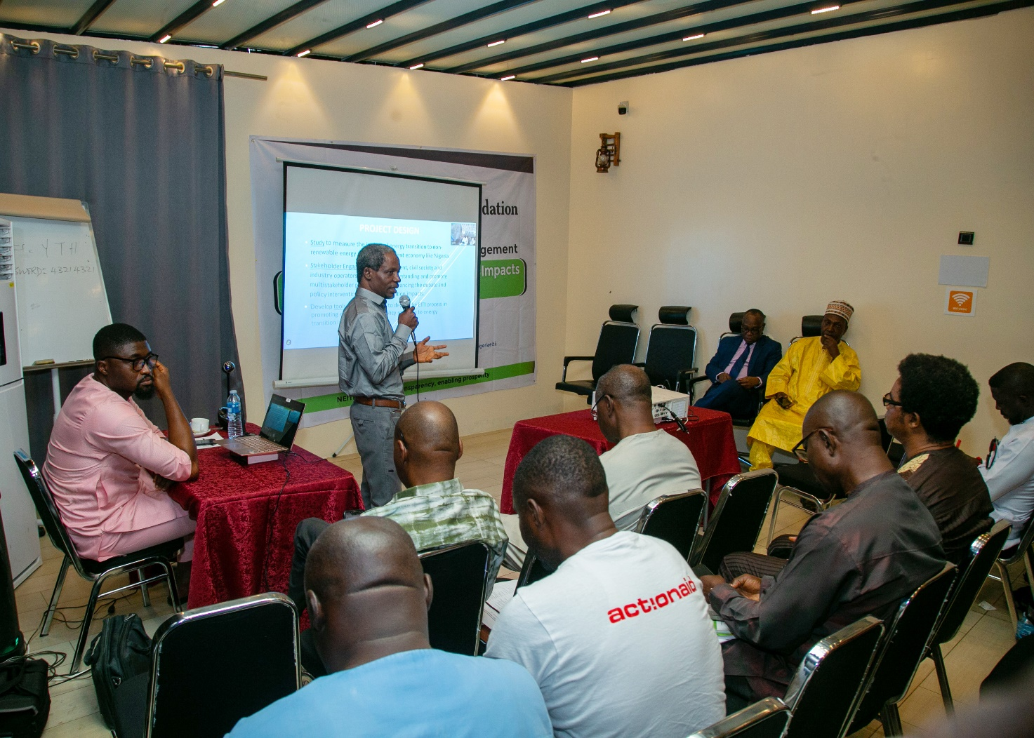

Nigeria Energy Transition: Study on Economic Impacts and Implications for Mineral Resource Governance and sustainable Green Growth.

Interim Report by Dr. Friday K. Ohuche (Consultant)
This presentation is necessary to lay bare our interim findings. It is to allow participants, operators in the field and all those interested to engage with what we have done so far in order that constructive critique of the work could be done. After detailed analysis of the work, provide your honest intellectual and practical observations so that we may put things together and come up with the best study in this area.
Many studies in Energy transition in Nigeria focus on either prospects or challenges of climate change and its remediation strategies. In this study, we focus on a different dimension which was to do a deep-dive analysis of the Economic Costs of ‘phasing out’ fossil fuel in Nigeria's energy transition implementation and its implications for the Nigerian economy. The Study also highlights the economic opportunities inherent in ‘phasing in’ renewable energy options and implications for both mineral resource governance and sustainable green growth
This presentation is necessary to brief the Board and all participants at today’s event on the progress of the work done so far as we gradually move towards conclusion.
Summary of the Rationale for the Study
- Global Energy landscape is changing. The world is reducing their demand for fossil fuel and many countries are committing to reducing carbon emission - what are options for fossil fuel dependent economies such as Nigeria?
- The need to diversify Nigerian economy away from fossil fuel dependence is also urgent and requires evidence-based policy guidance
- In the process of implementing energy transition, policy makers need guidance on revenue generation and employment creation in the economy
- Nigeria is currently classified as an Energy Poor Country. How does the transition ensure its energy security in the context of implementation of energy transition in Nigeria?

Indirect Economic Impact of over dependence on Fossil Fuel on the Nigerian Economy
In spite of fossil fuel obvious. contributions to Nigerian economy, three critical issues exert indirect economic Impact on Nigeria’s economy that warrant attention in this study:
- Persistent Energy Poverty
Energy poverty is defined as a situation where majority of Nigerians cannot access steady power supply to meet their basic lighting and cooking needs.
Access to electricity in Nigeria is currently at 35.4% of the population against Africa average of 57% (AFDB, 2023)
Energy poverty is both reinforced by poor generation and poor distribution with huge consequences on critical economic sectors and livelihoods
- Subsidy Regime
- Oil Spillage

Renewable Energy Endowments of Nigeria
Nigeria has huge endowments of renewable energy sources, yet suffer severe effect of climate change. Take these statistics for instance:
- Solar: Nigeria enjoys an average of 5.5 Kilowatt- hour of solar radiation per day making a prime location for solar power generation
- Hydro: Nigeria has a large hydro- power potential with about 27. 5 gigawatts of hydro-energy power
- Natural Gas: Nigeria has 210.54 trillion cubic feet (TCF) of gas, one of Africa’s largest
- Wind Energy Solar: Nigeria wind energy potential is estimated to be between 3,200 and 4,000 megawatts
- Biomass: Nigeria has approximately 34 million hectares of Arable land which is 75% of its total agricultural land area for the cultivation of crops that can support bio-energy

Summary of Nigeria’s Energy Transition Targets and Timelines (2022 – 2060)
Reduce GHG emissions by 20% (unconditional) and 47% (conditional) by 2030.
Reduce emissions by 50% from current levels by 2050 and achieve net zero emissions between 2050 and 2070.
Ensure 48% of the population use liquefied petroleum gas and 13% use improved cookstove by 2030
Achieve 2.5% annual reduction in energy intensity in all sectors.
Achieve 30% on grid electricity from renewables, 13 gw off-grid renewable energy, and reduction of grid transmission and distribution losses to 8% of final energy consumption by 2030.
Achieve zero gas flaring by 2030.

Methodology
- IDDDS Policy Research Approach (Identify, Diagnose, Design, Deliver and Sustain).
- Desk Review and Content Analysis:
Desk review involves review of all relevant documents and analyzing their content with a view to picking important information that will be needed in the review of literature for the study
- Trend Analysis and Forecasting
Use historical data to identify patterns of global oil and gas demand and supply and use it to project future trends in the context of energy transition programmes globally
- Scenario Analysis
- Impact Assessment
Impact Assessment methodology will be conducted on the scenarios created to ascertain the impact of gradual transition from fossil fuel to renewables in Nigeria
- Gap Analysis Procedure

Econometric Analysis and Forecasting Model
- Forecast model
Autoregressive Moving Average Forecast Equation
Yt = C + ΩtYt-1 + ΩpYt -p + E
Where
Yt = the forecast variable (lagged)
C = Constant
Ω= endogenous variables (differenced)
T= time trend
E = forecast Error term

Key Findings
The consultant made a lot of findings that could be assessed in the report.
One of the findings he emphasized was that a lot of studies have presented us with findings that oil and gas sector is the main “culprit” in greenhouse emissions and we are trying to phase it out. He stated that this is against our records and findings from this study.
According to this study, the economic sectors that generate the highest levels of greenhouse gas emissions in Nigeria are power, transport and firewood cooking while the Sectors with the lowest greenhouse emissions in Nigeria are oil and gas and industrial manufacturing. This is contrary to results of most studies
He also “queried” why we are in a haste to phase out fossil fuel while countries that buy from us are extending their dates of complying with transition to renewable from their initial dates. He cited examples of countries like China, India and most European countries that are extending their dates for transitioning to renewable energy.
Key Recommendations
More recommendations can be assessed on the report.
Some of them are:
Energy transition implementation programs should prioritize sectors that contribute the highest levels of greenhouse emission such as power generation, transportation and firewood cooking
Focusing energy transition implementation in the oil and gas sectors that contribute comparatively less greenhouse gas will undermine Nigeria’s fiscal sustainability in the short to medium term given the overreliance of the economy on fossil fuel

Clarification by Mr. Godwin Okpene, NEITI Project Lead
Owing to the fact that the report presented had a lot of monetary figures stated from the research done, it is only natural that media practitioners and participants may want to right away publish such figures to the consumption of the general public. Mr, Opkene, however, cautioned that, we all should understand that those financial figures quoted or stated have not been verified, confirmed and agreed upon yet, as the report at this point is still interim. “We have not engaged with this report yet, as such the report and all figures stated are subject to change. Therefore, we should tame our urge to publish them.” The report is to be reviewed and critiqued by all of us. When we move from this stage and get the final report approved and launched, then it is open to all to disseminate. But for now, let’s not make it public as this may be premature since more work is still to be done on it.
The Executive Secretary also added his voice to calling participants and all those whom they have shared the report with not to make it public yet as more work is to be done on it.

Questions, Answers and Contributions.
The Executive Secretary, NEITI, Dr. Orji Ogbonnaya Orji
He referred the consultant to pages 39 to 44 of his report. He said the data captured on those pages need to be verified. He also observed that some of the data dated back to 2019, and for us, it is old. By the time the report will finally be ready, we need data as recent as last year to dominate the report. For the data you submitted, we didn’t see GHS emissions implemented that focusses on CSOs.
GDP baseline you mentioned needs to establish linkage with the scenario presentation that you have analyzed
You need to provide clear implications to society at large. The implications you indicated for job and revenue are okay. We need to see implications for Civil Society Organization’s works, media works, communities and the rest.
Linkage between the scenario analysis and national average is key in this study. We need to see it. This is found in pages 40 – 44 of the report. Pay great attention to that and update your data accordingly.
At what point do we link the data you are bringing out and the survey data (raw data) you generated from the field? We would also want to see more of primary data from the report than secondary data since you conducted survey in the field.
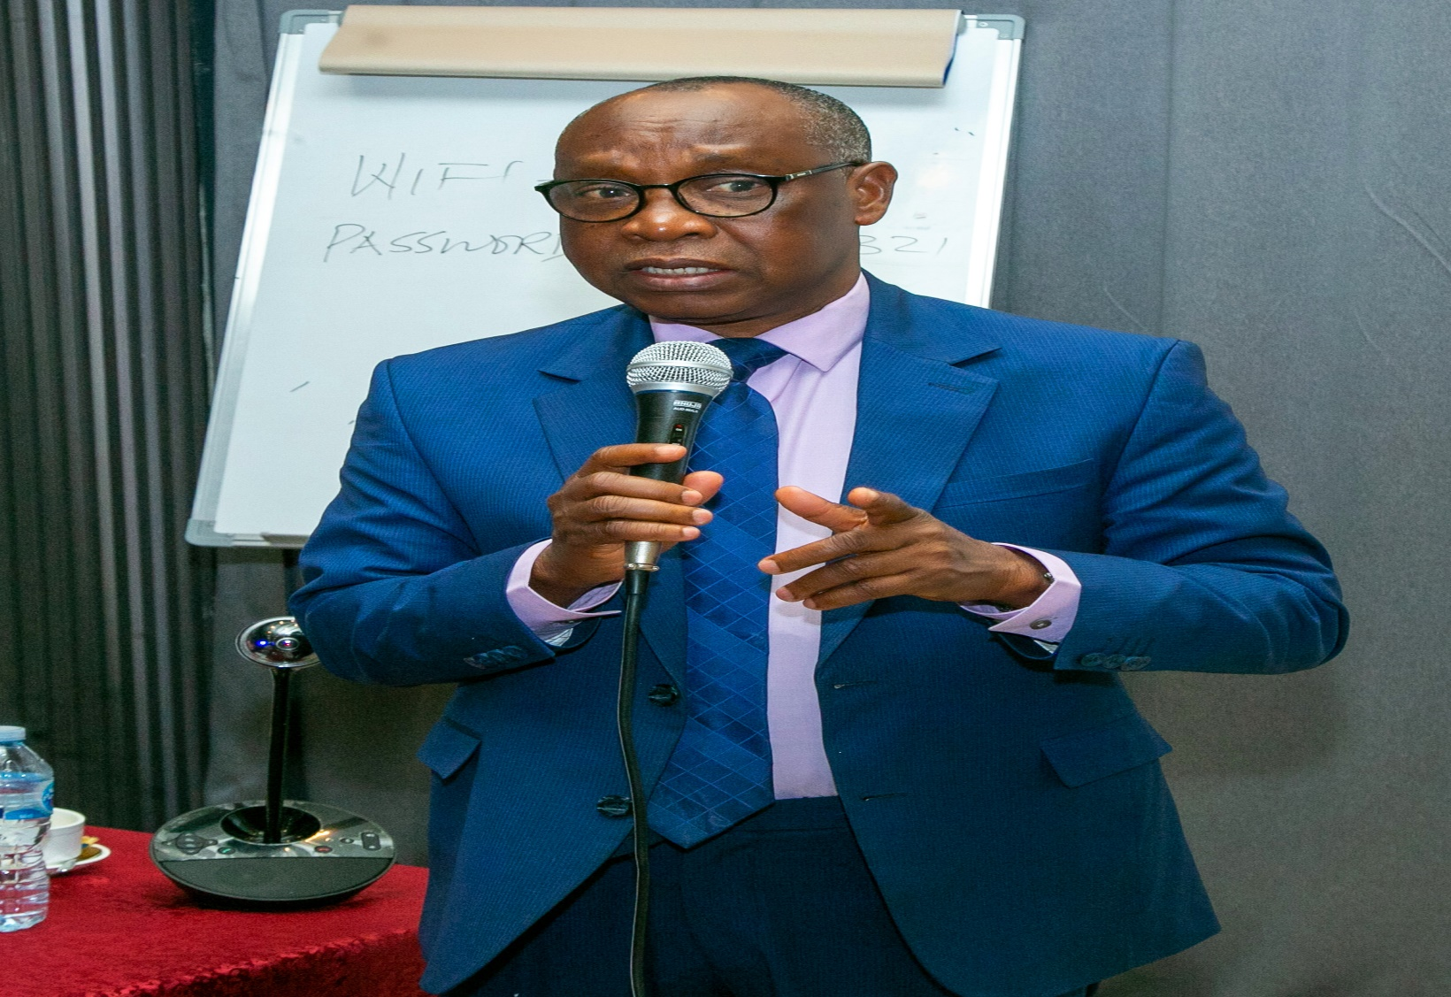
Mr. Kolawole Banwo, Former member, NEITI Board
You noted that contrary to many reports, the findings of this study suggest that power, energy and cooking constitute major contributors to carbon emission than oil and gas. Now, considering that the dominant source of power for transport is fossil fuel, don’t you think that it is better to take a composite stance in terms of analysis so that discussion around contribution will put them together rather than saying since it is fuel, we should not put It out? It could be argued that if petrol is small at the point of exploration, by the time it gets downstream and is consumed by energy users, it could account for higher percentage. The point is, oil and gas should not just be taken at the point of exploration alone, it should be considered also at the point of usage where emission is still recorded.
Secondly, I thought we would have a trend analysis because you seem to be very sure that countries that we are dealing with are adjusting their NDC contributions to tally with their national interests whereas we seem to be in a hurry. You seem to be very sure that the demand for fossil fuel will continue till 2040. I would like to see a presentation on demand trend analysis to see whether India, USA and co are already buying less of our fuel. We are in competition. Countries are discovering oil. We have to also check to see that production costs will not outweigh sales in the nearest future so that we don’t keep producing because we have deposits of minerals on ground, but because it is economically viable to produce.
Let’s see demand analysis trend of at least five years to ascertain whether these countries will continue to buy from us if we continue to produce. If not, the report shall be challenged on the grounds of why it urges us to continue to invest in fossil oil when the market will not be there when we need to sell. 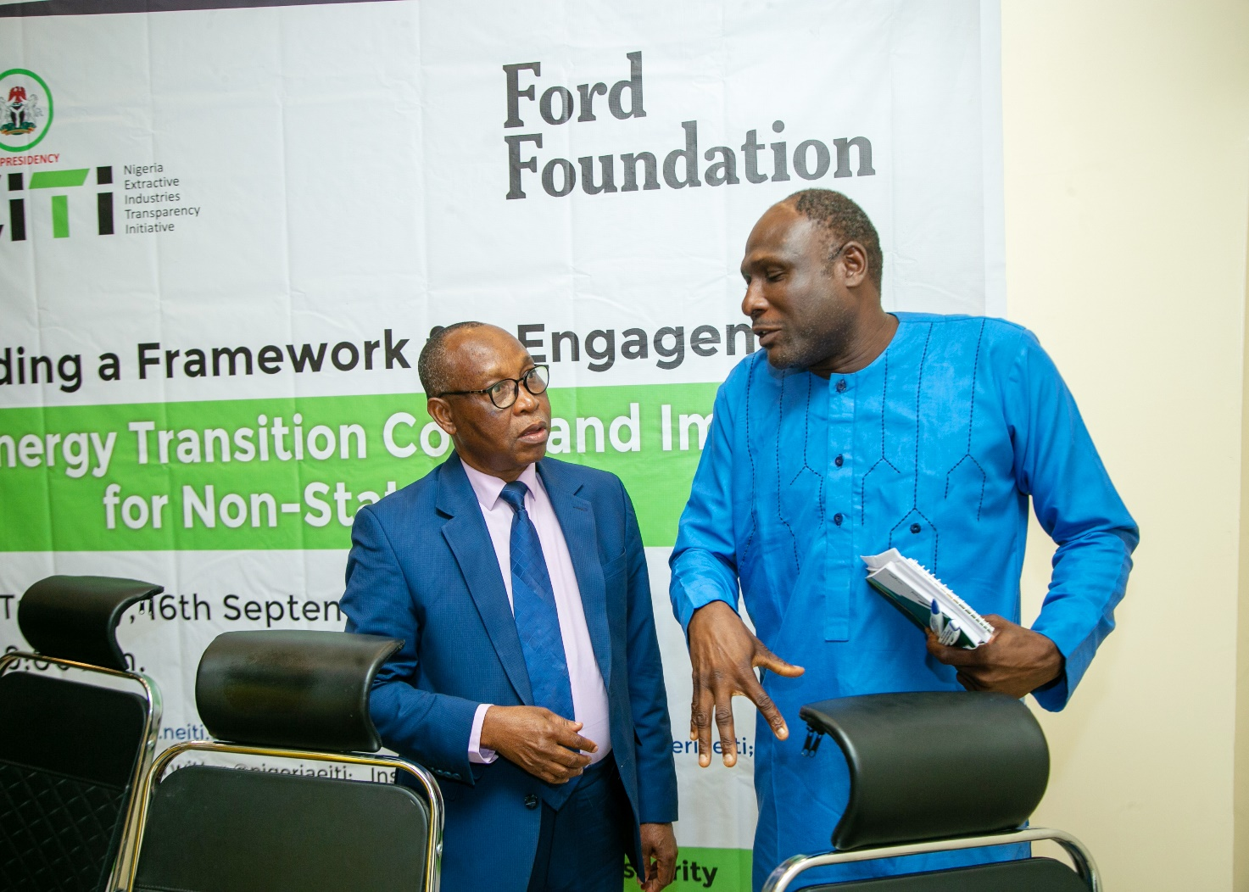
Just like you did analysis for fossil fuel, the analysis for opportunities that exist in earth minerals should be done too. This should be done in respect of moving to alternatives minerals – whether investments in other renewable minerals would be justified in terms of benefits that may accrue from them. This is so that it will not seem as if we are pushing for further investments in fossil without considering other options.

Prince Chris Azor, International Peace and Civil Responsibility Centre
I am more concerned about the masses and community people. If there is transition, there will be job losses by those who are at the bottom of social ladder in the community. Are they captured in your report? How will they be reabsorbed into new jobs that may be thrown up with the advent of renewable energy after being displaced from phasing out fossil production for which they have some level of expertise?
Your presentation seems to give impetus to the “new order”, but even the advanced countries like Germany and China are still investing in minerals like coal. Can you check that more closely?
Also, what happens to the communities that are currently devasted through exploration if those companies move to cleaner energy sources? How will the community people financially access those renewable resources? Are there plans for them in that regard?
There should be future accountability measures. For instance, how do we measure some of the expected gains? How will the people benefit in real terms?
He further suggested that there should be consideration for resource dependent countries in the international discourse about timelines for achieving zero emission. There should be some kind of moratorium. If we rush into it, it will break us. Let’s move at our own pace

Sulaiman Ayodare, Federal Resource Centre
I expected that the study will provide some space for some sort of debate. Europe was urging us on with transitioning, but when Russia invaded Ukraine, the African Development Bank came out with Africa Energy Outlook to say that if Africa utilizes its potentiality on fossil fuel fully, we will only contribute 3% to the global emission average. They were urging us on, but when the dynamics changed, a different narrative was being birthed. That is one side of the debate.
When you presented that oil and gas sector is not the major contributor to fossil emission, though I know you are looking at it sector by sector, I want to ask if you also considered the process of production of oil and gas, especially gas flaring. If that is considered, I want to know if that sector will still not be the biggest contributor.
What I expect to hear consistently in the presentation but that it seems not mentioned is “just transition.” How does transition affect those working in the carbon sector, and how does the community benefit? Justice is about how transition affects us as hydrocarbon dependent economies
There is an organization called Beyond Oil and Gas Alliance (BOGA) which Nigeria joined recently. Will we want to move because we have the imperative to move or just because we want to satisfy some interests somewhere?
Let the report also focus on government inconsistent policies. For instance, in the middle belt of the country, charcoal production has had government intervening inconsistently. Government makes policies to ban and unban charcoal production many times in recent years. These inconsistencies will affect our smooth transition.
Finally, let the report have options like, if we are moving away from fossil fuel without a particular form of investment or the other, we are bound to lose a lose this much or that much. For instance, if the report can show that a corresponding investment in renewable would cover up for losses that we may register as a result of transitioning from fossil fuel, it would be more acceptable.
The report has been more on extractive, understandably so, because NEITI is in the extractive industry and the study is being conducted by it. However, we have other renewables in other sectors. In Nigeria, the greatest renewable is solar. This should be included too.

Friday Ogezi, Action Aid International
He summarized the entire work into five subheadings:
Just transition
Implication for Nigeria’s economy – causes and effects
Domestic resource mobilization: He asked if we have the internal wherewithal in terms of finance to see to the prosecution of our transition project.
Revenue and public expenditure – making our policies and budgets to reflect energy transition.
Intersection between just transition and natural resource policy. Are there policies and regulations good enough to lead us smoothly in the transition?
He went further to ask if the “new destination” will provide affordable and accessible transition resources that the community people can benefit from. Note that the private sector is going to take large chunk of sector. The government must wade in to regulate the system for everyone to benefit.
He also called the attention of the consultant to the phrase “climate smart agriculture” that he used in his presentation. According to Ogazi, research has shown that climate smart agriculture is still the use of chimerical in agriculture which has been shown to the cause of some diseases. He urged the consultant to clarify this.
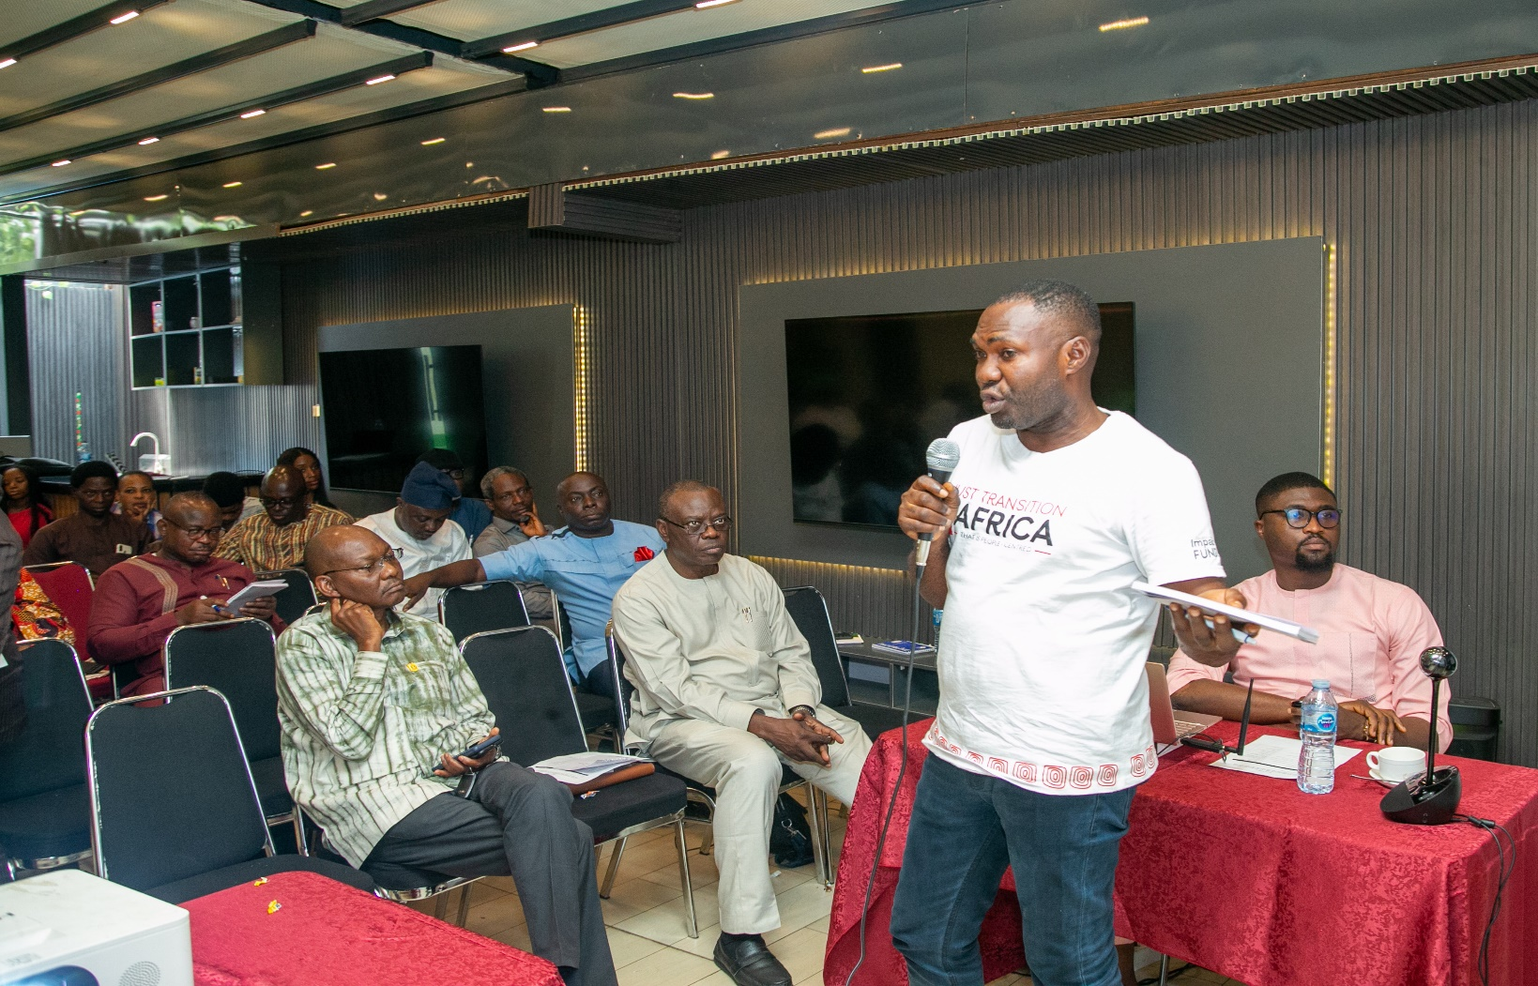

Ngozi Nwogechukwu, Divine Era Development and Social Rights Initiative
I want to corroborate the work you did so far, drawing from the work we did at Publish What You Pay (PWYP), now Resource Justice Network (RJN), called Disclose the Deal Campaign. We analyzed the funding of Nigeria in Oil and Gas. We looked at the investment to see if it tallies with the transition plan, the policies and the target that we have for this country. We analyzed a ten-year investment and we found out that there is still a lot of gaps. There is still huge dependence on fossil oil and gas which also reflected in your report. This shows that the timeframe we set for ourselves might not be realistic as it clearly shows that we are rushing too fast into transition while the main foundational issues to hold it fast are not properly addressed.
Your report rightly highlighted that there should be roles for national and subnational governments. In this transition, the most strategic thing to do is to carry all strata of government along.
In your recommendation too, you emphasized the need for Civil Society Organizations to invest more in the area of policy advocacy. We noted this in our report too that CSOs should help communities to develop resilience and understand major issues in the transition regime. CSOs need to build and deepen Knowledge gap in this area.
I just want to corroborate some of the high points of your presentation.

Oluwabukunmi Kaisser, A Media Director
You highlighted the role of mineral governance in driving sustainable greenhouse growth. Given Nigeria’s past challenges in oil governance, what would you say should be introduced to prevent critical minerals from becoming another resource curse?
You recommended providing clean cooking and climate smart agriculture. What specific financing or subsidy models would you recommend in achieving this and making the rural populace and downtrodden get access to these facilities, rather than being captured by elites which is a common thing in this country?

Response by the Consultant
I wish you had read the entire report. Most of the comments you made are systematically captured in the report. It is a 120-page report that needs time to digest.
I dedicated an entire section to financing, green minerals and other key areas. But I can’t present it all today. Do well to read through the entire report and make your contributions afterwards.
How will those at the lower echelon of our social strata benefit? I made a point under poverty reduction that employment of the masses is critical in just transition. I mentioned in the report that, when renewable energy technologies and other necessary accessories are being deployed, about 500,000 jobs would be created annually.
Another area is managing our budget which is different from identifying the problems with finance. Managing our budget is a political issue and is outside the purview of this study. For proper budget management, the government has to have the requisite political will to do the right thing.
I did a lot of trend analysis which I encourage you to check. I reviewed Russia, India, European countries and many African countries as case studies. I compared the five major economies in Africa on what they have done. Even the value chain in green minerals was analyzed. All are in the report.
I devoted a whole section to the case of job losses and the issue of investment in coal either in Nigeria or elsewhere. I stated that China has not left her coal. China is one of the greatest emitters in the world. Why then are we rushing? I made the case that why are those emitting the greatest into the greenhouse not shutting their coal mines but we are not looking to develop ours? I also made the case that Nigeria contributes only 0.03 per cent and Africa only 3 per cent but we have a disproportionate effect of the greenhouse emission, while industrialized nations that are contributing huge emission to the greenhouse are extending their dates for achieving zero emission but we are here rushing to meet our own earlier set date? We should check to set a more realistic agenda taking all factors into consideration.
I did not insinuate that oil and gas do not contribute to greenhouse emission. What I said is that gas is classified as clean energy, and most of our industries use gas as source of power. Hence, if we make that consideration, it means that anything that is coming from gas should not be accounted for.
They classify gas as lower than national cooking and lower than power. Comparatively, gas is not one of the biggest contributors.
I made very interesting points on Civil Society Organizations, such that I proposed that they should be made part of the policy making body in this area as they have first-hand information from the community.

Presentation by Tiga Bolton, Executive Director, Policy Alert

Centring Community Justice in the Energy Transition. Reflection from some communities in the Niger Delta.

He started by asserting that most of our oil and gas is sold abroad and burnt there. We need to factor in this fact so that in the calculation of overall oil and gas sector emissions, more accurate figures could be arrived at.
He showed us a picture of demobilized oil well at Atuogbadi community that was not decommissioned. The picture is for well 2. He said the well 1 was converted into a monument by Federal Ministry of Tourism. People go to well 1 to take pictures of where the “first” oil drilling took place.

He narrated that the oil company demobilized oil 1 over five decades ago and moved on but they didn’t decommission it, leading to sippage of oil as a result. The picture shows liquid substance which appears to be a mixture of water and oil. This is what spills to the farms, waters and community. The water people drink contains oil and all its component chemicals. He remarked. Think of the health challenges, the environmental pollution, impact on farmlands etc.

There is a community in Bayelsa state where Shell Petroleum had a programme called Olon. It is a programme that was expected to prepare the community for transitioning to renewables. The picture depicted showed houses built by Shell. On the surface, he said it looked nice, but it was just to cover up for environmental clean-up that Shell ought to do for the community it operated in and raked in humongous amount of money in the past six decades or more. They are supposed to restore the communities to where they met them before their operations started.

The decommissioning and abandonment provision of the PIA and other regulations that came after the PIA define decommissioning clearly. Decommissioning is not just defined in terms of the physical state of the environment but the chemical and biological states of the environment. Implementors of these regulations have failed flat in holding the companies to the terms of the definition of decommissioning. One would ask of the baseline, that is, documentation of how the communities were before companies’ activities started. This is one of our recommendations for this study.

From the work we did in the Niger Delta, we will share some facts. The Energy Transition Plan which is the overarching tool for managing Nigeria’s 2060 vision is actually unknown to most people within the communities. Many people who are at the heart of transition do not even know that there is a plan to take them on a journey to 2060. Also, the plan does not incorporate the dimension of the communities in terms of how the communities’ issues are going to be addressed in terms of health, livelihood losses, environmental impact, human rights impact.

The level of militarization that is involved in drilling a barrel of oil is heartrending. As community people come out of their houses in the morning, they have to raise their hands up, they do the same when returning to their houses in the evening. The communities are completely subjugated – human rights abuses, killings and other crimes that happen there are enormous and are all documented. That is why the work that National Human Rights Commission is beginning to do with NEITI and other partners is commendable. This is because what we want to do now is to ensure that these companies report human rights activities at the end of every year. This will be used as part of their license renewal requirement.

Another point from the work we have done is about divestment. Before you come to someone’s community to exploit any resource, there is a need to have a conversation with the people. Although, the Nigerian constitution puts ownership of land in the hands of the federal government in the Land Use Act, there is a natural title to resources in your community or on the land which you sit. There is a certain level of displacement, no matter how legal, the person that comes to exploit the resource would do to the community. That brings human rights perspective to the issue

The divestments that happened in Nigeria with any of the oil companies has one thing common amongst them – the shadiness of the process. People came into your community many years ago and started extracting without your knowledge. After negatively impacting your community immensely, they start preparing to leave without a conversation with you. The problem is that they have left behind a lot of legacy damages. The communities’ cultural artifacts are destroyed, biodiversity destroyed, their waters and fishes destroyed, livelihood destroyed, leaving the communities thoroughly devastated.

Recently, the UN wrote letters on the issue of divestment in Nigeria. We are still waiting for the Nigerian state to respond to this scathing indictment of the divestment processes that happened here. As CSOs and the media, we should lend our voices to the need for these divestments to be revisited.

The divestment process is central to energy transition because decommissioning and abandonment of sites leaving chemicals, distortion of biodiversity and leaving without clean-up and restoration impact badly on the communities and even subnationals. Now, what happens to the communities and subnationals who wholly rely on federal allocation if the oil is no longer flowing? the EU has given Nigeria 2030 as deadline to achieve some level of methane quality. They may not buy from us if by that time we do not comply. They are our biggest buyers. Those are the dangers

Another experience is the Host Community Development Plan. We met over 50 host communities in the Niger Delta alone that operate HCDP but most of them are oblivious of the transition plan. Sometimes, even those that are at the centre of the HCDP don’t know 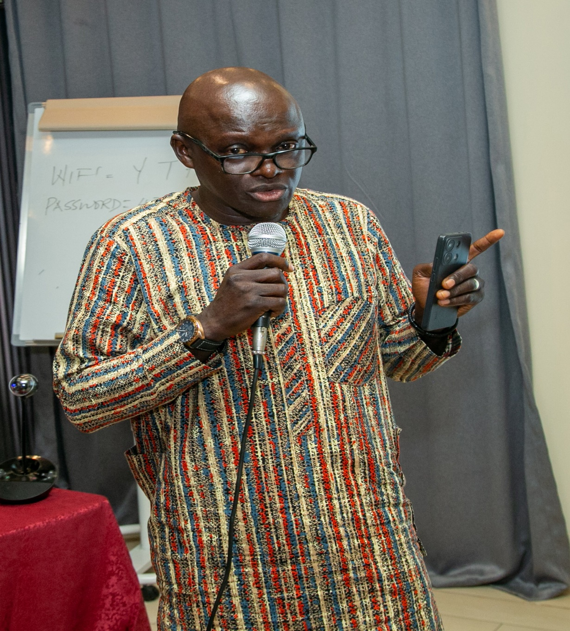 a thing about transitioning to renewal. They are only concerned about the infrastructure that would be built in their communities, neglecting the need for the intangible skills needed when transition eventually takes place. We are trying to handhold these communities to include transition relevant needs into their scheme of activities (NEEDS Assessment) and include them in community development plans.

The last thing to say is the stranded elements that will be created due to transition. We have identified a few in the course of our work. The more widely known ones are the stranded assets. There are also stranded communities which I highlighted earlier. Many of these communities are going to be left with the shorter hand of the stick. There is going to be stranded workers.

The corrupt interest of certain class of people may also constitute serious setback to transitioning. Fossil fuel drives a rentier economy and many people are profiting from that rent. These people who operate within the policy sphere and around corporate environments do not want the fossil fuel system to go. That is why we are doing some work at the international level that borders around corruption dimension of the transition regime. It is good we factor in the cost of corruption to the energy transition process in Nigeria.

Remarks by Executive Secretary

He called on the consultant to take note of all the observations, criticisms and recommendations made here today so that he could consider them before the final report is arrived at. He said he has some comments too that would be sent to the consultant.

He commended the last presenter for a good work. He pleaded with him to send his presentation to the consultant to be used as part of inputs in this study.

He equally drew the attention of the consultant to 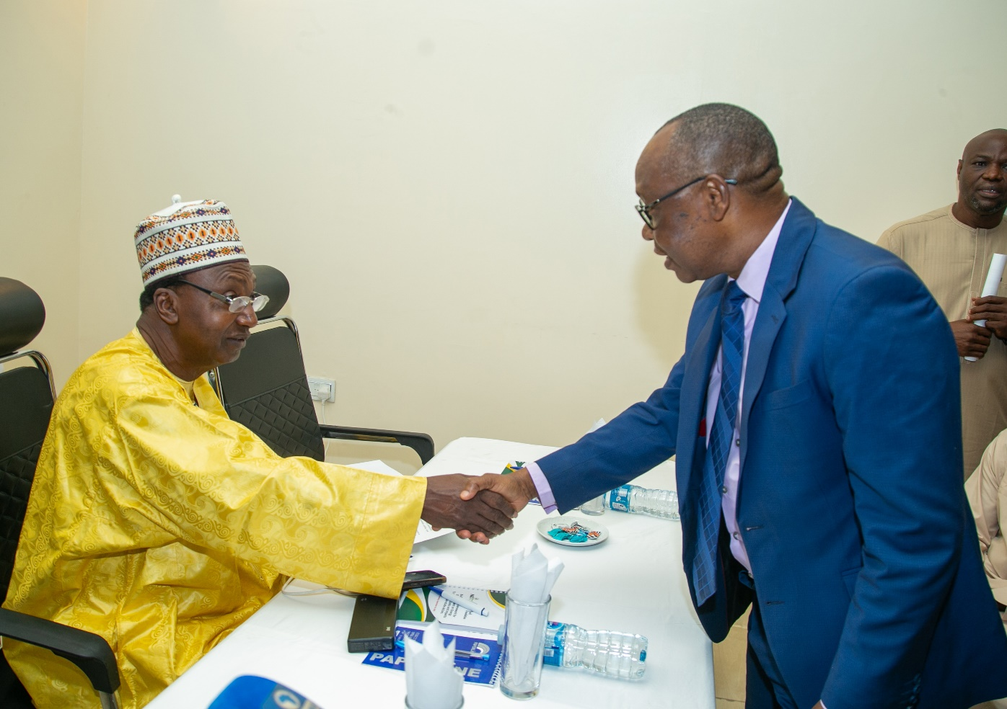an important element “cost of corruption” as espoused by the last presenter. He commented that just as the consultant calculated different costs in his work, he would like him to include “cost of corruption in divestment” as part of this study.

He said, when the final report is ready, it will be launched “loudly” and shared widely. Every one of you (your organization) will get a copy.

Finally, he reemphasized that anything presented today is not yet for public consumption as a lot of work is still going to be done. We should therefore, keep figures, findings and recommendations of today’s presentation to ourselves for now.

Break out session

The entire participants broke out into two groups – Mining and Oil and Gas. The first group was to brainstorm on today’s topic as it relates to mining while the second group was to brainstorm on today’s topic as it relates to oil and gas. Participants freely choose which group to belong to. They were given 30 minutes to discuss, harmonize their points and delegate one person to present their conclusion.

The discussion was to be done under the following questions or considerations:

- Impact description (list impact types)
- What are the impact indicators?
- Who would we or should we engage with? (stakeholders’ mapping)
- What engagement tools and strategies do we apply?
- What are the expected outcomes? (In shaping energy transition policy and implementation)

Group 1 (Mining)

Impact description

- Environmental Impact – abandoned mines, loss of farmlands, destruction of environment.
- Socioeconomic impact – loss of self-worth as a result of loss of livelihood
- Employment impact – loss of jobs, new skills for new jobs as transition comes in.

Impact Description

- Biodiversity loss/loss of livelihood
- Social insecurity (SGVB) – loss of jobs especially artisanal miners who are at the bottom ladder
- Environmental degradation
- Health – STDs, retardation in children

Stakeholder mapping
- Government and relevant MDAs
- National Council for Climate Change
- Ministry of Women Affairs
- Ministry of Environment
- Host Communities

State Actors Nonstate Actors
Government | Civil Society Organizations
MDAs | Media

Engagement Tools and Strategies

- Community dialogue/town hall meeting
- Advocacy visits
- Sensitization/capacity building
- Feedback mechanisms
- Legislation and policy briefs
- Stakeholder’s mapping
- Media engagement
- Application of technology

Expected Outcomes

- Diversified economy – new technologies, skills etc
- Job creation/upskilling
- Knowledgeable citizenry
- Increase in energy access
- Empowerment and employment
- A clear national strategy for critical mineral governance.

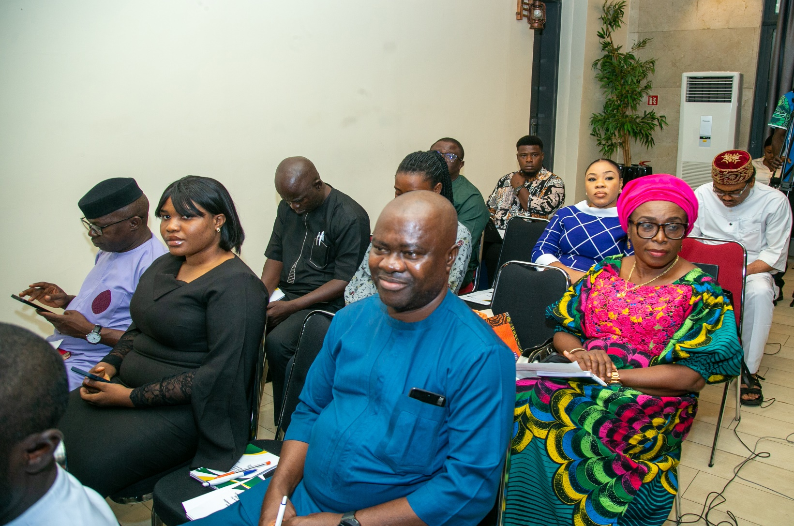

Group 2.
Topic: Oil and Gas (Impact: If Nigeria phases out oil and gas to renewable energy what will be?)

- The Impact:

- Livelihoods of vulnerable communities will be affected; more conflict and militancy issues will arise because of the transition and environmental degradation.
- Communities are not aware or educated in the transition processes, thereby creating a gap between the people and the process being undertaken in their communities.
- In oil producing communities in Nigeria, when there is a transition from one company to the other or a transition from one natural resource to the other, the process is always shady. Transition from fossil fuel to renewable energy will be a difficulty process for them to adapt.
- Adjusting to new approaches other than the traditional method of using firewood will come with challenges, cultural influence will also be a factor as some communities believe cooking with firewood makes their local food sweeter than using other means.
- Communities are also not included in the transition process. This alienates community from what is being done.
- If there is no immediate alternative adequate to support local energy for cooking apart from deforestation, then there would be problem.

Positive Impact:

- Reduced environmental and health related issues.
- Reduction in carbon emissions.
- Will create opportunities for diversity
- Helps address and improve the energy outlook for Nigeria.
- Opportunity for innovation and New Jobs created
- Create alternatives for livelihood and solutions.
- Revenue increase for the country

Positive Impact indicators:

- Increase in Number of Jobs
- Increase in revenue through diversification
- Increased innovation and technology advancement

Negative impact Indicators.

- Increase in natural resources depletion
- Very few households may be able to access renewable energy

Stakeholders’ mapping: (who to engage)
- Religious, traditional leaders
- Organized private sector
- Regulatory authorities
- Legislators
- State Government and Agencies.

Advocacy Strategy and tools for Policy engagement:
- Research
- Participatory rural appraisals
- Policy Briefs
- Community GIS
- Validation workshops
- Media engagements, cooperation litigations, lobbying, dialogue.

Examples of the policies to rely on for just transition include: NDCs, NAP, Climate change Act, PIA, AU Chatter, gender policies and related labour laws.
Outcomes:
If well implemented, we would have:

- A successful Energy Transition
- There would be improved energy availability, cheap and accessible to communities
Challenges:
- Disruption in energy value chain especially with regards to accessing CNG. Compressed Natural Gas is a source of renewable that every vehicle user is being advised to use. But the stations for refilling are not adequately distributed across the country. This is one of the challenges we are talking about.
- Adapting to technology changes may be slow
Overall, we are saying that the transition to renewable energy must be “democratic” and countries should be allowed to move at their own pace.

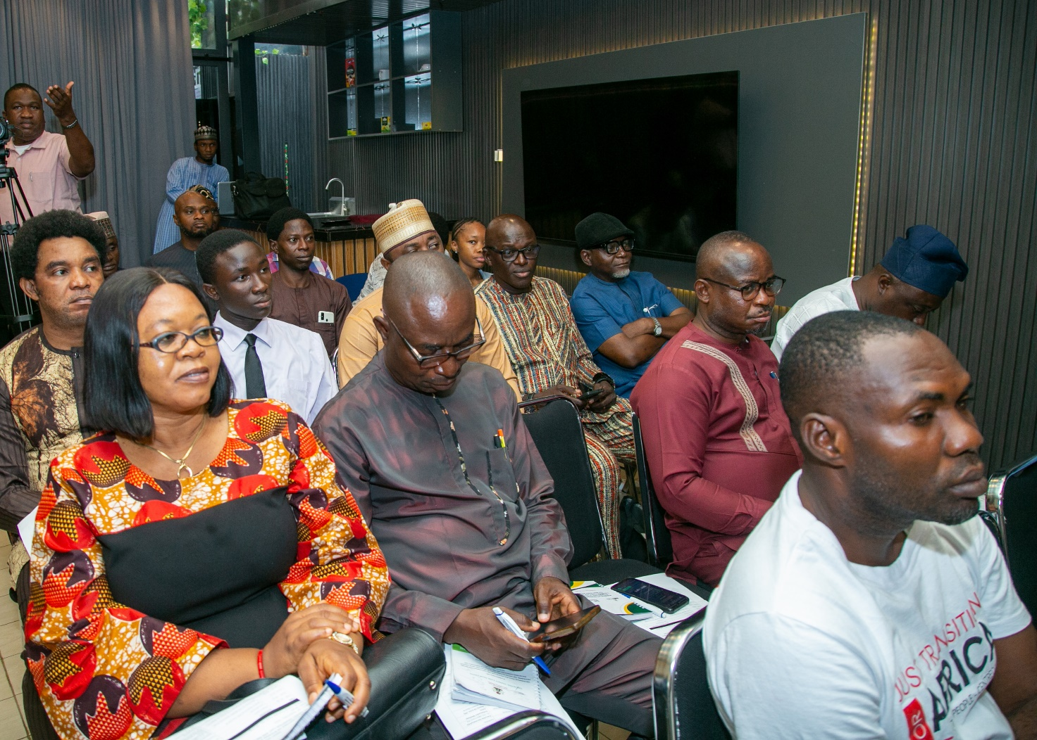

What next?

What next here means the next steps we necessarily have to take to bring this study to the robust conclusion that is intended.

The immediate outcome of this retreat which is the immediate next step is to collate inputs, update report, and validate it. We are going to have this same session with government agencies and industry operators too in a week’s time so as to get their input too.

After that, we engage the report and do validation, approval, sign off, publishing before launching it. At this point, we will have a broader engagement with all relevant stakeholders.

One of the most important aspects of this study that is worth mentioning here was the development of the framework for the study which was the activity we did before today’s sitting. At the point of validation, we will constitute a small technical team constating representatives of stakeholders here today, those of government and industry player to work on the framework and get it validated.

The framework may not be part of this report when it is eventually published. We may publish a small document to capture it in its entirety.

Closing Remark

The closing remark was delivered by Dr. Dieter Bassi, Director, Policy, Planning and Strategy, NEITI on behalf of the Executive Secretary.

On behalf of the National Stakeholders’ Working Group, the management of NEITI, NEITI technical team in charge of the project, he thanked all participants for not just coming but engaging in a long, robust and quality conversation. He assured them all of NEITI’s determination to get the best report at the end of the study. He equally enjoined participants to engage with the interim report and send in their contributions so that “collectively we will achieve a great report”.

The event came to a close at 4:03pm with the first stanza of the national anthem.
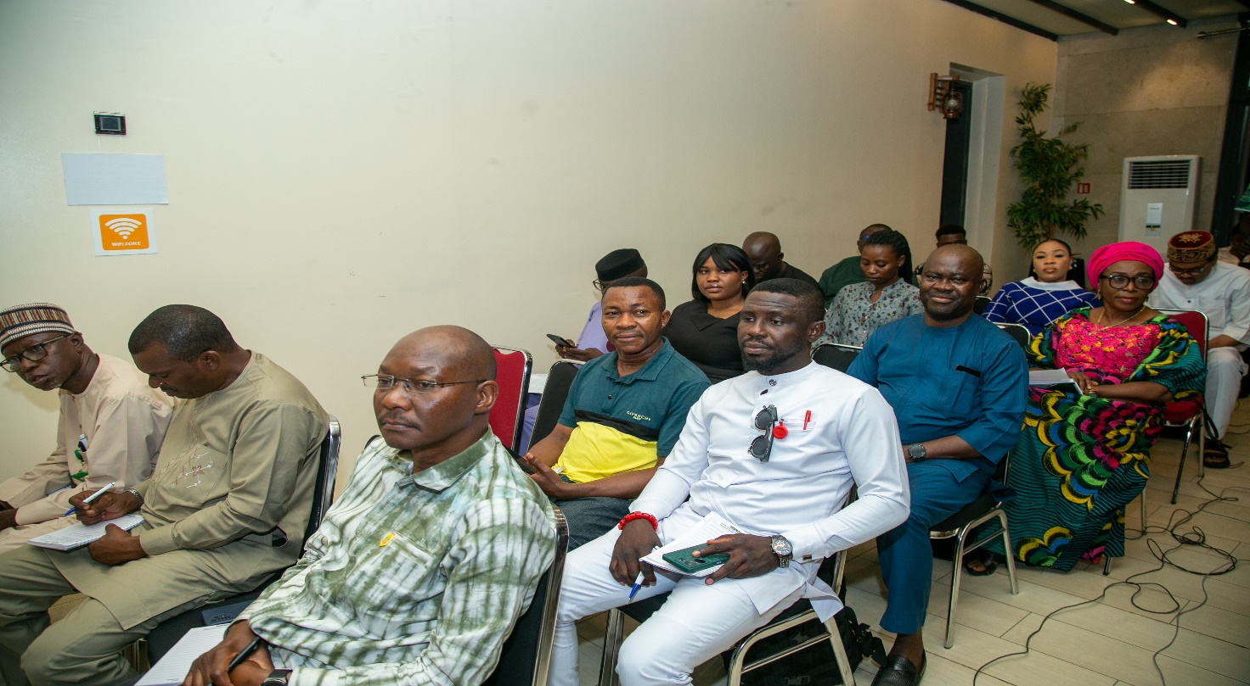

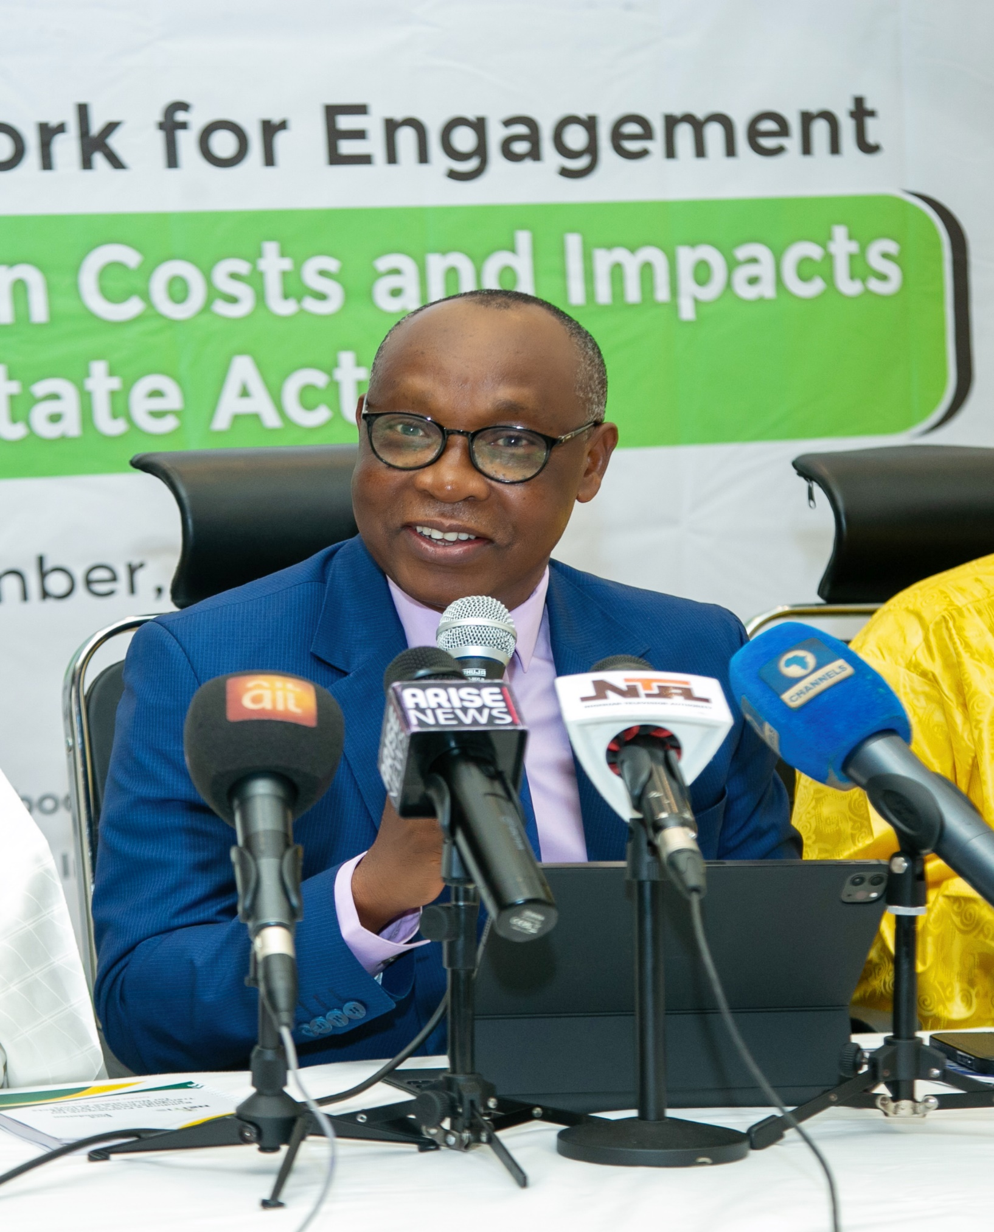
Annex: Photo Gallery
Executive Secretary, NEITI, Dr. Orji Ogbonnaya Orji.
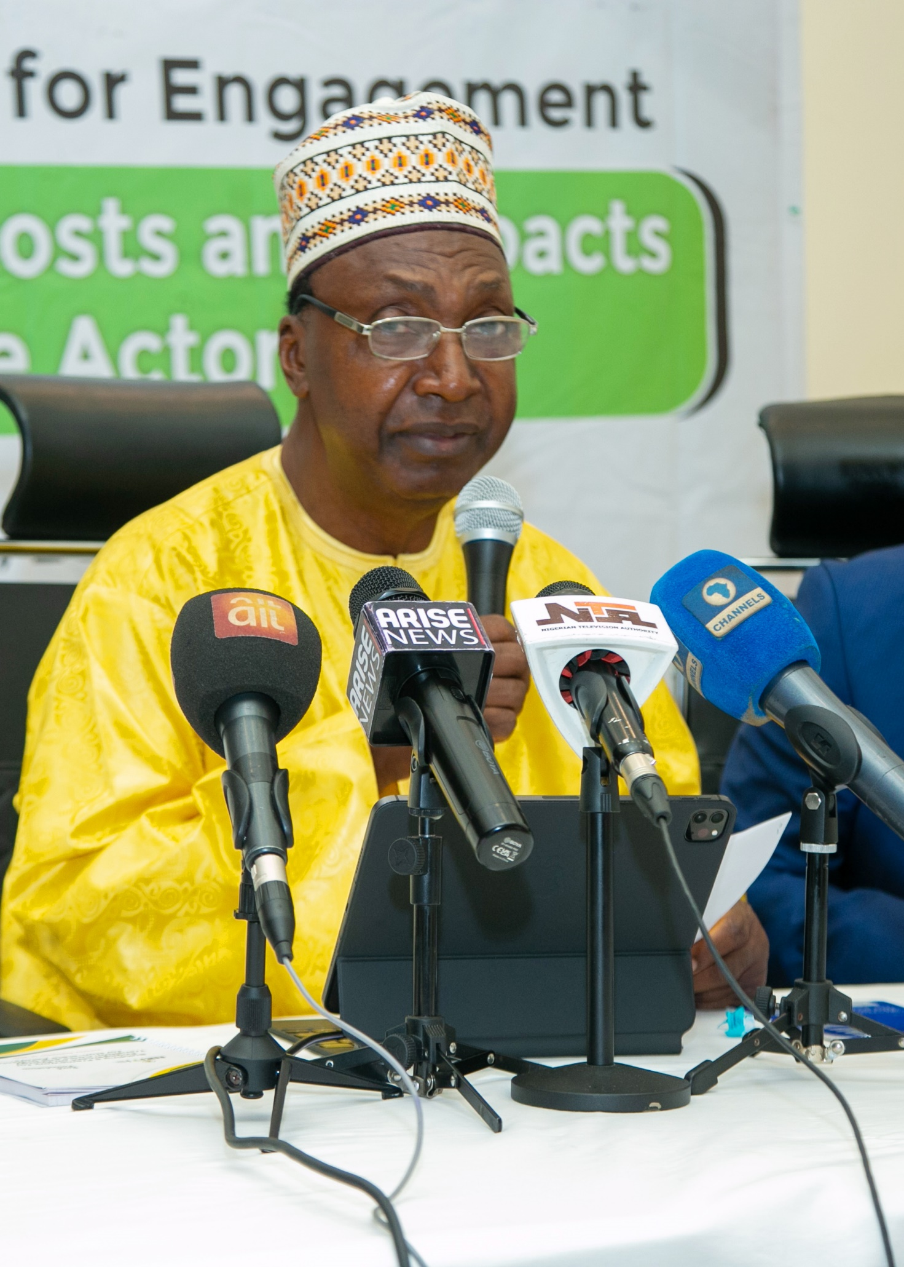
Alternate Chair, NEITI Board, Amb. Mathew Adole
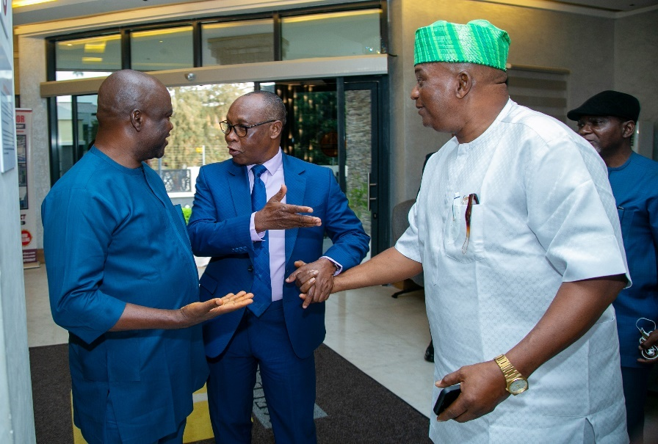
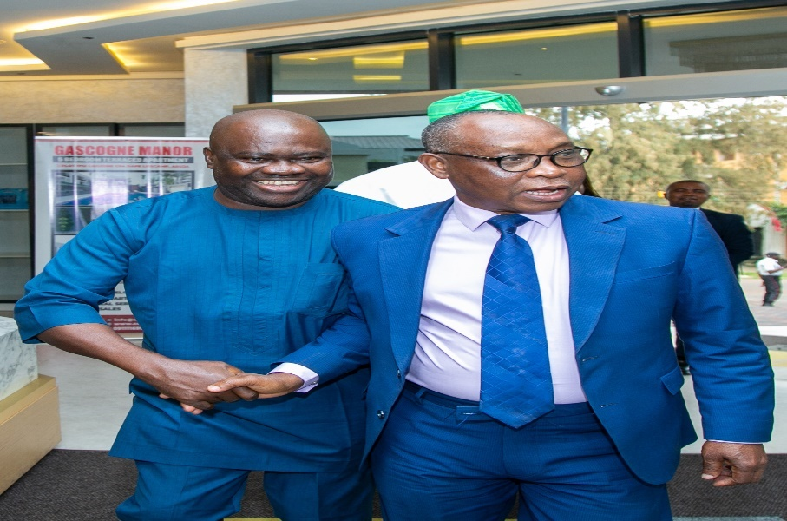
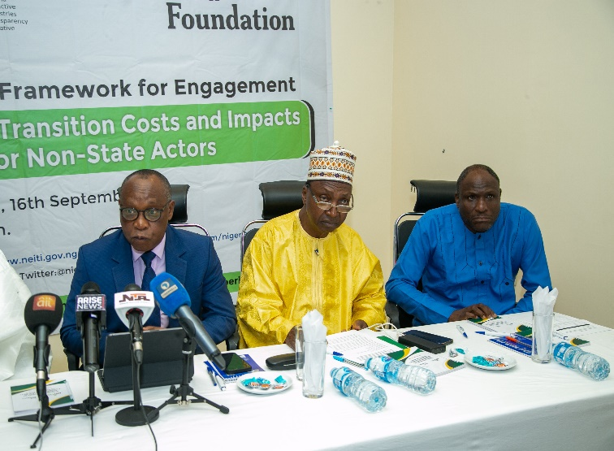
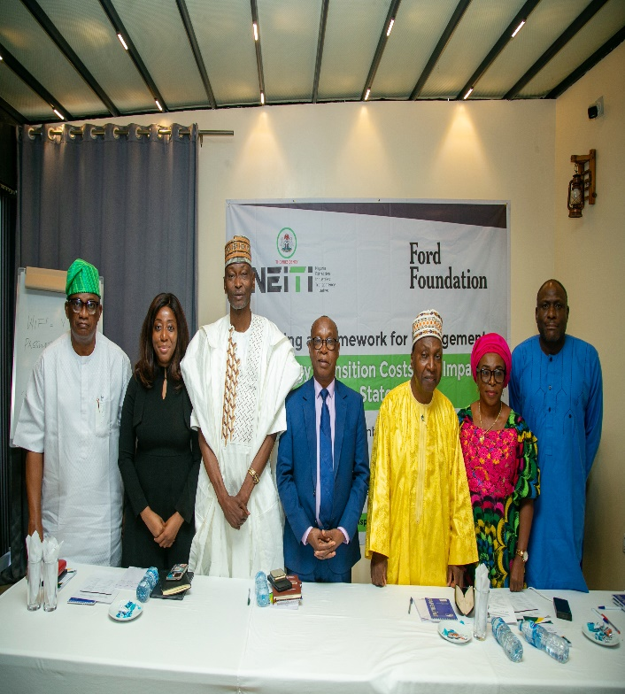
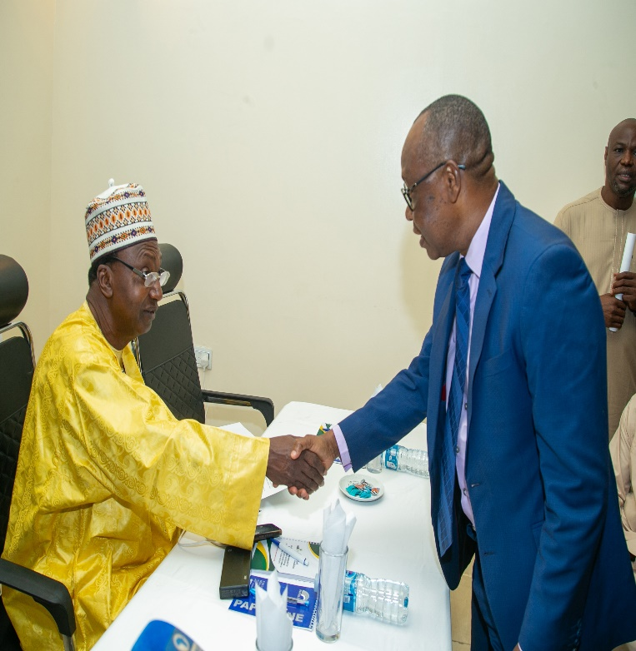
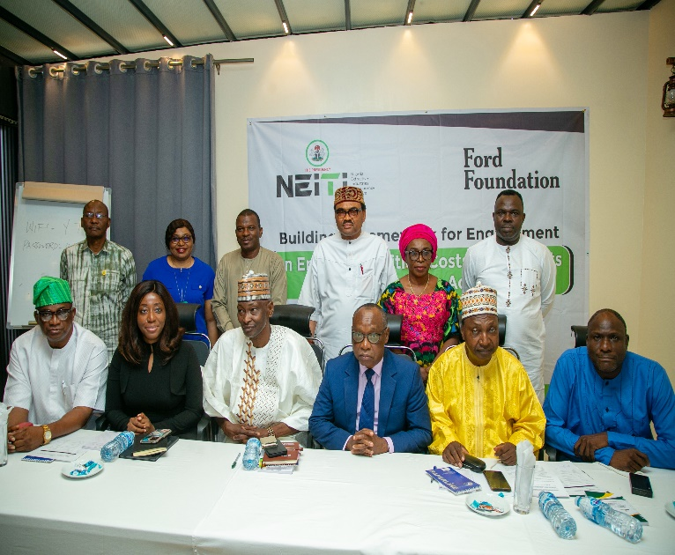
A Cross Section of Dignitaries at the Event
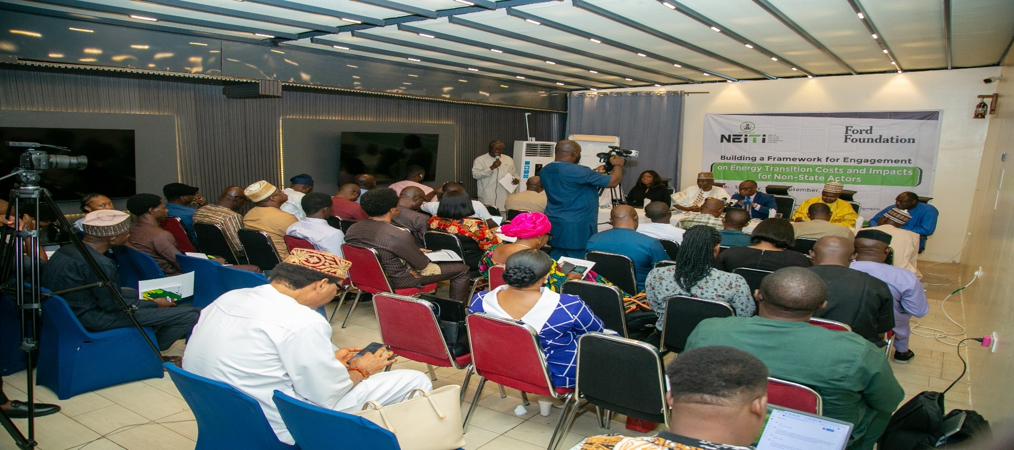
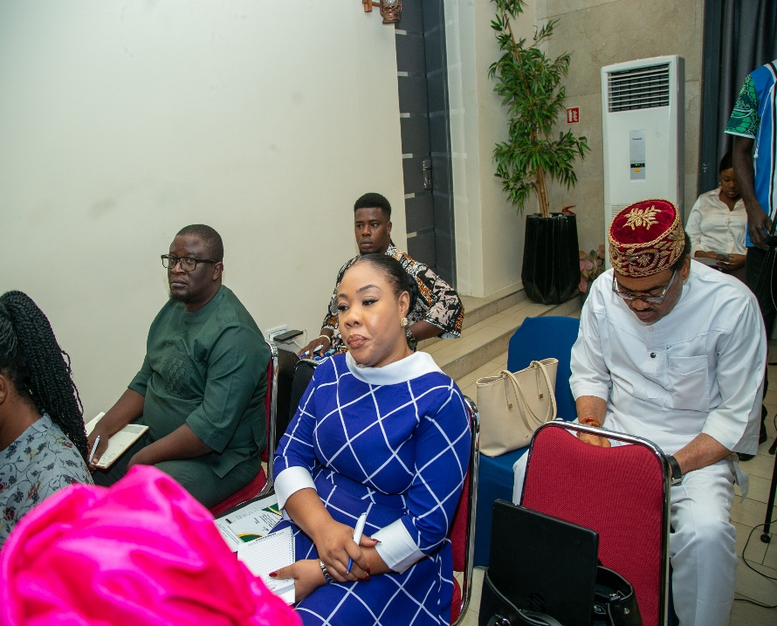
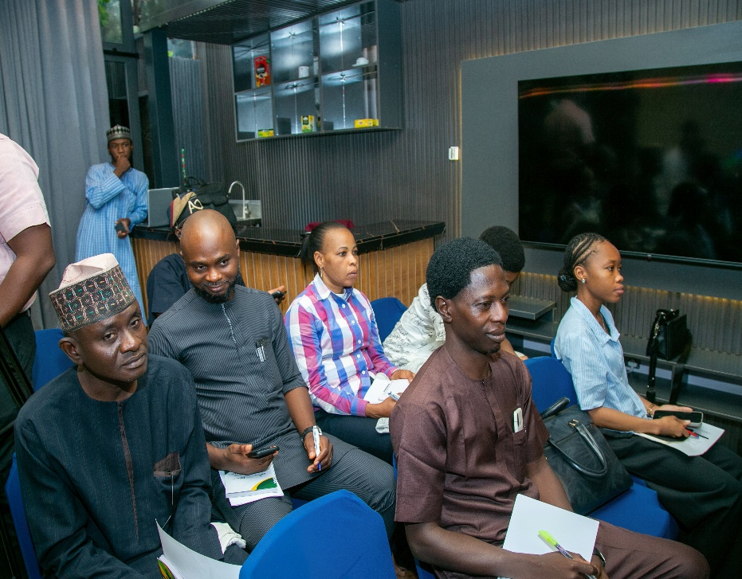
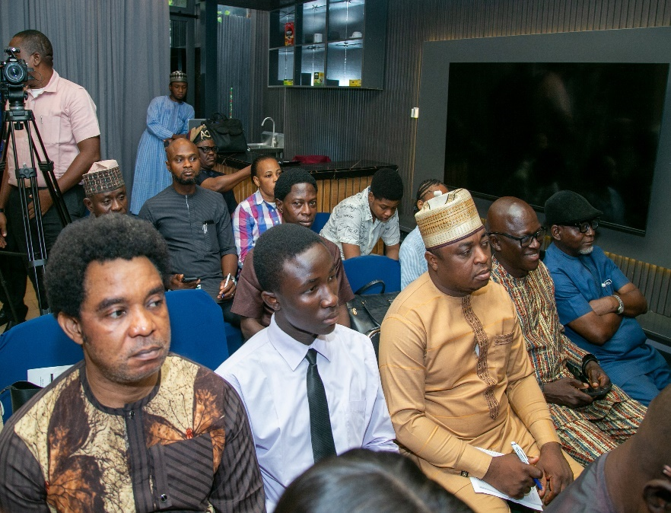
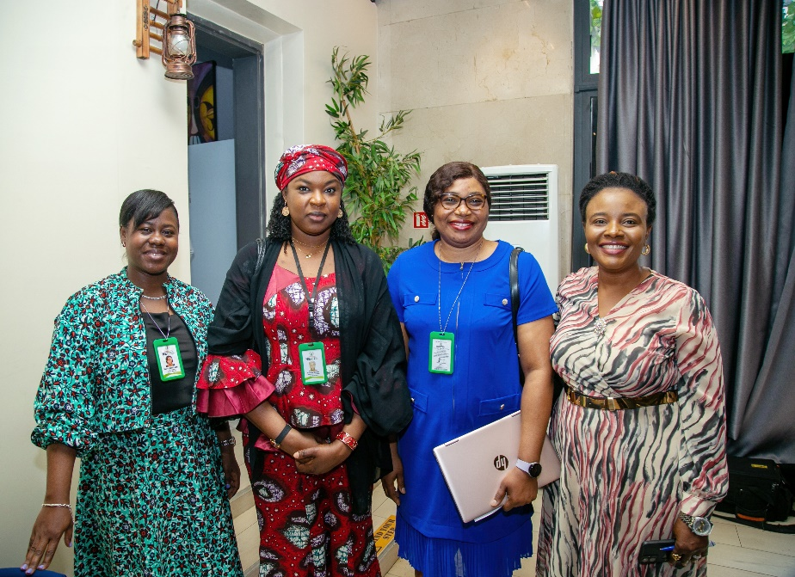
A Cross Section of Participants at the Roundtable
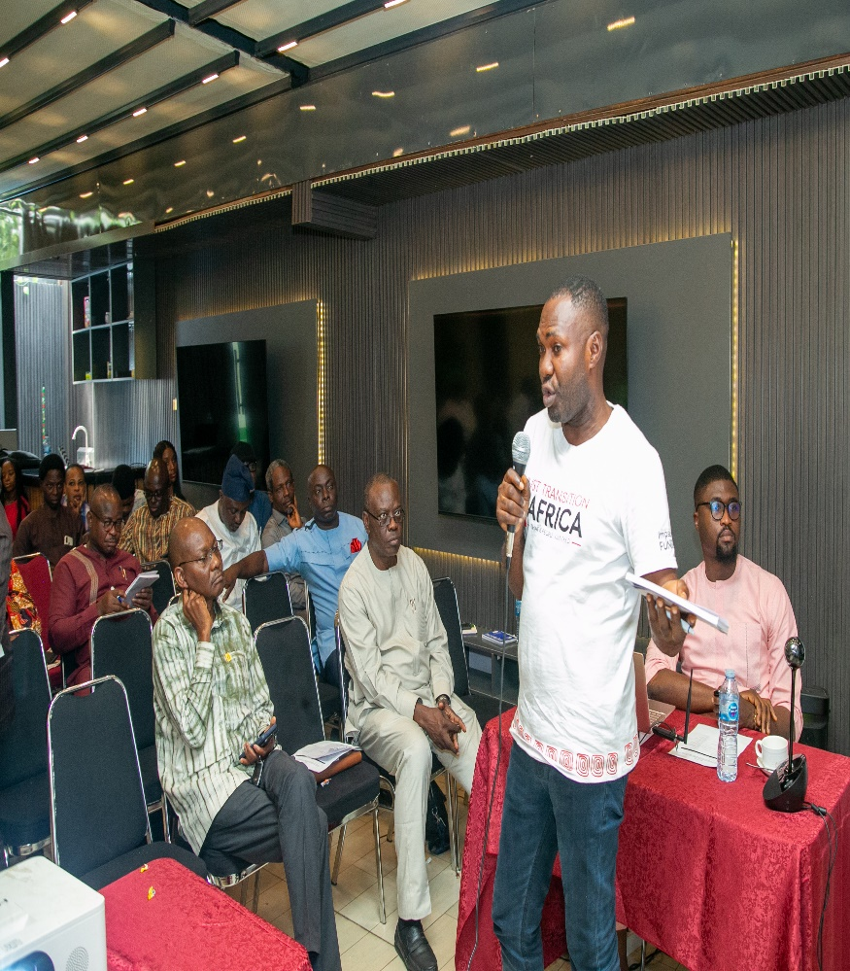
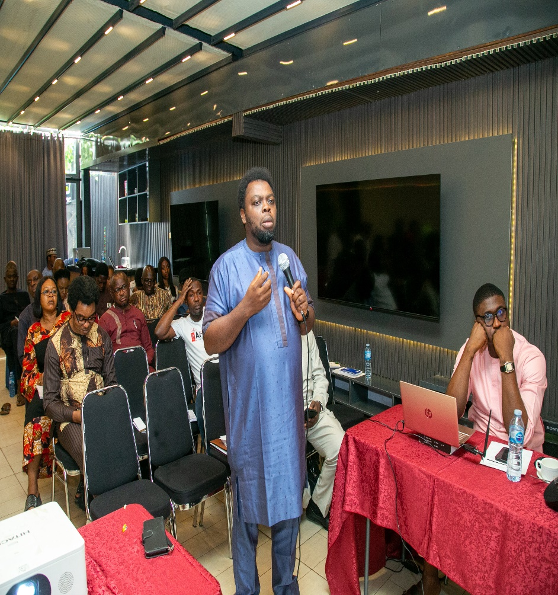
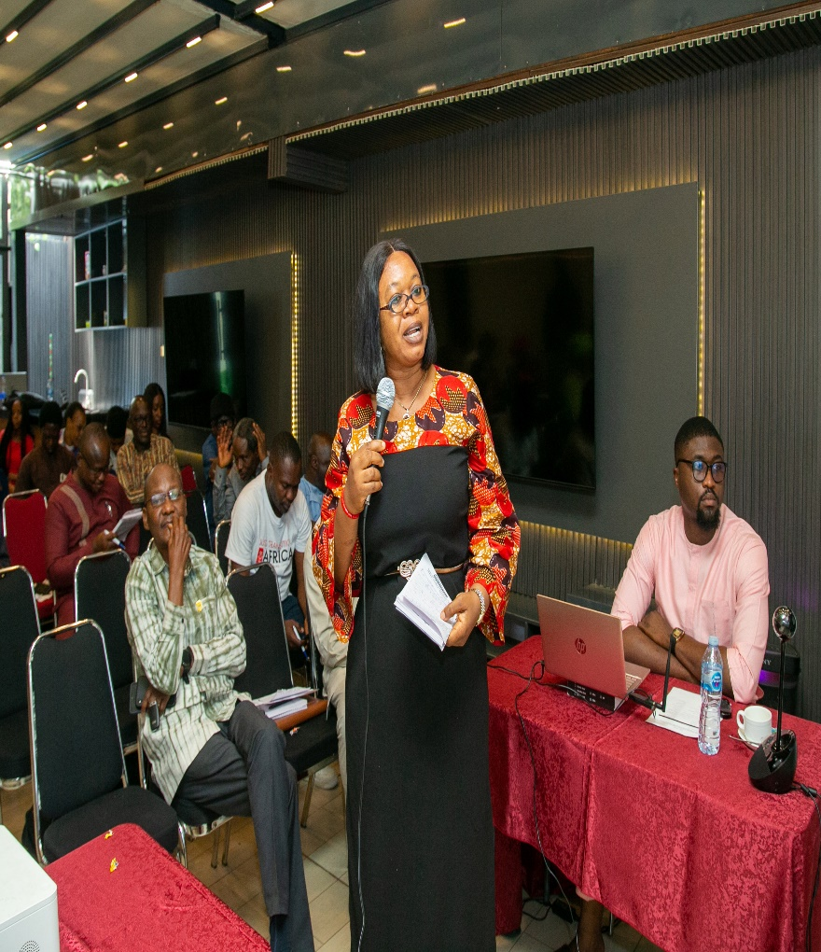
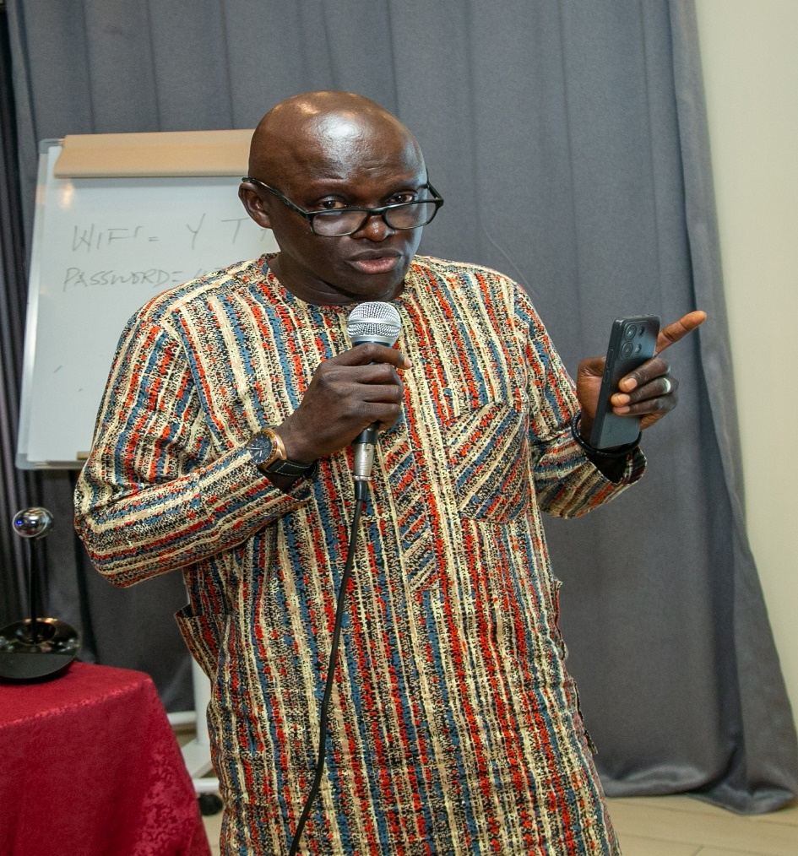
Participants making contributions at the Roundtable

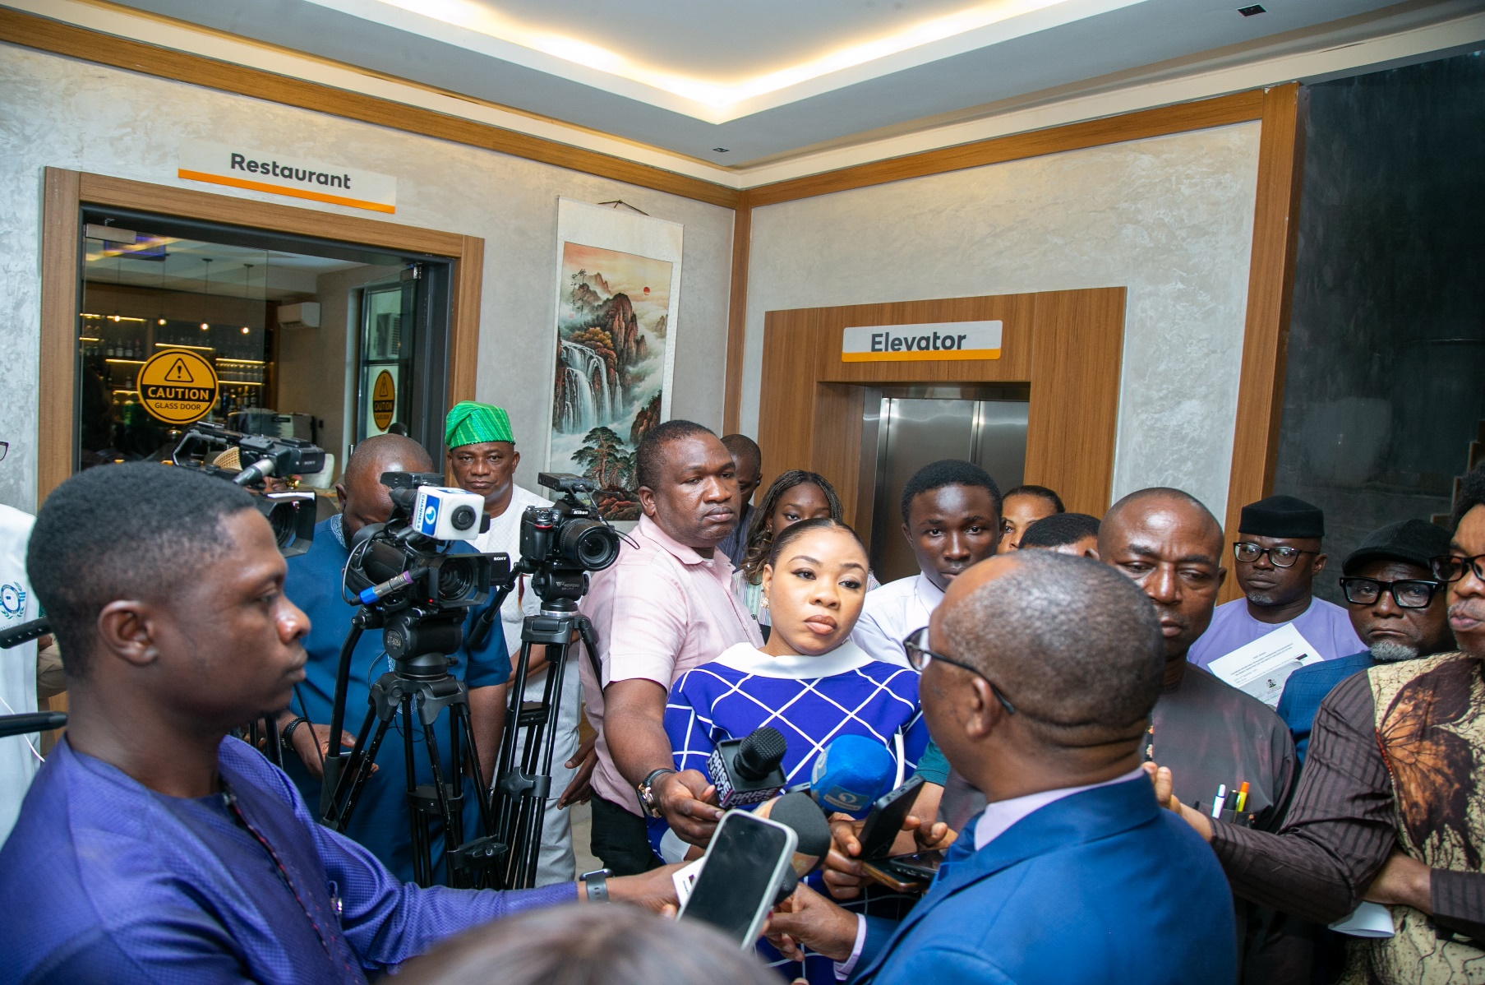
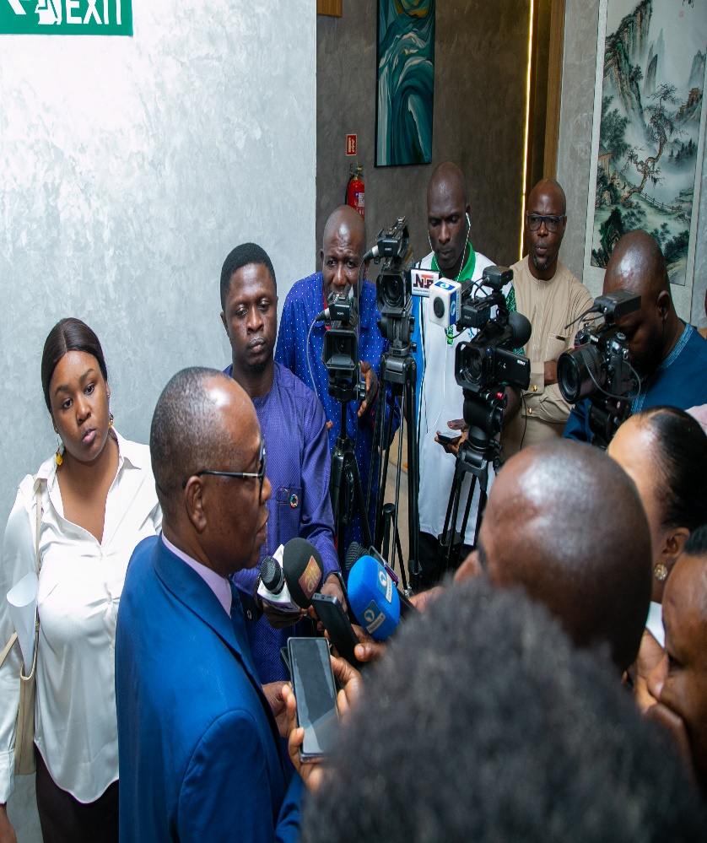
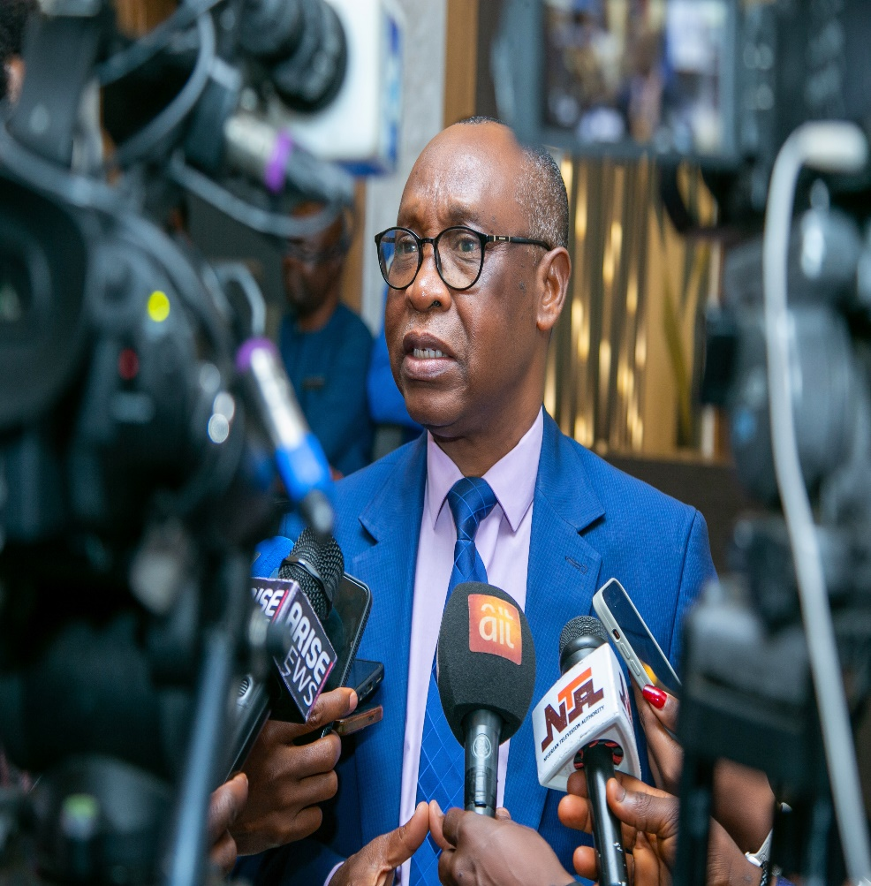
Media Crew Interviewing Dr. Orjo Ogbonnaya Orji, Executive Secretary, NEITI.

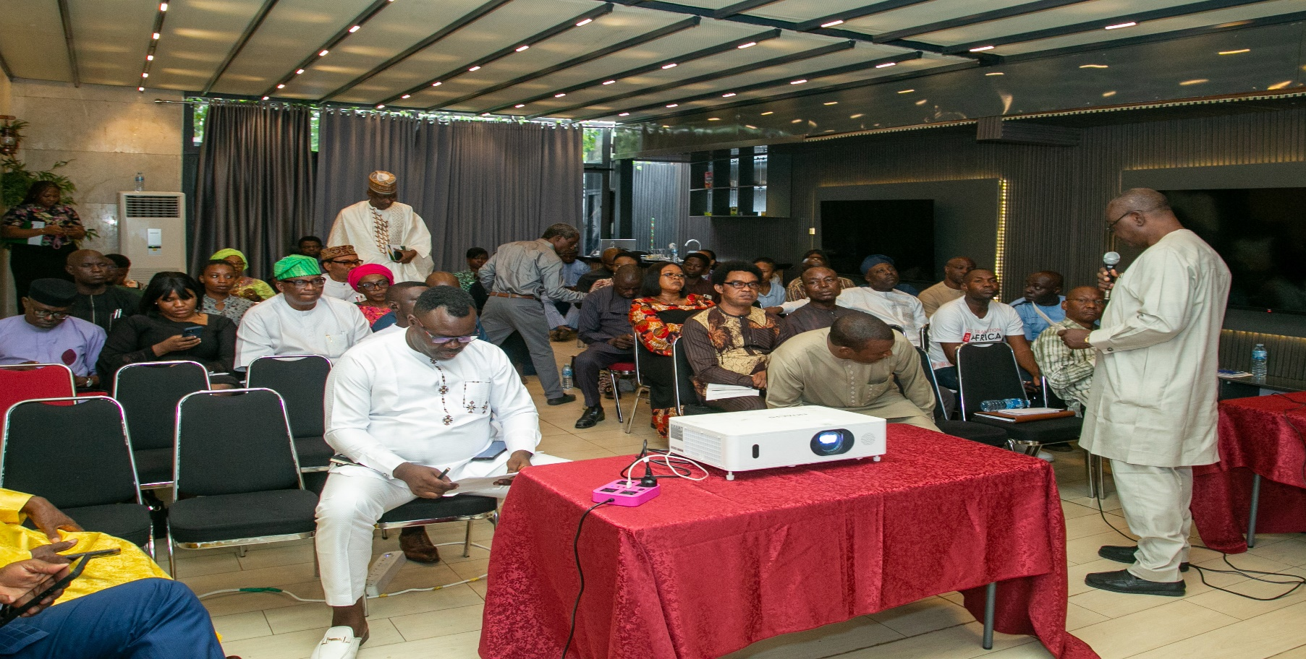
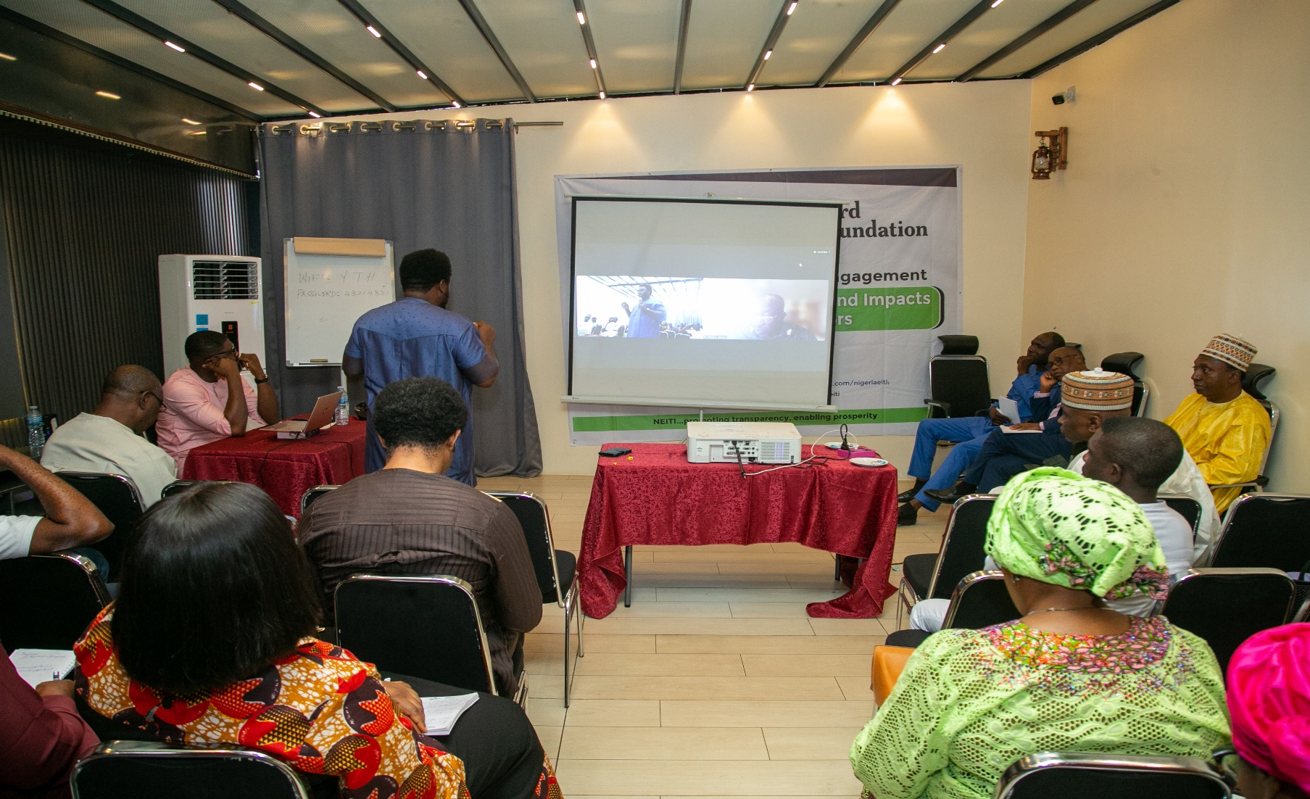
Event ongoing at Yellow Trumpet Hotel, Wuse II, Abuja

