CAPACITY BUILDING FOR RELEVANT GOVERNMENT INSTITUTIONS, MINERS, CSOS & MEDIA ON NEITI STANDARDS FROM 8TH -9TH OF DECEMBER 2025 AT CRISPAN HOTEL JOS PLATEAU STATE, NIGERIA
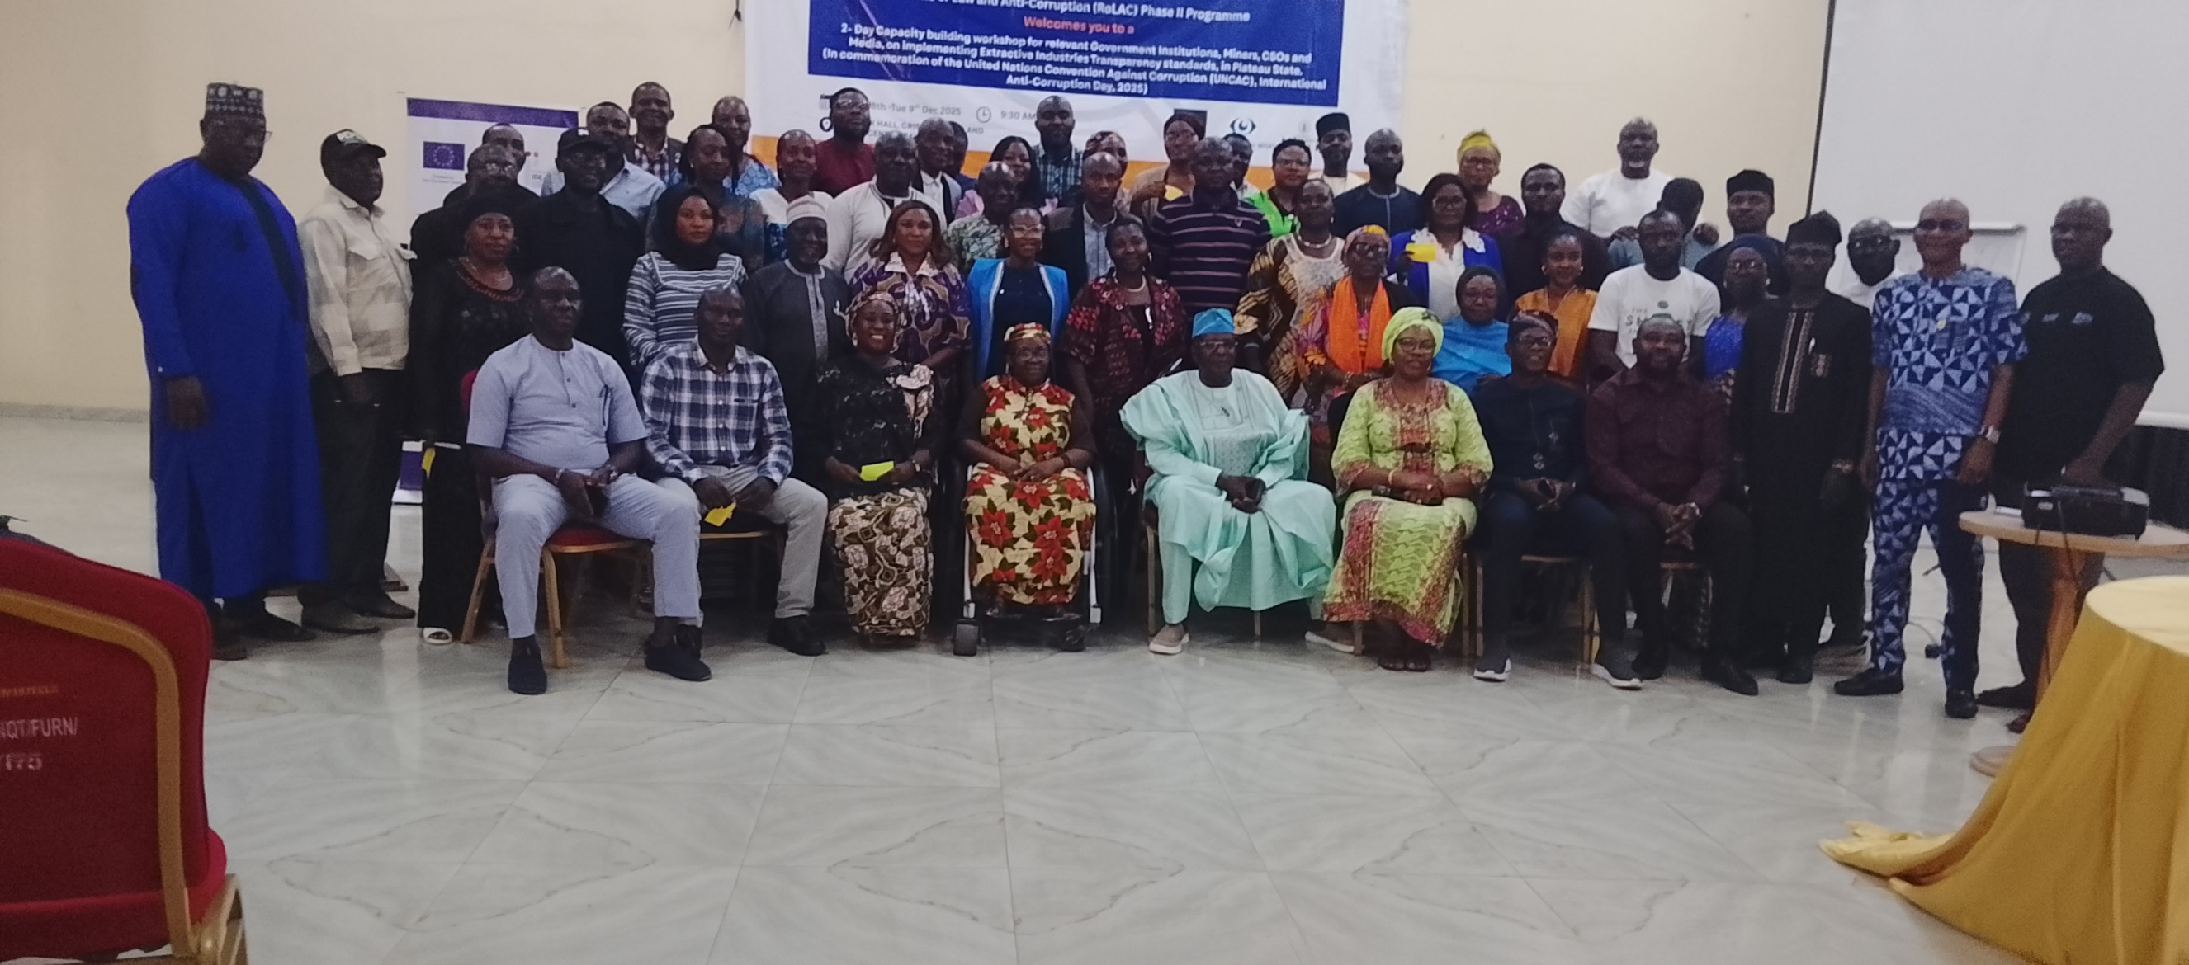

Implementing Programme: Rule of Law and Anti-Corruption (RoLAC II) Programme
Partners: PWYP Nigeria, NEITI, Plateau State OGP Team

DECEMBER 2025

BACKGROUND
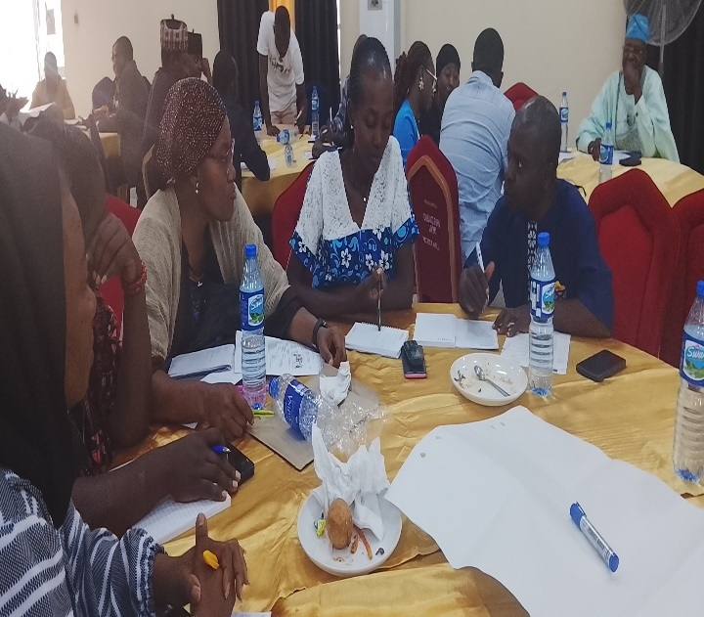
Plateau State has demonstrated strong commitment towards institutionalizing transparency, accountability, and efficient governance systems, particularly within its extractive sector. This commitment was reinforced during a recent high-level engagement with the Executive Governor of Plateau State, which resulted in the formulation of the Plateau State Transparency and Accountability Strategy (PLASIAS). The strategy seeks to reinforce the culture of probity, ethical governance, and transparent administration across both public and private institutions.
A key pillar of PLASIAS is the improvement of the State’s Ease of Doing Business environment, emphasizing predictable regulatory frameworks for business registration, operations, and exit. This initiative is especially critical for the extractive industry, where Plateau State holds significant mineral deposits including copper, iron ore, tin, columbite, and other strategic solid minerals. According to the NEITI 2022/2023 Solid Minerals Resource Audit Report, Plateau State ranks among the highest in deposits of renewable energy minerals in Nigeria.
However, the extractive sector in Plateau State faces persistent challenges, notably:
- Weak institutional oversight of mining operations
- Noncompliance with environmental and social safeguards
- Informal and illegal mining activities
- Diminished Internally Generated Revenue (IGR) due to leakages
- Escalating insecurity associated with uncontrolled mining sites
These issues have contributed to Plateau State’s declining fiscal health. The NBS 2023 IGR Report ranked Plateau State 23rd out of 37 states, while the BudgiT State of States Report (2025) placed the state at 31st of 35 states, indicating the urgent need for reforms.
The current administration has taken initial bold steps, including the February 2025 suspension of mining operations pending the verification and registration of all mining companies. This demonstrates political will to restore order and transparency in the sector.
In alignment with these efforts, the Rule of Law and Anti-Corruption (RoLAC II) Programme which focuses on strengthening the rule of law, anti-corruption frameworks, public procurement, and extractive industry governance organized a two-day capacity-building workshop for state and non-state actors in Plateau State. This intervention aims to enhance coordination, improve knowledge of NEITI standards, and facilitate the adoption of transparent practices in managing the extractive sector.

DESCRIPTION OF THE ACTIVITY
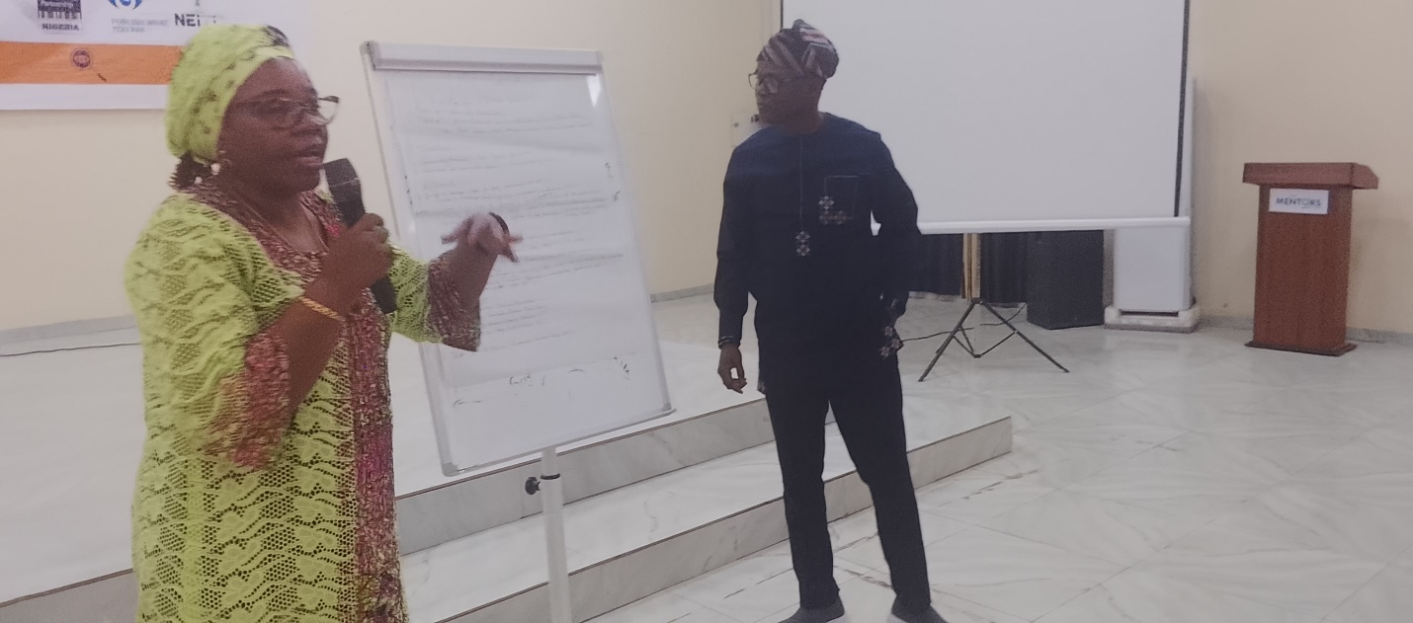The two-day activity was designed as a technical yet practical knowledge-exchange platform, bringing together:
- State Ministries, Departments, and Agencies (MDAs)
- Local Government Authorities
- Miners’ associations
- Civil Society Organizations (CSOs)
- Media practitioners
- Extractive governance advocates
- Plateau State OGP Secretariat
- Representatives from NEITI and PWYP

Day 1: Foundations of Transparency in the Extractive Sector
Day 1 focused on building foundational knowledge on the potential gaps and challenges of mining on the Plateau and as well as the global and national frameworks guiding extractive industry governance. Facilitators delivered interactive sessions on:
- Evolution of mining on the Plateau
- Potential mineral resources in Plateau state.
- Gaps as well as challenges in the mining sector in Plateau state
- Overview of NEITI Mandate and Global EITI Standards
- Extractive Governance Terminology and Regulatory Frameworks
- Legal Provisions for Solid Minerals Development in Nigeria
- Transparency Mechanisms in Licensing, Production, Revenue, and Contract Disclosure
The day featured practical demonstrations using real data from NEITI’s solid minerals audit reports and case studies from other states such as Kaduna, Edo, and Cross River.

Day 2: Practical Approaches and Adoption of NEITI Standards
Day 2 focused on applicable methods for strengthening transparency, accountability, and oversight in Plateau State:
- Roles of State and Non-State Actors in Strengthening Accountability
- Collaborative approaches for state–non-state coordination
- Identification of local challenges and development of solutions
- Data use for policy analysis and decision-making
- Monitoring and reporting frameworks for community and media watchdogs
- Practical case examples of contract disclosure, community development agreements (CDAs), and environmental compliance
Participants were divided into working groups to develop a Roadmap identifying issues, and key actions needed for Improved Extractive Governance in Plateau State, culminating in the drafting of a session communique outlining agreed-upon steps for implementation.
At the end of the workshop, participants collaboratively produced:
- A Roadmap for Extractive Transparency in Plateau State
- A Communique summarizing commitments, recommended actions, and collaborative pathways for improved sector management

PROGRAM OUTCOME
The activity generated the following outcomes:

a) Improved Knowledge of Extractive Transparency Standards
Participants gained advanced understanding of NEITI standards, global EITI benchmarks, and the legal and regulatory framework guiding Nigeria’s solid minerals sector—including contract transparency, beneficial ownership disclosures, and community engagement obligations.

b) Enhanced Institutional Capacity for Extractive Governance
Government officials, miners, CSOs, and media practitioners strengthened their technical capacity to monitor, analyze, and report mining activities using standardized approaches aligned with NEITI guidelines.

c) Strengthened Coordination and Monitoring Mechanisms
A platform for sustained collaboration among state agencies, civil society, traditional institutions, and the media was established. This will support improved oversight and reduce duplication of efforts.

d) Communique on Improved Extractive Governance in Plateau State
Participants jointly endorsed a communique outlining actionable steps for promoting responsible mining, improving licensing procedures, strengthening monitoring systems, and enforcing compliance with environmental and social safeguards.

e) Comprehensive Documentation of the Event
A detailed activity report including attendance list, facilitators’ presentations, session summaries, participant observations, and photographs was compiled for accountability and knowledge-sharing.

PARTICIPATION
- The Hon. Commissioner Plateau State Ministry of Environment, climate change and mineral development (commissioner, permanent secretary, director or admin director on mineral development)
- Plateau State Internal Revenue Service
- LGAs Authority
- Representatives of CAN and JNI
- Civil Society Organization CSOs representatives
- Plateau State OGP
- PWYP - 3

KEY ACTION STEPS / RECOMMENDATIONS
Participants recommended the following:
- Establish a multi-stakeholder extractive governance working group in Plateau State.
- Integrate NEITI reporting standards into state-level regulatory processes.
- Strengthen the capacity of miners and host communities on environmental compliance and contract transparency.
- Increase the engagement of media in investigative reporting on the extractive sector.
- Conduct quarterly monitoring exercises to assess improvements.
- Provide continuous state–non-state coordination support through the RoLAC II programme.

RECOMMENDATIONS
Participants recommended:
- Establishment of a multi-stakeholder extractive governance working group in Plateau State.
- Continued training for miners, CSOs, and media on transparency tools.
- Integration of NEITI standards into state regulatory processes.
- Strengthening community-based monitoring mechanisms.
- Quarterly monitoring of progress under the newly developed roadmap.
- Increased media engagement in investigative reporting on the mining sector.

CONCLUSION
The 2-day capacity-building workshop successfully enhanced understanding of NEITI standards and strengthened the capacity of state and non-state actors involved in Plateau State’s extractive sector. The collaborative spirit demonstrated by participants has set the foundation for improved governance, increased transparency, and a more accountable and secure extractive environment in Plateau State.
The activity represents a significant step toward implementing the Plateau State Transparency and Accountability Strategy (PLASIAS) and aligns with RoLAC II’s broader objectives of strengthening rule of law and anti-corruption systems in Nigeria.
ACTION PLAN:
S/N | ISSUES IDENTIFIED | KEY ACTIONS NEEDED | TIMELINE | PERSON(S) RESPONSIBLE
1 | Unregulated small-scale artisanal mining sites | Set up framework to regulate ASM and sustain awareness of the inimical effect of ASM in the state | 1st and 2nd quarter of 2026 | Ministries of environment, mines and steel development etc
2 | Revenue losses from the sector | Setting of strong M&E mechanisms/frameworks | ‘’ | Plateau state inland revenue service
3 | Environmental degradation | Review of the EIA reports for environmental audit and enforce compliance | January-December 2026 | CSOs, NGOs, Plateau state ministry of environment
4 | Lack of knowledge on CDAs | Host community townhall sensitization | ‘’ | Ministry of environment, NGOs, CSOs
5 | Institutionalization of the mining sector in Plateau state. | Push for the forming and training of community monitors, and establish a framework for sustainable mining in the state (CDAs, EIAs, Gender, anti-corruption, energy transition, /climate change etc) | 1st quarter of 2026 | RJN, NEITI, OGP Plateau state etc
6 | Data gaps on mining activities, production volumes, environmental and social impacts | Conduct routine due diligence around mining activities in the state | Continuous | Plateau state Burau for Statistics
7 | Lack of transparency and accountability in the sector | Domestication of Plateau state Extractive Industry Transparency Initiative (PLEITI) | 12-48 months | Plateau state Government
8 | Under-aged children at mining site | Sensitization/awareness of the child’s rights act in mining host communities | Continuous | CSOs, Government relevant MDAs
9 | Human rights abuses/violations in host communities | Ensure routine human rights due diligence in host communities | 2nd and 3rd quarter 2026 | CSOs/NGOs, mining companies, National Human Rights Commission

