REPORT ON NEITI COMPANIES FORUM
Introduction And Attendance
The Nigeria Extractive Industries Transparency Initiative (NEITI) Companies Forum was held on 29th June 2026 at Black Diamond Hotel Victoria Island, Lagos state. The event began at 10:30am.
The Forum was convened by the Oil Producers Trade Session (OPTS) and the Miners Association of Nigeria (MAN), in partnership with the Nigeria Extractive Industries Transparency Initiative (NEITI) and funding support from the European Union Rule of Law and Anti–Corruption (ROLAC) programme being implemented by the International IDEA. Over 60 participants drawn from the oil, gas and mining sectors were in attendance.
Opening Session, Remarks and Program Overview.
The Chairman NEITI Companies Forum and Executive Director OPTS, Mr Oghenegwueke Ajaifia spoke on the role and functions of NEITI in the oil and gas sector as it affects the economy. He explained that transparency, efficiency, effectiveness, sustainability and accountability are vital in the oil and gas sector, as it curbs individual interests and promotes collective goals. He also spoke about reporting being a fundamental aspect of EITI and NEITI validation process. Reporting also helps encourage foreign investors to invest in the country as necessary information are easily and readily accessible to the investors and also the citizens. He advised that investors in the extractive sector to take advantage of the energy crisis going on in the middle east as international companies and multinationals are always willing and ready to do business with Africa and Nigeria in particular.
Highlighting recent macroeconomic stability, he observed that sector interventions have successfully restored critical infrastructures resulting in a structural optimisation within the NEITI-Companies Forum.
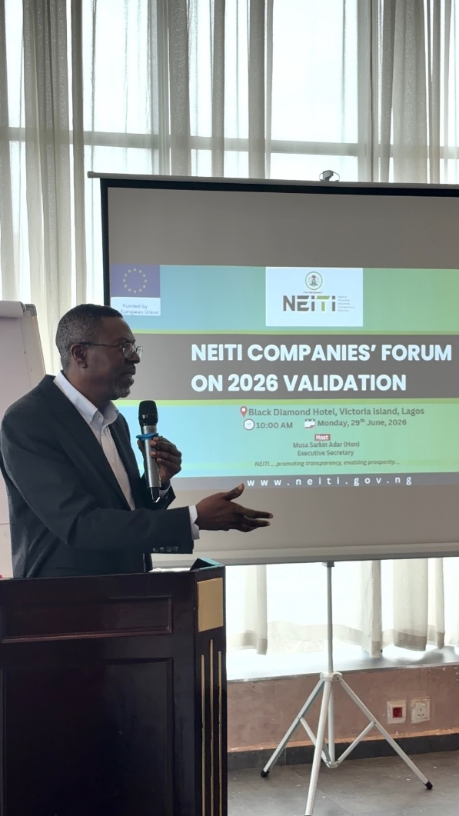
The Chairman, NEITI Companies Forum & Executive Director OPTS, Mr Gwueke Ajaifia, giving the welcome remarks.

Mr Ajaifia urged companies to embrace self-reporting noting that transparency is a key component that amplify companies’ agenda, enhance credibility and promote investment decisions. He asserted that companies can improve transparency and accountability with or without NEITI not just for immediate gain but for the future generation.
The resulting benefits will extend nationwide through increased state revenues, job creation, and the broader stimulation of domestic industries.
He affirmed that “moving forward, the NEITI-Companies Forum must utilize the opportunity created by the platform to drive internal improvements. The forum can significantly enhance its internal and external engagements, fostering deeper interaction with minimal oversight from NEITI.
Remarks by the President Miners Association of Nigeria
The President of the Miners Association of Nigeria (MAN) and the Deputy Chairman of the NEITI Companies Forum on the NEITI NSWG, Mr. Dele Ayanleke, emphasized that the solid minerals sector has emerged as a key driver for Nigeria's economic diversification. He noted that the country's vast mineral wealth is strategically positioned to attract investments, support sustainable growth, and drive employment and industrial development. To further accelerate this progress, Mr. Dele Ayanleke commended the Federal Government's ongoing reforms to reposition the sector, stating that the Miners Association of Nigeria remains an active partner in these changes while continuing to advocate for responsible mining, environmental stewardship, and global best practices.
Mr. Dele Ayanleke explained that central to this structural development is the reinforcement of sector governance. He praised NEITI for consistently promoting openness in revenue collection, contract transparency, and beneficial ownership disclosure, highlighting that its multi-stakeholder engagement has successfully strengthened public confidence across extractive industries.
On the current 2026 EITI Validation, Mr. Dele Ayanleke stated that the exercise is a vital opportunity for Nigeria to demonstrate its commitment to international best practices. He maintained that validation is a reflection of the collective national efforts to reduce corruption risks and ensure mineral resources benefit all Nigerians. Consequently, Mr. Dele Ayanleke reaffirmed the NMA's absolute commitment to complying with statutory reporting obligations by providing timely and accurate information, while stressing the importance of deepening collaboration with regulatory agencies, civil society, and development partners to strengthen transparency throughout the mining value chain.
Speech by the Executive Secretary
The Executive Secretary of NEITI, Hon. Musa Sarkin Adar, announced that Nigeria is prepared for the commencement of the 2026 EITI Validation on July 1st 2026. He emphasized that under the leadership of President Bola Ahmed Tinubu, the Federal Government remains firmly committed to the implementation of the EITI and to strengthening transparency, accountability, and good governance across the nation's extractive industries.
Hon. Adar explained that the extractive companies are indispensable partners in the EITI implementation process, noting that the quality, completeness, and timeliness of corporate disclosures will significantly shape Nigeria's overall performance. To ensure maximum readiness and seamless coordination, he detailed a series of targeted stakeholder engagements conducted by NEITI. These included critical bilateral meetings with sister agencies such as NUPRC, NMDPRA, NNPC Ltd, NRS, and PTDF as well as consultative sessions with civil society organizations, the media, the Inter-Ministerial Task Team, the NEITI National Stakeholders Working Group (NSWG), and international validators.
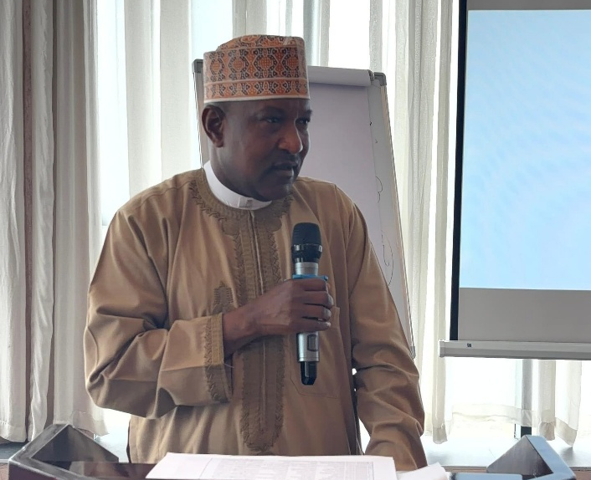
The Executive Secretary NEITI, Hon Musa Sarkin Adar, giving his speech at the NEITI Companies Forum.
The central focus of discussion at the NEITI Companies Forum was the Validation Templates, which Hon. Adar stated is the principal instrument which companies are expected to populate as well as present as evidence of their compliance with the EITI Standard. He urged all participating entities to populate these templates with the highest level of diligence, ensuring that every submission is accurate, evidence-based, and backed by relevant documentation.
In his call to action, Hon. Adar stressed that the success of the 2026 Validation is a shared responsibility divided among government, industry operators, and civil society. He called for stronger support from extractive companies in executing audit recommendations, advancing beneficial ownership transparency, and enforcing revenue accountability, ultimately urging operators to own the documentation process and project a positive global image of Nigeria's natural resource governance.
Technical Sessions
In her presentation on the “Overview of Nigeria’s EITI Validation under the 2023 Standard: Key Findings and Implications for Nigeria”. The Director of the Communications and Stakeholders Management Department (NEITI), Mrs. Obiageli Onuorah, outlined the primary objective of the meeting, emphasizing the critical importance of the validation process for participating companies. Her presentation provided a comprehensive overview of the validation framework, its strategic purpose for Nigeria, and the potential implications of non-compliance.
Mrs. Onuorah highlighted the structural differences between the templates utilized during the 2023 validation cycle (under the 2019 EITI Standard) and the current 2026 cycle (under the 2023 EITI Standard). She noted that the current framework places greater emphasis on transparency, accountability, and anti-corruption measures. Furthermore, the EITI has expanded its requirements regarding stakeholder engagement, placing increased scrutiny on the active participation of all stakeholders, specifically corporate entities.
The Director of the Policy, Planning & Strategy Department (NEITI), Dr. Dieter Bassi, alongside, the Executive Director of the Centre for Transparency Advocacy (CTA) and the former EITI and NEITI Board member, Mrs. Faith Nwadishi co-facilitated a presentation on the Review of Nigeria’s Validation Templates: Companies Feedback. A Stakeholder Template (Component B – Stakeholder Engagement, Requirements 1.2 and 1.4 a(i)).
Mrs. Nwadishi reviewed the core objectives of the component, which aim to evaluate corporate roles, identify gaps in company engagement, and establish mechanisms to address these deficiencies. To optimize this process, she advanced the following strategic recommendations:
- Outreach and Capacity Building: The NEITI-Companies Forum should organise targeted outreach programs for members and broader stakeholder groups. This capacity-building measure is designed to improve reporting quality.
- Corporate entities are advised to designate an EITI Focal Person possessing deep institutional knowledge of EITI principles to oversee template completion. This measure is designed to also improve reporting quality and institutional feedback loops.
- Institutional Alignment: Companies should develop joint initiatives with the NSWG to identify operational gaps and actively involve industry associations in EITI processes. Furthermore, member companies are encouraged to leverage the EITI International Companies’ Association by formally registering through the NEIT-Companies Forum.
- Policy and Reporting Compliance: Corporate policy departments must review internal anti-corruption frameworks and institute post-event reporting that documents active EITI engagement. Entities must provide verifiable evidence demonstrating that stakeholders were engaged during company-led events where EITI standards were cited. Companies must also ensure strict alignment between internal corporate reporting, EITI standards, and national regulations.
- Operational Recommendations for OPTS: The Oil Producers Trade Section (OPTS) should integrate dedicated EITI sessions into broader oil and gas conferences.
- Additional recommendations include conducting intensive two-day EITI training seminars for companies, designating advanced-trained desk officers to monitor EITI frameworks, implementing internal tracking systems, and training corporate communications staff on EITI reporting protocols.
Data Collection and Template Validation Requirements
Dr. Dieter Basi led the session on executing the EITI validation template regarding corporate engagement. The session aimed to present preliminary data compiled from NEITI’s technical repositories to industry stakeholders for verification, endorsement, and supplementary data provision.
To complete this exercise, Dr. Basi requested the leadership of the Companies Forum to provide NEITI with a directory of personnel familiar with the validation process. Additionally, corporate entities are to validate the required, key evidential documentation covering the 2024–2026 period, including:
- Minutes and documentation of Host Communities Trust Fund meetings.
- Minutes and documentation of Community Development Stakeholders (CDS) meetings.
- Verifiable documentation of at least one Corporate Social Responsibility (CSR) initiative.
- Current corporate Anti-Corruption Policies.
Nominations for Sectoral Coordination
To facilitate seamless data collection and sectoral coordination, the following representatives volunteered to lead the collation efforts for their respective industries:
- Oil and Gas Sector: Mr. Babatunde Oni, Senior Legal Adviser, SEPLAT Energy Plc.
- Mining Sector: Engr. Shittu Wasiu Akinwole, Assistant General Manager (Quarry), BUA Group.

Recommendations and Next Steps for Companies’ Forum
The Chairman NEITI Companies Forum and the Deputy Chair, put forward the following recommendations to improve the processes of the NEITI Companies Forum:

- The current biannual scheduling of the Companies Forum should be upgraded to a quarterly framework to enhance institutional outreach and maintain continuous policy dialogue.
- To resolve significant inconsistencies in corporate representation identified between 2023 and 2026, standardized membership protocols will be enforced. This will eliminate governance gaps that previously necessitated direct, independent data reconciliation requests from the EITI International Secretariat to individual corporate entities.
- All participating corporate entities must systematically submit comprehensive documentation regarding their Corporate Social Responsibility (CSR) initiatives, Community Development Agreements (CDAs), and Community Development Trusts (CDTs) to NEITI to ensure verified transparency in subnational social investments.
- A comprehensive administrative reorganization will commence, anchored on the formalization of a Company’s Forum Act. This framework will culminate in the establishment of a dedicated, permanent Companies Forum Secretariat to independently manage operations, optimize data collection, and oversee stakeholder relations.
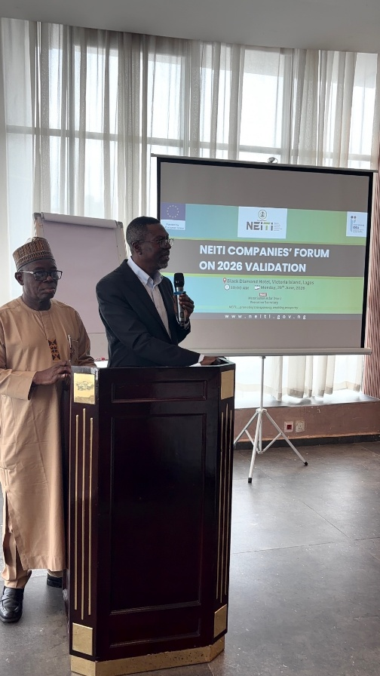
The Chairman and Deputy Chairman NEITI Companies Forum presenting their recommendation and call to actions for the Forum.

Closing
The South-West Zonal Representative of the NEITI Board, Mr. Abdel-Jeleel Olasupo, gave the vote of thanks, thanking all participants for attending. The event ended at 4:00pm.

Cross section of the participants at the NEITI-Companies Forum
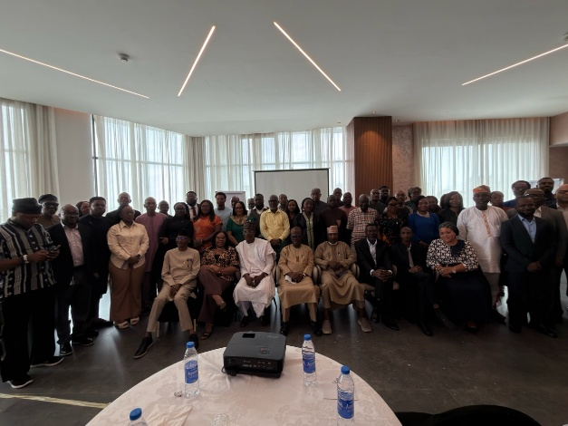
Group Photograph of participants at the NEITI Companies Forum
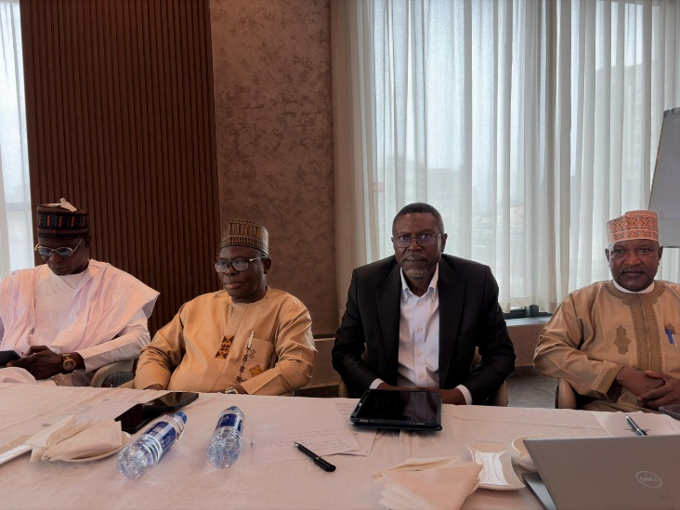
The South-West Zonal Representative on the NSWG, Mr. Abdel-Jeleel Olasupo, the Deputy Chairman, NEITI Companies Forum and President of Miners Association of Nigeria (MAN), Mr Dele Ayanleke, The Chairman, NEITI Companies Forum and Executive Director, Oil Producers Trade Section (OPTS), Mr Oghenegwueke Ajaifia and the Executive Secretary, NEITI, Hon Musa Sarkin Adar at the NEITI-Companies Forum.

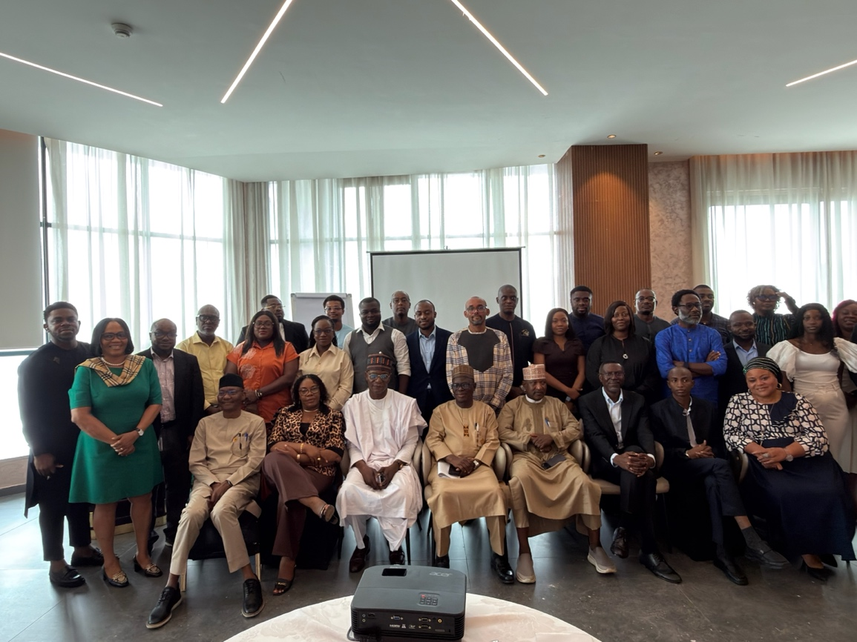
Cross section of the Key speakers and the Oil and Gas Companies Representatives
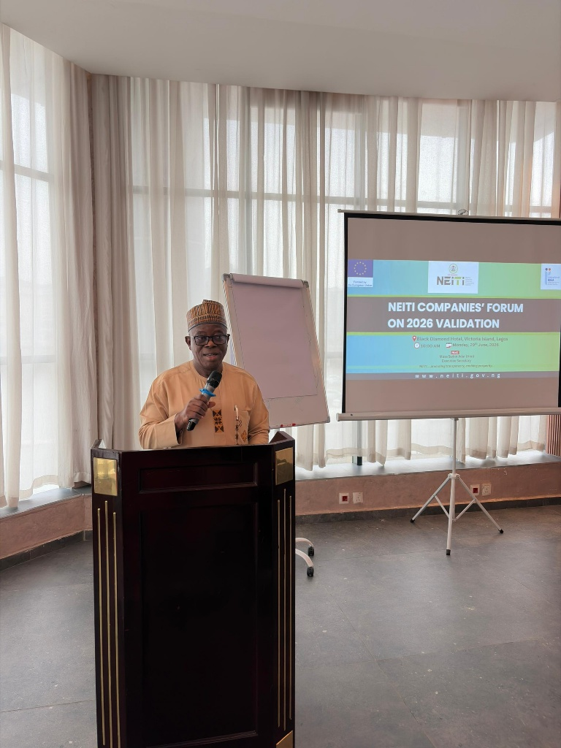
The Deputy Chairman and President Miners Association of Nigeria (MAN), NEITI Companies Forum, Mr. Dele Ayanleke delivering his welcome remarks.

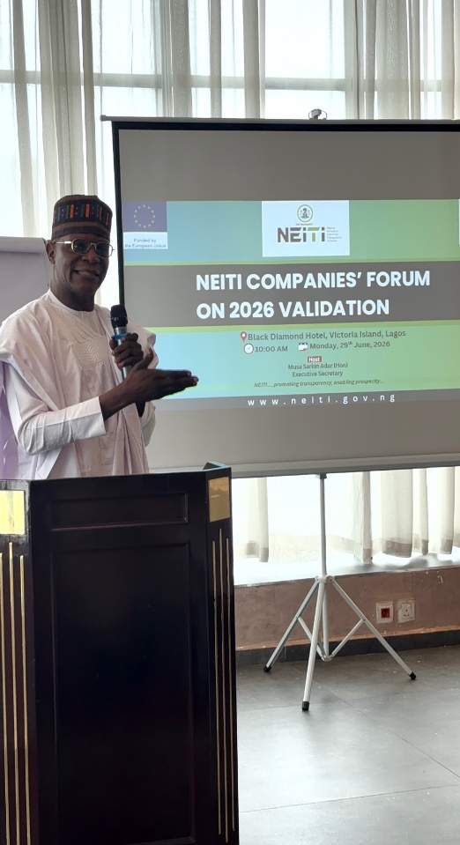
The South-West Zonal Representative on the NEITI NSWG, Hon. Taiwo Olasupo, giving his remarks.

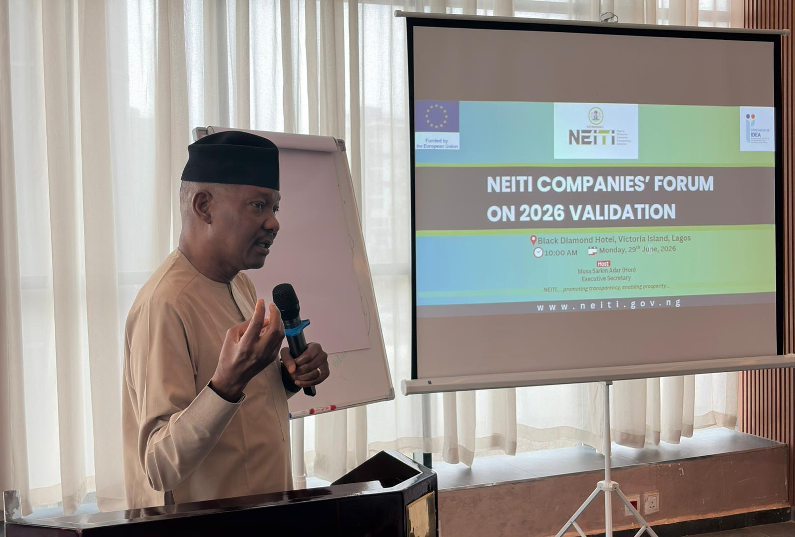
The Director Policy Planning and Strategy Department, NEITI, Dr Dieter Bassi taking the Technical Session on the Validation Template.

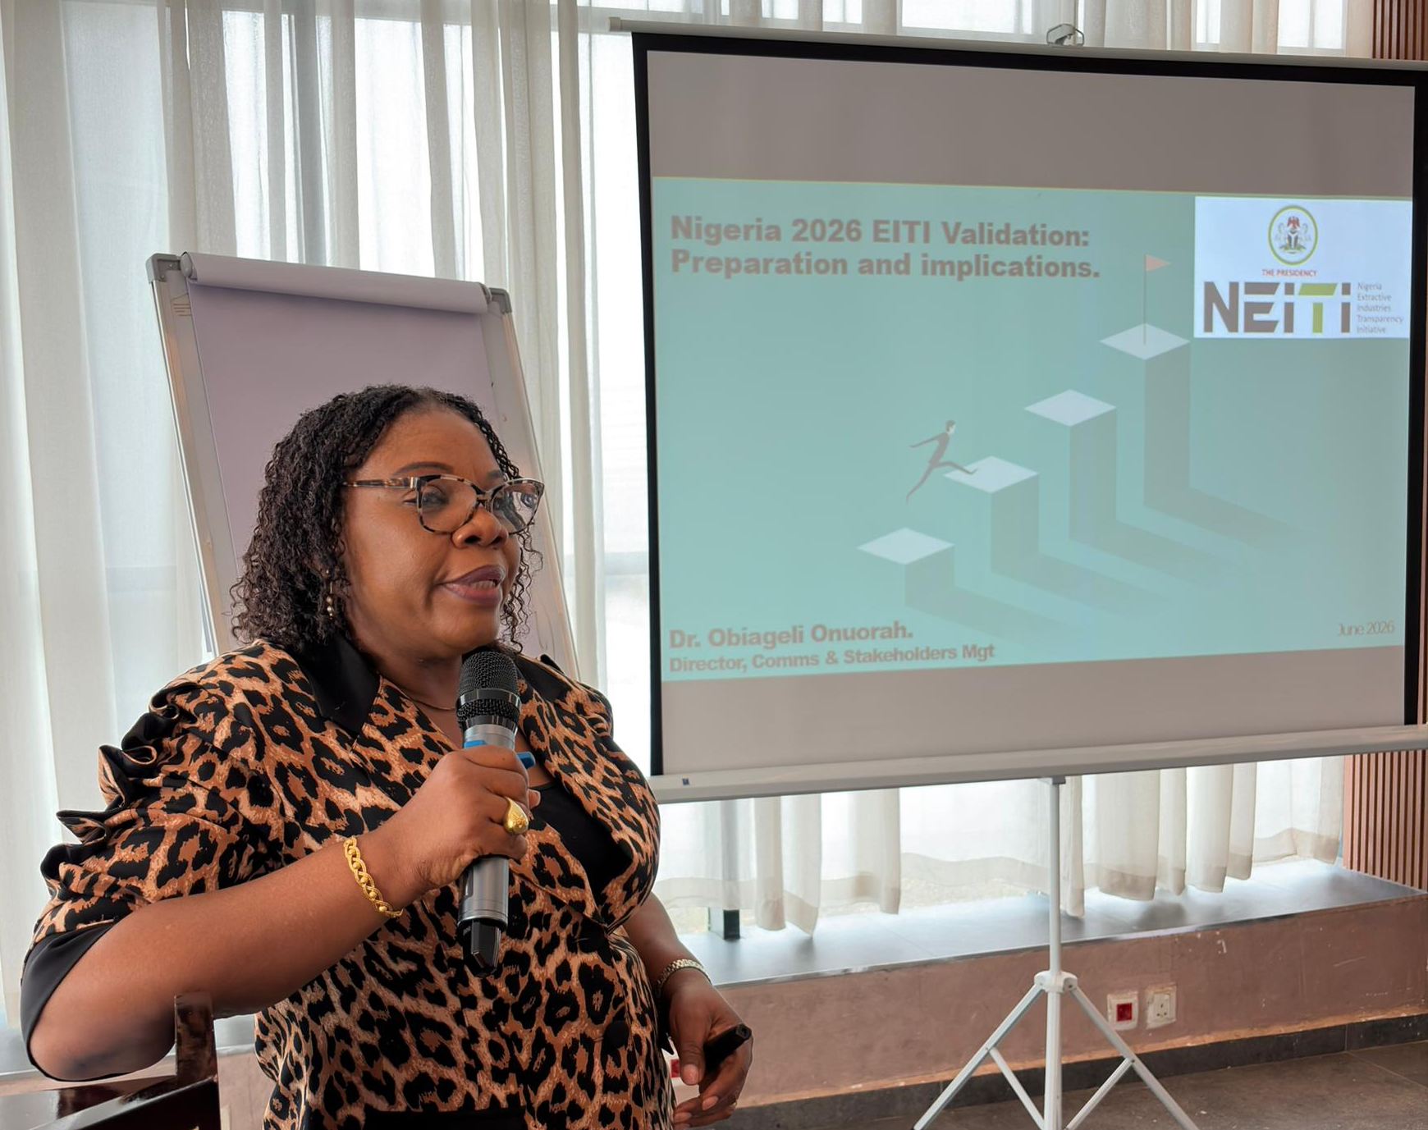
The Director, Communications and Stakeholders Management Department, NEITI, Mrs Obiageli Onuorah delivering a presentation.
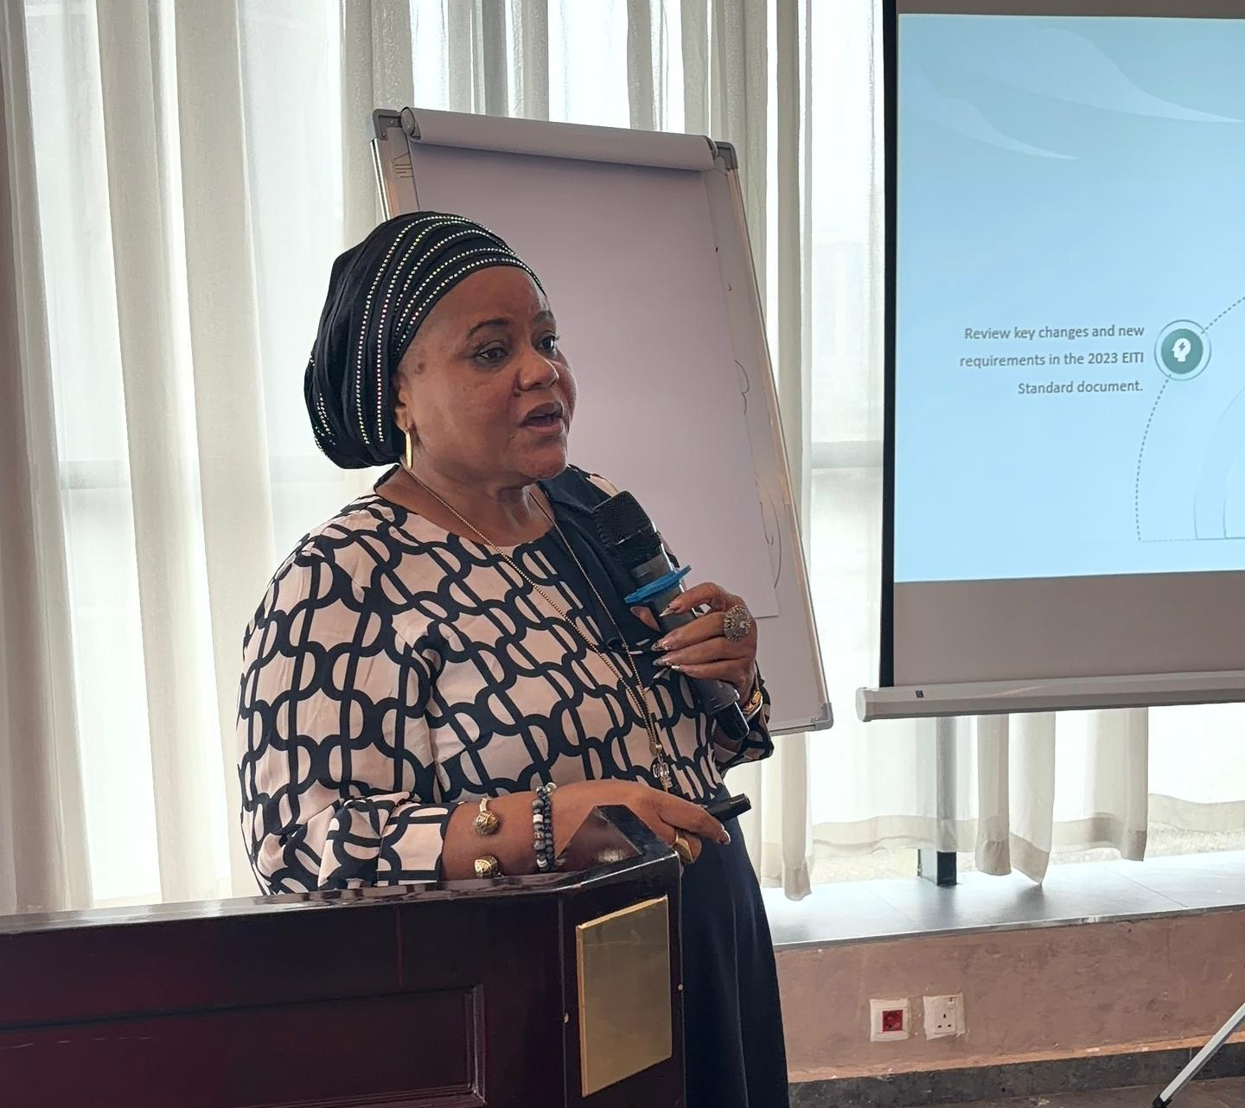
The Executive Director, Center for Transparency Advocacy (CTA), Mrs Faith Nwadishi during her presentation.

Attendees included representatives from key oil gas and mining organizations such as SEPLAT Energy PLC, BUA Cement, Shoreline Natural Resources, Renaissance Africa Energy company limited, Nigeria National Petroleum Company Limited (NNPCL), TotalEnergies EP Nigeria Limited, Heirs Energies, Dangote Cement Plc, Sizhe global Nigeria Limited, Ilera Mines Limited.
The National Stakeholder Working Group (NSWG) present were:
- The Chairman NEITI Companies Forum and Executive Director Oil Producers Trade Section (OPTS), Mr Oghenegwueke Ajaifia.
- The Deputy Chairman NEITI Companies Forum and President of Miners Association of Nigeria (MAN), Mr Dele Ayanleke.
- The South-West Zonal Representative, Mr. Abdel-Jeleel Olasupo.
- The Executive Secretary, NEITI, Hon Musa Sarkin Adar
Other key speakers include, former Board Member of the Extractive Industries Transparency Initiative (EITI) and NEITI, Mrs. Faith Nwadishi. Dr Obiageli Onuorah, Director Communications and stakeholders Management, Dr Dieter Bassi (Mni) Director, Policy Planning and strategy, NEITI and the Assistant Project Officer on Anticorruption at RoLAC, Mohammed Sani Kassim.
The Rule of Law and Anti-Corruption (RoLAC) program of the International Institute for Democracy and Electoral Assistance (International IDEA) provided support for the logistics component of the programme.
The event was moderated by the Deputy Director Communications and Stakeholders Management Department, NEITI, Mr Chris Ochonu.

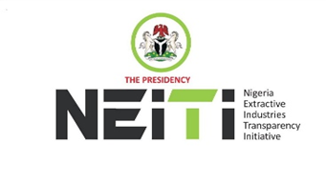
NEITI-COMPANIES FORUM
THEME: ENGAGEMENT ON 2026 EITI VALIDATION
DATE: 29th June 2026
TIME: 10am
VENUE: Black Diamond Hotel, Victoria Island, Lagos.
AGENDA
TIME | ACTIVITIES | RESPONSIBLE PERSONS
9.00-10.00 | Arrival & Registration | All Participants
10:00-10:00 | 3rd Stanza of the National Anthem | All Participants
10.00-10.15 | Introduction of Guests | Facilitator
10:15-10:25 | Welcome Remarks | Mr. Gwueke Ajaifia, Chair NEITI Companies Forum (Oil & Gas)
10: 25 – 10: 35 | Opening Remarks by the Deputy Chair | Mr. Dele Ayanleke, Deputy Chair NEITI-Companies Forum (Mining)
10:35- 10:50 | Speech by the Executive Secretary | Hon. Musa Sarkin Adar  Executive Secretary, NEITI.
10:50- 11:20 | Tea break
11:20-12:00 | Presentation 1:  Overview of Nigeria’s EITI Validation under the 2023 Standard: Key Findings and Implications for Nigeria | Dr. Obiageli Onuorah. Director, Communications and Stakeholders Management, NEITI
12:00-12:20 | Interactive session | All Participants
12:20- 14:00 | Presentation 2:  The Review of Nigeria Validation Templates: Companies Feedback. | Dr Dieter Bassi Mni Director, Policy Planning and Strategy, NEITI  Ms Faith Nwadishi, Former EITI Board Member and Former Representative of Civil Society on the NSWG
14:00-14:20 | Interactive session | All Participants
14:20-15:00 | Next Steps:  Roadmap for stronger Companies participation and engagement. | Mr. Gwueke Ajaifia, and Mr Dele Ayanleke, Chair and Deputy Chair NEITI-Companies Forum
15:00-15:10 | A.O.B | All Participants
15:20-16:30 | Closing Remarks: Summary of Key Decisions and Call to Action | Executive Secretary of NEITI, Hon Musa Sarkin Adar and Chairman, NEITI- Companies Forum. Mr. Gwueke Ajaifia.
16:30 | End of Meeting | All Participants

