REPORT ON THE CSO/MEDIA ENGAGEMENT ON THE 2026 NIGERIA’S VALIDATION
Dates: 24th June 2026
Venue: Rockview Royale Hotel, Abuja
Attendance: 90 Participants
The Engagement commenced at 10:40am
Introduction
The CSO/Media Engagement on 2026 Nigeria’s Validation was convened by the Nigeria Extractive Industries Transparency Initiative (NEITI) with funding support from the Rule of Law and Anti-Corruption (RoLAC) programme of the International Institute for Democracy and Electoral Assistance (International IDEA).
At the programme, diverse representatives from key civil society organizations (CSOs) and media, such as Policy Alert, Resource Justice Network Nigeria (RJNN), Human and Environmental Development Agenda (HEDA), Socio-Economic Research and Development Centre (SERDEC), Concert for Civic Dialogue and Good Governance (CCIDESOR), Civil Society Legislative Advocacy Center(CISLAC) ThisDay, Vanguard, Channels Television, Federal Radio Corporation of Nigeria (FRCN), Mediatracnet, Extractive 360, Leadership and Nigerian Television Authority (NTA) were in attendance.
The event was moderated by the Deputy Director of the Communications and Stakeholders Management Department at NEITI, Mr. Chris Ochonu.
Opening Session, Remarks and Program Overview
The chief host, the Civil Society representative on the NEITI National Stakeholders Working Group (NSWG) and Coordinator of the Resource Justice Network Nigeria (RJNN), Dr. Erisa Danladi, introduced the dignitaries present. Notable attendees included the South-South zonal representative, Dr. Leo Akpan, representing the NEITI NSWG Chairman, Senator George Akume alongside the NEITI Management and members of the NEITI Validation Committee.
Dr. Danladi delivered the opening remarks. She emphasized that the validation process is an opportunity for learning, reflection, and strengthening transparency and governance within Nigeria's extractive sector. Dr. Erisa Danladi highlighted that independent and meaningful civil society participation is essential to the credibility of the EITI process.
Her speech acknowledged Nigeria's progress in producing credible reports, advancing beneficial ownership disclosures, and promoting contract transparency. Civil society organizations have driven these achievements through research, advocacy, and monitoring NEITI recommendations. However, critical challenges persist, including the need to deepen subnational and community engagements, improve data accessibility, implement audit recommendations, and enhance transparency in the solid minerals sector. Additionally, protecting and expanding a vibrant civic space remains vital for effective governance. To address these issues, she called for:
- Stronger mechanisms to implement NEITI recommendations alongside robust follow-up actions by relevant government institutions.
- Expanding community-level engagement and domesticating NEITI processes across states.
- Need for sustained capacity strengthening, improved access to information, and meaningful engagement opportunities for civil society.
- Greater transparency in the solid minerals sector is required specifically regarding licensing, beneficial ownership, contract disclosure, and environmental compliance. Finally, she urged deeper collaboration among government, industry, and civil society stakeholders to advance sustainable resource governance.

Remarks by the Executive Secretary NEITI
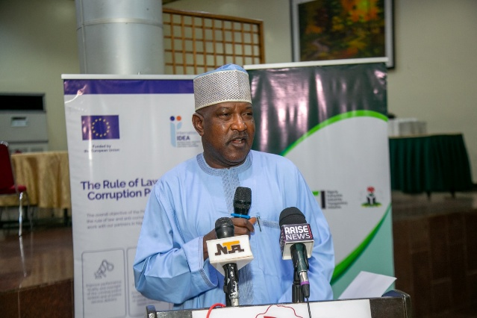
Executive Secretary of NEITI, Hon. Musa Sarkin Adar, giving his remarks
The Executive Secretary of NEITI, Hon. Musa Sarkin Adar while delivering his remarks stated that his primary objective is to position Nigeria as a globally recognized international partner by ensuring that there is transparency and accountability in the extractive sector. He emphasized that the administration of President Bola Ahmed Tinubu is deeply committed to this goal.
He explained that ahead of the official commencement of the 2026 Nigeria’s EITI Validation on July 1, 2026, NEITI has held strategic bilateral meetings with the EITI International Secretariat and critical sister agencies, including NMDPRA, NNPC Ltd, NUPRC, and NRS, to review timelines and improve coordination.
Furthermore, to improve transparency, he stated that NEITI will expand its reporting scope to feature subnational data. He outlined a targeted timeline of preparatory engagements, including the civil society and media sessions, the NSWG template approval meeting and the NEITI Companies Forum that will take place in Lagos in the coming days ahead of the EITI validation task team's arrival in August, 2026.
Hon. Adar called on civil society organisations and the media to serve as EITI ambassadors and actively own Nigeria's validation process by making direct inputs into the validation templates. He charged these groups with tracking the implementation of audit recommendations, monitoring institutional disclosures, and sustaining public engagement around beneficial ownership transparency. Finally, he stressed the importance of projecting a positive image of Nigeria during the validation period and beyond to secure a successful outcome for the nation.
Remarks by EU-IIDEA
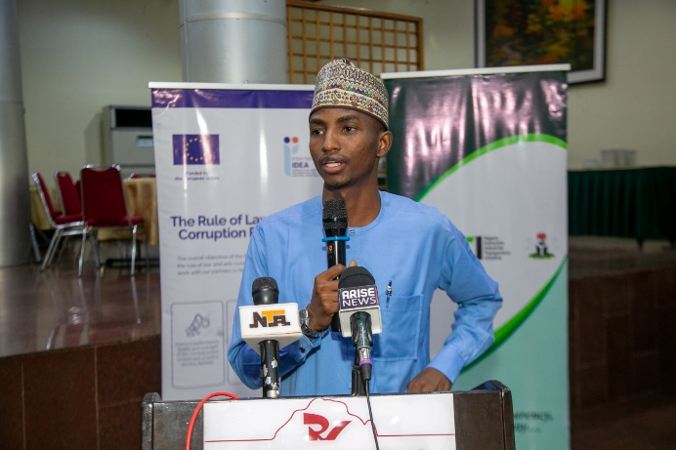
Associate Program Officer of RoLAC, Mr. Muhammad Sani Kassim giving a goodwill message
The Associate Program Officer of RoLAC, a programme of EU-IIDEA, Mr. Muhammad Sani Kassim while delivering a goodwill message on behalf of RoLAC highlighted three core programs being implemented by RoLAC to support Nigeria’s anti-corruption efforts.
He introduced the Ending Sexual and Gender-Based Violence (ESGBV) program, which supports the government's response to gender-based violence, noting that IIDEA aims to collaborate with the civil society and media constituencies to advance this cause.
Mr. Kassim recognized the EITI's foundational co-creation principle as a vital mechanism for improving democracy and extractive resource governance. He stressed the importance of these engagements and urged stakeholders to continually advocate for greater diversity within the EITI process.
Remarks by the Rep of the SGF and Chairman of the NSWG.
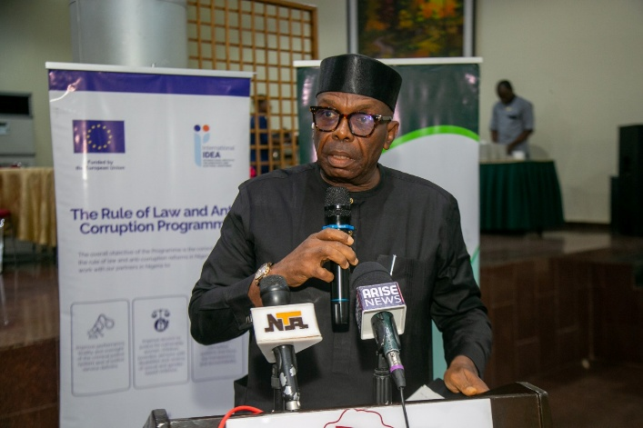
South-South zonal representative on the NEITI NSWG, Dr. Steve Akpan, giving an opening remark.
The South-South zonal representative on the NEITI NSWG, Dr. Steve Akpan, delivered an opening remark on behalf of the Chairman of the NEITI National Stakeholder Working Group (NSWG) and Secretary to the Government of the Federation, Senator George Akume. He stated that the engagement was crucial for the civil society to validate the NSWG submissions contained in the EITI validation templates. He noted that the NSWG is actively working to ensure Nigeria emerges stronger, adopts key learnings, and delivers tangible benefits to its citizens using the the EITI Validation as a tool for improved extractive sector governance.
Dr. Akpan highlighted that a request for an extension of the validation timeline had been declined, making the upcoming week critical. He stressed the importance of immediate, unified action and pleaded for strengthened cooperation between NEITI, civil society organizations (CSOs), and the media. Acknowledging these groups as vital pillars of the validation process, he reaffirmed the Board’s commitment to supporting Civil Society and the media to ensure their contributions remain impactful.
Dr. Akpan concluded by expressing appreciation to the Rule of Law and Anti-Corruption (RoLAC) programme for their continued support, while calling for active, high-level participation from all stakeholders to secure a successful validation outcome for the nation.
Technical Presentations and Validation Template Session
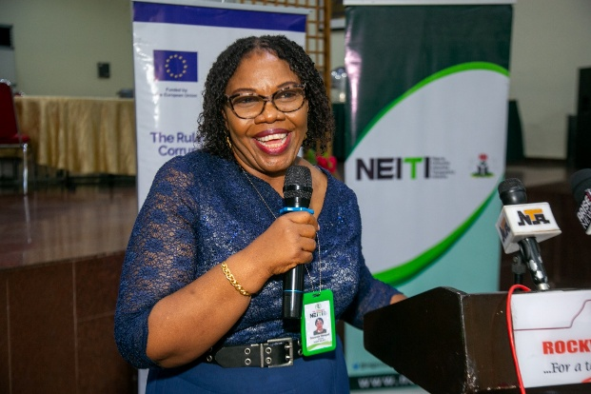
Director of Communications and Stakeholders Management at NEITI, Mrs. Obiageli Onuorah, delivering her presentation
The Director of Communications and Stakeholders Management at NEITI, Mrs. Obiageli Onuorah, delivered the first presentation, titled “Overview of Nigeria EITI Validation under the 2023 Standard: Key Findings and Implications for Nigeria.” Her presentation provided a comprehensive review of what validation is about and Nigeria's validation preparedness, noting that engagements held in 2024 and 2025 established clear timelines, stakeholder roles, and the consequences for non-compliance. She explained that the current engagement focused on executing the commitments made during those prior sessions and validation of the submissions to be made.
She explained that the primary objective of the event was to strengthen civil society readiness, clarify the distinct roles and expectations of the media and CSOs under the NEITI and EITI frameworks, and drive local participation and buy-in at the subnational level.
In defining the process, Mrs. Onuorah explained that validation is a critical quality assurance safeguard that secures Nigeria's strategic processes and aligns it with international best practices. She revealed that while the 2023 validation highlighted 15 corrective actions, NEITI has since achieved significant improvements across several of those listed areas.
While concluding her presentation, she mentioned some direct benefits of the validation process for civil society and the media, emphasizing that it amplifies citizens' voices, drives institutional capacity building, and provides a powerful platform to leverage donor funding, international partnerships, and strategic support.
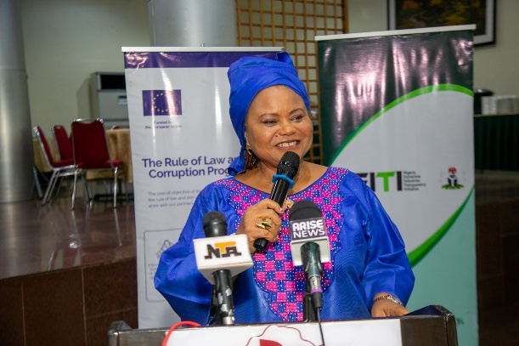
Mrs. Faith Nwadishi delivery her presentation at the CSO/Media Engagement on Validation
The Executive Director of the Center for Transparency Advocacy (CTA), Mrs. Faith Nwadishi provided a historical overview of Nigeria’s validation history, noting that the 2026 exercise marks the country's fifth cycle since its inception in 2007.
While delivering a presentation titled “The Review of Nigeria Validation Templates: Civil Society and Media Feedback,” she emphasized that active civil society and media participation is what drives successful stakeholder engagement.
Clarifying specific roles of both groups, Mrs. Nwadishi explained that the upcoming validation focuses heavily on the depth of stakeholder engagement, assessing direct impact and how effectively stakeholders utilize EITI data.
She highlighted that media feedback significantly enhances transparency, and she urged participants to utilize NEITI reports to conduct outreach at the subnational level. To streamline communication, she recommended that NEITI establish a dedicated rapid response feedback channel to enhance civil society and media reporting
In her concluding remarks, Mrs. Nwadishi noted that civil society inputs significantly enhances the robustness and national relevance of the templates, while media feedback improves clarity and accessibility for the broader public. She emphasized an interactive review process to ensures the templates align with local contexts. She stressed that the entire validation framework requires continuous reinforcement through stakeholder collaboration. She urged the Multi-Stakeholder Group (MSG) to establish a mechanism for regularly monitoring obstacles encountered in the implementation of EITI.
She stated that a report should be produced after every meeting of the civil society during their engagements to ensure accountability and transparency. In addition, she called on civil society organizations (CSOs) to submit regular reports to NEITI so that these contributions can be integrated into the Validation process
Ms. Nwadishi in collaboration with Kolawole Banwo, also a former Civil Society representative on the National Stakeholders Working Group subsequently facilitated an interactive session guiding members on the responses provided to the EITI validation templates.
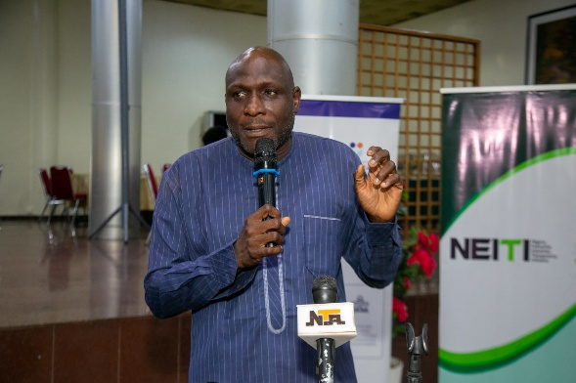
Mr. Kolawole Banwo delivering his presentation
The former Representative of Civil Society on the NSWG, Mr. Kolawole Banwo, shared post-submission reflections focusing on the template documentation process. He emphasized that the validation templates must be completed by the civil society organisation coordinators in collaboration with the wider constituency to reflect a consolidated consensus. Mr. Banwo noted that while internal conflicts are sometimes exaggerated or driven by isolated dissenting opinions, unresolved divergent views can create significant issues after the templates are populated and submitted. He also highlighted that the template structure allows groups outside the NSWG to contact validation teams directly to provide alternative perspectives.
To effectively manage the post-submission process, Mr. Banwo advised on the importance of balancing divergent views, providing concrete evidence for all populated data, and harmonizing accountability with national patriotism.
He concluded by urging the constituency to mobilize for consultative sessions, balance collective interests against individual positions, and rigorously test internal feedback loops to ensure a unified approach.
Recommendations
During the validation of the template session, the civil society and media constituency put forward the following key recommendations to NEITI to address operational gaps and strengthen future validation compliance:
- Appoint a dedicated media representative to the NEITI governing board as a specific corrective action to include media representation.
- Establish a dedicated Rapid Response Team within NEITI to foster an enabling environment for relaying, tracking, and managing feedback or challenges faced by civil society and media advocates when using EITI data.
- Formally integrate organized labor into the civil society and media engagement process to ensure comprehensive constituency input.
- Engage the government on policy solutions regarding the periodic dissolution of the board, which disrupts the continuity of the National Stakeholder Working Group (NSWG).
- Utilize this validation cycle as an advocacy launchpad to address the unequal numerical representation of constituencies on the board, recognizing that EITI implementation guidelines should align harmoniously with national sovereign laws.
- Improve on existing Board meeting structures regarding timely meeting schedules, ensuring invitations and event materials are distributed ahead of NSWG meetings for adequate preparation.
Group Photograph
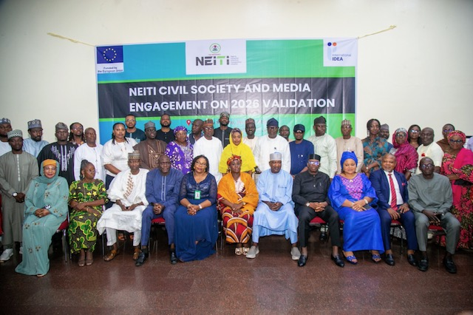
Closing
The Director of Communications and Stakeholders Management at NEITI, Mrs. Obiageli Onuorah, gave the vote of thanks. Meeting was concluded at 5pm.
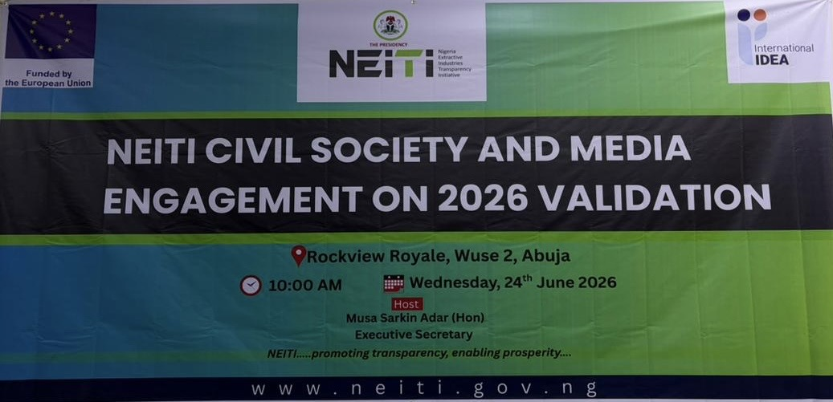
Banner for the Programme

