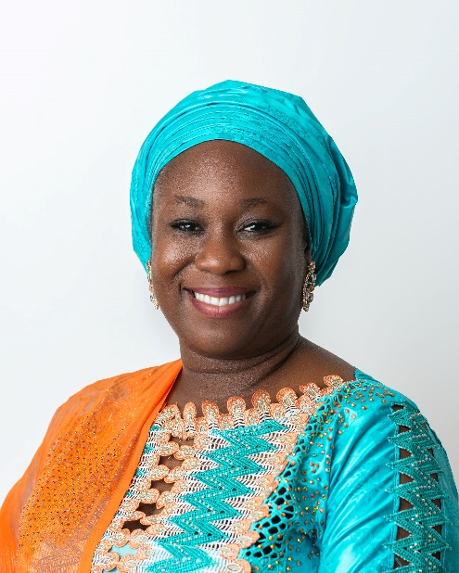
Dr Erisa Danladi Sarki
Dr. Erisa Danladi is a seasoned development practitioner, researcher, and governance expert with over two decades of experience in transparency, accountability, community development, and public policy.
She currently serves as the Civil Society Representative on the Governing Board of the Nigeria Extractive Industries Transparency Initiative and is the National Coordinator of Publish What You Pay Nigeria.
Dr. Danladi has led and contributed to numerous national and international initiatives on extractive governance, gender inclusion, sustainable development, and civic engagement, and is widely recognised for her commitment to advancing transparency and inclusive resource governance in Nigeria.

