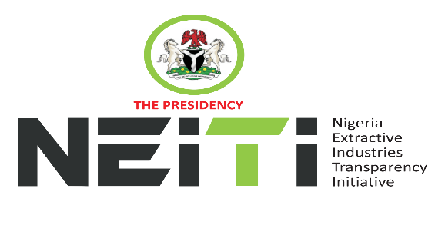
NSWG Ref No: 2/2026

Agenda
TAKE NOTICE that a meeting of the NSWG is scheduled to hold as follows:
DATE: 26th June 2026
TIME: 10:00hrs
VENUE: Executive Conference Room, Office of the Secretary to the Government of the Federation.
To discuss:
- Opening Prayer
- Review and Adoption of Agenda
- Chairman’s Opening Remarks
- Minutes of Meeting: Ref. No. 1/2026 held 13th March 2026 and Matters Arising from the Minutes
- Executive Secretary’s Status Report and Comments to the Report
- Stakeholders Constituency Reports
- CSO
- Companies/Industries
- NNPCL
- OPTS & Miners Association
- Revenue-FIRS
- Gender/Women in Extractives Representative
- Zonal Representatives
- Validation of Nigeria’s implementation of the EITI
- AOB
- Notices
- Closing

By Order of the NSWG

