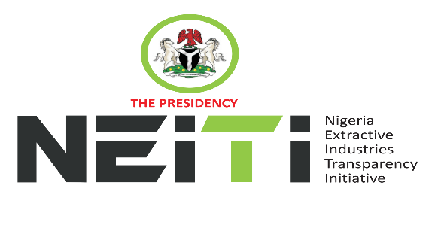
NSWG Ref No: 1/2026

Agenda
TAKE NOTICE that a meeting of the NSWG is scheduled to hold as follows:
DATE: 13th March, 2026
TIME: 10:00hrs
VENUE: Abuja
To discuss:
- Opening Prayer
- Review and Adoption of Agenda
- Chairman’s Opening Remarks
- Executive Secretary’s Status Report and Comments to the Report
- EITI 2026 Validation
- Minutes of Meeting: Ref. No. 4/2025 held 12th December, 2025 and Matters Arising from the Minutes
- Stakeholders Constituency Reports
- CSO
- Companies/Industries
- NNPCL
- OPTS & Miners Association
- Revenue-FIRS
- Gender/Women in Extractives Representative
- Zonal Representatives
- Report of the NSWG Committees
- Audit & Risk Committee
- AOB
- Notices
- Closing

By Order of the NSWG

