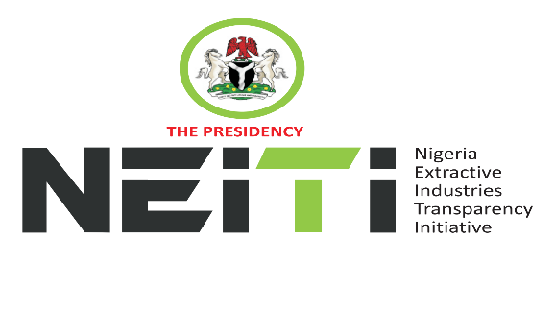
NSWG Ref No: 2/2025

Agenda
TAKE NOTICE that a meeting of the NSWG is scheduled to hold as follows:
DATE: 26th August, 2025
TIME: 12:00hrs
VENUE: Virtual Meeting
To discuss:
- Opening Prayer
- Review and Adoption of Agenda
- Chairman’s Opening Remarks
- Minutes of Meeting: Ref. No. 1/2025 held 9th May, 2025 and Matters Arising from the Minutes
- Executive Secretary’s Status Report and Comments to the Report
- Stakeholders Constituency Reports
- CSO
- Companies/Industries
- NNPCL
- OPTS & Miners Association
- Revenue-FIRS
- Gender/Women in Extractives Representative
- Zonal Representatives
- Report of the NSWG Committees:
- Board Memos for consideration and approval
- Secretariat Operational Memos
- AOB
- Notices
- Closing

By Order of the NSWG

