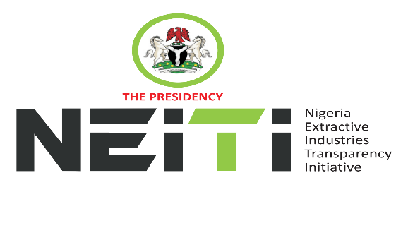
NSWG Ref No: 4/2025

Agenda
TAKE NOTICE that a meeting of the NSWG is scheduled to hold as follows:
DATE: 12th December, 2025
TIME: 9:00hrs
VENUE: Black Diamond Hotel, Victoria Island Lagos
To discuss:
- Opening Prayer
- Introduction of New Executive Secretary and members of the NSWG
- Review and Adoption of Agenda
- Chairman’s Opening Remarks
- Minutes of Meeting: Ref. No. 3/2025 held 11th November, 2025 and Matters Arising from the Minutes
- Executive Secretary’s Status Report and Comments to the Report
- Stakeholders Constituency Reports
- CSO
- Companies/Industries
- NNPCL
- OPTS & Miners Association
- Revenue-FIRS
- Gender/Women in Extractives Representative
- Zonal Representatives
- Board Memos for consideration and approval
- 2026 Annual Country Workplan
- Staff Promotions
- AOB
- Notices
- Closing

By Order of the NSWG

