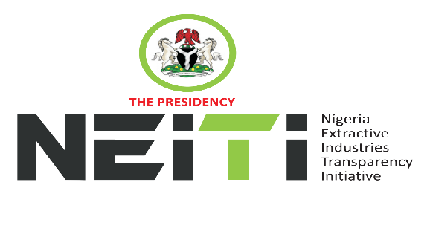
NSWG Ref No: 1/2025

TAKE NOTICE that a meeting of the NSWG is scheduled to hold as follows:
DATE: 9th May, 2025
TIME: 11:00hrs
VENUE: Sun Heaven Conference Room Umuahia, Abia State
To discuss:
- Opening Prayer
- Review and Adoption of Agenda
- Chairman’s Opening Remarks
- Minutes of Meeting: Ref. No. 4/2024 held 12th December, 2024 and Matters Arising from the Minutes
- Executive Secretary’s Status Report and Comments to the Report
- Stakeholders Constituency Reports
- CSO
- Companies/Industries
- NNPCL
- OPTS & Miners Association
- Revenue-FIRS
- Gender/Women in Extractives Representative
- Zonal Representatives
- EITI Validation – Status of work plan implementation
- Report of the NSWG Committees:
- Communications & Civil Society Steering Committee
- Human Resources & Ethics Committee
- Board Memos for consideration and approval
- HR Manual
- Staff Promotion
- NEITI 2024 Industry Audit (Oil & Gas and Solid Minerals)
- AOB
- Notices
- Closing
By Order of the NSWG

