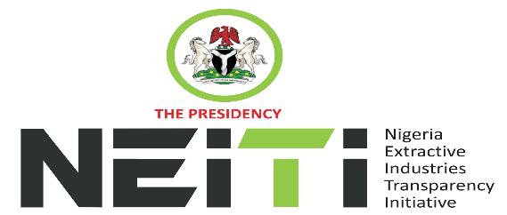
NSWG Ref No: 3/2024
TAKE NOTICE that a meeting of the NSWG is scheduled to hold as follows:
DATE: 25th September, 2024
TIME: 11:00hrs
VENUE: Conference Room OSGF
To discuss:
- Opening Prayer
- Review and Adoption of Agenda
- Chairman’s Opening Remarks
- Minutes of Meeting: Ref. No. 2/2024 held 18th July, 2024 and Matters Arising from the Minutes
- Executive Secretary’s Status Report and Comments to the Report
- Report of the Extractive Committee
- Overview of the highlights of the reports, Consideration and Approval of:
- 2022/2023 NEITI Oil & Gas Audit Report
- 2022/2023 NEITI Solid Minerals Audit Report
- Board Memos for consideration and approval
- Framework for Constituency Engagement
- Draft 2025 NEITI Budget
- Approval for Engagement of Consultants for FASD 2022-2023
9. AOB
10. Notices
11. Closing

By Order of the NSWG

