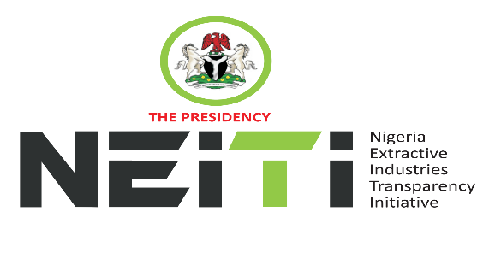
NSWG Ref No: 4/2024

TAKE NOTICE that a meeting of the NSWG is scheduled to hold as follows:
DATE: 12th December, 2024
TIME: 11:00hrs
VENUE: Virtual Meeting
To discuss:
- Opening Prayer
- Review and Adoption of Agenda
- Chairman’s Opening Remarks
- Minutes of Meeting: Ref. No. 3/2024 held 25th September, 2024 and Matters Arising from the Minutes
- Executive Secretary’s Status Report and Comments to the Report
- Stakeholders Constituency Reports
- CSO
- Companies/Industries
- NNPCL
- OPTS & Miners Association
- Revenue-FIRS
- Gender/Women in Extractives Representative
- Zonal Representatives
- Report of the NSWG Committees:
- Strategy & Implementation/Validation Committee
- Extractive Industry Committee
- Human Resources & Ethics Committee
- Communications & Civil Society Steering Committee
- Audit & Risk Committee
- Board Memos for consideration and approval
- 2025 Budget
- 2025 Country Workplan
- FASD – EITI Component 1
- Secretariat Operational Memos

- AOB
- Notices
- Closing

By Order of the NSWG

